

ANNUAL PROGRESS REPORT
April 2014 to March 2015

Contents
Sl. No. | Particular | Page No
 | Instructions for Filling the Format
 | Summary of KVK Annual Report (Quantifiable Achievement) for the year 2013-14
1 | General Information
2 | On Farm Testing
3 | Achievements of Frontline Demonstrations
4 | Documentation of the need assessment conducted by the KVK for the training programme
5 | Training programmes
6 | Extension Activities
7 | Literature Developed/Published (with full title, author & reference)
8 | Production and supply of Technological products
9 | Activities of Soil and Water Testing Laboratory
10 | Rainwater Harvesting
11 | Utilization of Farmer Hostel facilities
12 | Utilization of Staff Quarter facilities
13 | Details of SAC Meeting
14 | Status of Kisan Mobile Advisory
15 | Status of Convergence with agricultural schemes
16. | Status of Revolving Funds
17. | Awards & Recognition
18. | Details of KVK Agro-technological Park
19. | Farm Innovators
20. | KVK interaction with progressive farmers
21. | Outreach of KVK
22. | Technology Demonstration under Tribal Sub Plan on Pulses/ Programme on Harnessing Pulses/ Quality Protein Maize
23. | KVK Ring
24. | Important visitors to KVK
25. | Status of KVK Website
26. | Status of E-connectivity
27. | Status of RTI
28. | Status of Citizen Charter
29. | Attended HRD activities organized by ZPD
30. | Attended HRD activities organized by DES
31. | Attended HRD activities by KVK Staff
32 | Agri Alert report
33. | Details of Technological Week Celebration
34. | Interventions on Drought Mitigation
35. | Proposal of NICRA
36. | Proposed works under NAIP
37. | Case study / Success Story to be developed
38. | Action Photographs
Instructions for Filling the Format

- Do not change/modify/ delete any column of any of the table. However, additional rows can be created, if required.
- Do not merge columns, rows.
- Please repeat the name of KVK in each table in the column “Name of KVK”
- Do not fill the non-numerical values in numeric field
- Do not repeat the unit while reporting data as it is already mentioned in the heading row
- Strictly fill the data in desired unit only. If it is reported in other unit, convert it in the desired unit
- Please mention only standard English names of crops (Do not mention Urd, Arhar, Til, Kulthi, Moong, Bajra, etc.)
- Additional relevant information may be provided at the end of Format by creating heading “Additional Information”
- Also read the instructions mentioned just below the table
- Your suggestions for improvement in the format for your simplicity as well as data compilation may be given at the end of the format
- Do not press any Enter Key in any of the columns while making entry in the columns of the table. Use only arrow key /Tab key/ mouse pointer while movement from one column/row to another.
- Gray color cells in summary table need not to be filled.
- Crop name should be spelled correct and standard English name should be used i.e Cereals, Pulses, Oilseed:- Rice (not use Paddy), Wheat, Barley, Kodo, Kutki, Maize, Jwar, Bajra, Pigeon pea (not use Tur, Arhar, Red gram), Blackgram (not use Urd), Greengram (not use Moong/Moongbean), Chickpea (not use Horse gram, Gram, Chana), Field pea, Horse gram (Kulthi), Lentil, Mustard (not use Rai, Sarsoan), Soybean, Linseed, Groundnut, Sesame (not use Til), Niger (not use Ram Til), Safflower (not use Kusum).
Vegetable :- Vegetable pea, Bottle guard, Bitter guard, Okra (not use Bhindi or Ladies finger).
Fruits :- Mango, Guava, Custard apple, Pear etc.
Spices :- Black Peeper, Turmeric, Ginger, Cardamom etc.

REPORTING PERIOD – April 2014to March 2015
Summary of KVK Annual Report (Quantifiable Achievement) for the year 2013-14
S.N. | Quantifiable Achievement | Number | Beneficiaries (nos.)
1 | On Farm Testing
 | Proposed OFT | 15 | 150
 | On Going OFT | 15 | 150
 | Technologies assessed (Completed OFT) | 6 | 60
 | Technologies refined | - | -
 | On farm trials conducted | 15 | 249
2 | Frontline demonstrations | - | -
 | Proposed Frontline demonstrations | 15 | 5152
 | On Going Frontline demonstrations | 15 | 150
 | FLDs conducted on crops | 12 | 117
 | Area under crops (ha.) | 42 | 147
 | FLD on farm implement and tools | 1 | 14
 | FLD on livestock/ AH enterprises (Dairy/ Sheep and Goat/Poultry/ Duckery/ Piggery etc.) | 3 | 30
 | FLD on Fisheries - Finger lings | - | -
 | FLD on other enterprises (Bee keeping, lac, mushroom, sericulture, value addition, vermi compost, etc.) | - | -
 | FLD on Women in Agriculture - ( Nutritional garden, Income generation, Value addition, Drudgery reduction, etc.) | - | -
3 | Training programmes | No. of Course | Duration (days) | Participants
 | Farmers | 48 | 48 | 987
 | Farm women | - | - | -
 | Rural youth | - | - | -
 | Extension personnel/ In service | 4 | 4 | 90
 | Vocational trainings | 3 | 118 | 75
 | Sponsored Training | 37 | 40 | 1732
 | Total | 92 | 210 | 2884
 |  | No. of programmes | Participants
4 | Extension Programmes | 346 | 1800
5 | Production of technology inputs etc | Qty | Beneficiaries (nos.)
 | Seed (qt.) | 5.25 | 177
 | Planting material produced (nos.) | - | -
6 | Livestock | Qty | Beneficiaries (nos.)
 | Livestock strains ( Nos) | - | -
 | Milk Yield - Cow, Buffelo etc. (in liter) | - | -
 | Fish (Kg.) | - | -
 | Fingerlings (nos.) | - | -
 | Poultry-Eggs (nos.) | - | -
 | Ducks (nos.) | - | -
 | Chicks etc. (nos.) | - | -
7 | Bio Products | Qty | Beneficiaries (nos.)
 | Bio Agents -Earth worm (Kg.) | - | -
 | Trichoderma (kg.) | 500 | 500
 | Bio Fertilizers- Vermi compost, Rhizobium, PSB , BGA , Mycorriza , Azotobacter , Azospirillum etc. (Kg.) | 1475 | 850
 | Bio Pesticide-Panchgavya, Neem Extract , Neem oil etc.(lit.) | 2 | 4
 | Any other significant achievement in the Zone | Nos. | Participants/ beneficiaries
 | Award (Best KVK award and scientist and farmer’s award) | - | -
 | Publications ( Res. Paper/ pop. Art./Bulletin,etc.) | 8 | 8000
 | KVK News letter | 4 | 2000
 | SAC Meetings conducted | 1 | 40
 | Soil sample tested | 1500 | 428
 | Water sample tested | - | -
 | RWH System (Special training and field visit on RWH structure and MIS in KVKs) | - | -
 | KVK-KMA (Message and beneficiaries) | 70 | 7100
 | Convergence programmes | - | -
 | Sponsored programmes | - | -
 | KVK Progressive Farmers interaction | 2 | 29
 | No. of Technology Week Celebrations | - | -
 | Attended HRD activities organized by ZPD | 5 | -
 | Attended HRD activities organized by DES | 3 | -
 | Attended HRD activities by KVK Staff(Refresher /Short course, Training programme etc. ) | 8 | -
9 | Current status of Revolving Funds ( Amt. in Rs.)
10 |  | No. of blocks | No. of villages
 | Outreach of KVK in the District | 3 | 182
11 |  | ICAR | SAU | Others
 | No. of important visitors to KVK (nos.) | 2 | 9 | 2
12 |  | Working (Yes/No) | No. of Update
 | Status of KVK Website | Yes | 20
13 |  | Application received | Application disposed
 | Status of RTI (nos.) | - | -
14 |  | Query received | Query dissolved
 | Citizen Charter (nos.) | - | -
15 |  | Working (Yes/No) | No. of programme viewed
 | E-connectivity | - | -
16 |  | Filled | Vacant
 | Staff Position | PC-1  SMS-3  PA-1 | -  3  3
17 | Workshop/ Seminar/ Conference attended by staff of KVK ( nos) | 10
 | Publication received from ICAR /other organization (nos.) | -
 |  | Particulars | Organization
 | Agri alerts (epidemic, high serious nature problem, Cyclone etc. reported first time to ZPD, SAU, Agri. Deptt. and ICAR) | Hail storm | SAU
1. GENERAL INFORMATION
1.1. Staff Position (as on date 1/04/15)

Name of KVK. | Sanctioned post | Name of the  incumbent | Discipline | Highest degree | Subject of  Specialization | Pay Scale (Rs.) | Present basic (Rs.) | Date of joining | Permanent  /Temporary | Category (SC/ST/  OBC/  Others)
Umaria | Programme Coordinator | Dr. K.P. Tiwari | Agronomy | - Ph.D | - Agronomy | 37400-67000 | 53820 | 22/9/14 | -Permanen | - Gen.
Umaria | Subject Matter Specialist1 | Shri K. Sahare | Ext. Education | M.Sc., NET | Ext. Education | 15600-39100 | 26590 | 5/05/07 | Permanent | Sc
Umaria | Subject Matter Specialist2 | Dr. B. K. Tiwari | Agronomy | Ph.D., NET | Agronomy | -do- | 29790 | 2/07/07 | Permanent | Gen.
Umaria | Subject Matter Specialist3 | Dr. R.R. Singh | LPM | Ph.D. | LPM | -do- | 21600 | 13/10/11 | Permanent | Gen
Umaria | Subject Matter Specialist4
Umaria | Subject Matter Specialist5 | - | - | - | - | - | - | - | - | -
Umaria | Subject Matter Specialist6 | - | - | - | - | - | - | - | - | -
Umaria | Programme Assistant | - | - | - | - | - | - | - | - | -
Umaria | Farm Manager | - | - | - | - | - | - | - | - | -
Umaria | Computer Programmer | Shri Arun Kumar Rajak | Computer | MCA | Computer Scinece | 9300-34800 +GP 3600 | 17150 | 08-04-2008 | Permanent | OBC
Umaria | Accountant / superintendent | - | - | - | - | - | - | - | - | -
Umaria | Stenographer | - | - | - | - | - | - | - | - | -
Umaria | Driver | Shri R.K. Vishwakarma |  | 12th passed |  | 5200-20200 + GP 1900 | 9080 | 10/07/08 | Permanent | OBC
Umaria | Driver | Shri S.K. Vaishya |  | 12th Passed |  | 5200-20200 + GP 1900 | 9080 | 11/07/08 | Permanent | SC
Umaria | Supporting staff | - | - | - | - | - | - | - | - | -
Umaria | Supporting staff | - | - | - | - | - | - | - | - | -

1.2. DISTRICT PROFILE (detail of geographical area, cultivation, Land, resources, opportunities, irrigation, populations etc.)–
District Profile:
1.2.1. Administrative & census -
Tehsil | Block | Geographical area (sqkm) | Village | Gram Panchayat | Population 2001 | Literacy % | % of population
 |  |  |  |  |  |  | SC | ST
Karkeli | Karkeli | 1678 | 277 | 107 | 190816 | 51.4 | 4.75 | 54.01
Manpur | Manpur | 1952 | 211 | 83 | 167069 | 61.86 | 8.62 | 34.49
Pali | Pali | 873 | 101 | 44 | 74945 | 57.17 | 4.98 | 64.14
District | Umaria | 4503 | 589 | 234 | 432880 | 56.50 | 6.30 | 48.20

Particulars | Madhya Pradesh | Umaria
Population (2011) | 72,597,565 | 643,579
Decadal Population Growth Rate(2001-11) | 20.30% | 24.70%
Population Density Per Sq.km(2011) | 236 | 158
Level of Urbanization(2011) | 27.60% | 17.20%
Proportion of ST Population(20011) | 20.30% | 44.00%
Contribution to State Economy(2008-09) - |  | 0.59%
Per Capita Income(INR), Current Prices(2008-09) | 24,709 | 17,313
Contribution of Primary Sector to Economy(2008-09) | 31.50% | 29.00%
Contribution of Secondary Sector to Economy(2008-09) | 22.90% | 29.70%
Contribution of Tertiary Sector to Economy(2008-09) | 45.60% | 41.30%

1.2.2. Geographical & Agricultural situation of Umaria-

- Longitude - 23⁰-31' N - 23⁰37' N
- Latitude - 30⁰-10' E - 800⁰50' E
- MSL - 487.95 M.
S. No. | Particulars | Area (ha) | % Area/Units
1. | Geographical area | 450329 ha. | --
2. | Forest area | 236714 ha. | 52.56
3. | Net cultivated area | 106566 ha. | 23.66
4. | Waste-land area | 32830 ha. | 11.89
5 | Double cropped area | 35110 ha | 7.2
6. | Cropping intensity | -- | 133
7. | Irrigated area | 26680 ha. | 25
8. | Average rainfall (mm) | -- | 1374.7 mm
9. | No. of farmers | -- | 800037
10. | Average size of land holding | 0.17 ha. | --

1.2.3. Forest statistics of district Umaria
S. No. | Particulars | Nos.
1 | Geographical area of the district: | 4503 sq. km
2 | Total forest area | 1413 sq. km (31.38 %)
3 | Reserved forest | 84193.76 ha (59.5 %)
4 | Protected forest | 57601.99 ha (40.4 %)
5 | Forest area consist
 | Teak forest | 2.77 %
 | Sal forest | 43.06 %
 | Mix forest | 37.17 %
 | Other forest | 7.55 %
6 | Forest protection society | 95 Nos (53040.46 ha)
 | Village forest society | 111 Nos. (58187.294 ha)

1.2.4. Cropping pattern -
S. No. | Cropping pattern | Area (ha) | % of Net cultivated area
1. | Kharif crop - Rabi fellow | 54090 | 50.75
2. | Kharif fellow- Rabi crop | 18430 | 17.29
3. | Kharif crop - Rabi crop | 32570 | 30.56
4. | Mono cropped area | 72520 | 68.05

1.2. DISTRICT PROFILE (detail of geographical area, cultivation, Land, resources, opportunities, irrigation, populations etc.)–

KVK Name | Agro-climatic zone | No . of Blocks | No. of Panchayats | Population | Literacy | SC and ST Population | No. of farmers | Average land holding

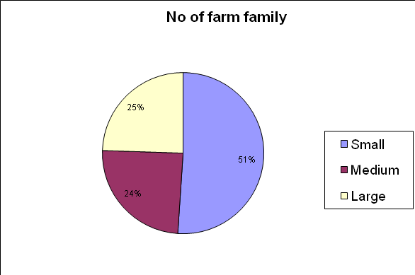

1.2.5. Cropping intensity and productivity of major crop -
S. No. | Crops | Area (ha) | Production (000 mt) | Productivity (kg/ha) |  | % of Income
 |  |  |  | Productivity | Price | % of Income
a. | Cereal crop -
 | Kharif
 | Paddy | 48.09 | 136.67 | 2842 | 1450 | 67.28
 | Maize | 11.13 | 23.37 | 2100 | 1310 | 10.39
 | Sorghum | 0.43 | 0.43 | 1003 | 1200 | 0.18
 | Kodo-kutki | 14.32 | 15.52 | 1084 | 1200 | 6.32
 | Rabi
 | Wheat | 30.3 | 29.82 | 984 | 1550 | 15.69
 | Barley | 0.40 | 0.34 | 860 | 1200 | 0.14
b. | Pulse -
 | Kharif
 | Pigeon pea | 14.31 | 12.16 | 850 | 4300 | 60.08
 | Black gram | 4.63 | 3.47 | 750 | 3200 | 12.76
 | Green gram | 0.17 | 0.08 | 480 | 3500 | 0.32
 | Rabi
 | Gram | 8.0 | 3.98 | 498 | 3200 | 14.63
 | Pea | 2.60 | 0.75 | 289 | 3500 | 3.02
 | Lentil | 6.30 | 2.0 | 318 | 4000 | 9.19
c. | Oilseed -
 | Kharif
 | Sesame | 3.72 | 2.05 | 550 | 5000 | 18.44
 | Niger | 1.65 | 0.74 | 450 | 3000 | 3.99
 | Soybean | 4.23 | 7.40 | 1750 | 4000 | 53.24
 | Rabi
 | Mustard/Rai | 8.00 | 3.50 | 438 | 3000 | 18.89
 | Linseed | 3.2 | 1.12 | 350 | 2700 | 5.44

1.2.6. Fertilizer consumption (NPK) Kg/ha -
Season | N | P | K | Total
Kharif | 10.24 | 8.27 | 0.62 | 19.13
Rabi | 28.89 | 22.78 | 0.87 | 52.54

1.2.7. Seed replacement rate (%) -
Kharif | 21.00%
Rabi | 17.78 %
Total - | 19.39 %

1.2.8. Major farming systems/enterprises (based on the analysis made by the KVK scientist)
S. No | Farming system/enterprise
1 | Agriculture
2 | Agriculture + Dairy
3 | Collection of Minor Forest Produce
4 | Forest based industry
5 | Vegetable farming
6 | Pisces culture
7 | Backyard poultry
8 | Goatary

1.3. DETAILS OF ADOPTED VILLAGE during 1.4.2014to 31.3.2015(Approved by competent Authority in meetings/workshops)
KVK Name | Village Name | Year of adoption | Block Name | Distance from KVK | Population | Number of farmers (having land in the village)
UMARIA | Taali-Dhaurkhoh | 2014 | Karkeli | 10 KM | 2779 | 782

1.4. THRUST AREAS identified by KVK (Approved by competent Authority in meetings/workshop)
KVK Name | THRUST AREA
Umaria | Varietal Diversification- Availability of quality seed through seed production technology and Seed replacement.
Umaria | Technological diversification
Umaria | Crop diversification
Umaria | Integrated farming system
Umaria | Rainwater and irrigation management
Umaria | Integrated nutrient management
Umaria | Integrated pest management
Umaria | Promotion of organic farming along with balanced nutrition.
Umaria | Strengthen of linkage between farmer’s and extension system
Umaria | Farm mechanization and drudgery reduction
Umaria | Development of rural entrepreneurship for income and employment generation like Bee Keeping and mushroom cultivation
Umaria | Increasing productivity of vegetables
Umaria | Integrated livestock management

1.5. PROBLEM IDENTIFIED by KVK (Approved by competent Authority in meetings/workshop)

KVK Name | Problem identified | Methods of problem identification | Location Name of Village & Block
Umaria | Lack of knowledge about milch Animals, poultry , fish and goatery management | PRA | Tali and Dhourkho Block Karkeli
Umaria | Lack of agrotechnical knowledge, | PRA | Tali and Dhourkho Block Karkeli
Umaria | Low seed replacement rate, | PRA | Tali and Dhourkho Block Karkeli
Umaria | Traditional method of cropping, | PRA | Tali and Dhourkho Block Karkeli
Umaria | No use of improved farm implements, | PRA | Tali and Dhourkho Block Karkeli
Umaria | Mono cropping, | PRA | Tali and Dhourkho Block Karkeli
Umaria | No knowledge of shaded cropping technology, | PRA | Tali and Dhourkho Block Karkeli
Umaria | Lack of awareness about improved milch animals and their feeding habits, | PRA | Tali and Dhourkho Block Karkeli
Umaria | No knowledge of disease and insect pest management, | PRA | Tali and Dhourkho Block Karkeli
Umaria | No knowledge about women drudgery reduction and their lean period utilization | PRA | Tali and Dhourkho Block Karkeli
Umaria | No knowledge about soil test basis cropping system | PRA | Tali and Dhourkho Block Karkeli
Umaria | No knowledge about poultry, fish and goatery management, | PRA | Tali and Dhourkho Block Karkeli
Umaria | Lack of awareness about soil and water conservation measures | PRA | Tali and Dhourkho Block Karkeli

2. On Farm Testing
Note-
* Thematic area should be spelled correct and follow standard pattern i.e. Integrated Nutrient Management in place of INM or Inte. Nutrient Mngt. Etc.
*Crop name should be spelled correct and standard English name should be used i.e Chick pea in place of gram/chana , Paddy in place of Rice/chawal , brinjal in place of egg plant/bhata/baigan etc.
*Don’t press enter key to navigate among column use arrow or tab key
*don’t add space before or after statement within the table cell
2.1 Information about OFT

KVK name | Year | Season | Problem diagnose | Title of OFT | Category of technology (Assessment/ Refinement) | Thematic Area | Crop/ enterprise | Farming Situations | No. of trials | Results (q/ha) |  |  | Net Returns (Rs./ha) |  |  | Recommendations
 |  |  |  |  |  |  |  |  |  | FP (T₁) | RP (T₂) | T3 | FP (T₁) | RP (T₂) | T3 | Recommendations
Umaria / 1 | 2014-15 | Kharif | Yellow vein mosaic in soybean | Assessment of YMV management in soybean | Assessment | IPM | Soybean | Rainfed | 11 | 12.2 | 16.79 | 13.98 | 16308 | 28578 | 20948 | Trial should be repeated for next year
Umaria / 2 | 2014-15 | Kharif | Low yield due to dense planting | Assessment of different spacing of paddy in SRI system | Assessment | Crop management | Paddy | Irrigated | 10 | 33.85 | 57.57 | 50.2 | 25168 | 54759 | 43948 | Trial should be repeated for next year
Umaria / 3 | 2014-15 | Kharif | Poor yield due to imbalance nutrition in SRI system | Assessment of integrated nutrient management in paddy in SRI system | Assessment | INM | Paddy | Irrigated | 11 | 42.0 | 60.75 | 55.18 | 35350 | 57034 | 51266 | Trial should be repeated for next year
Umaria / 4 | 2014-15 | Kharif | Poor yield due to traditional method of sowing | Assessment of SPI technique of pigeon pea | Assessment | Crop management | Pigeonpea | Rainfed | 34 | 10.18 | 28.19 | - | 20282 | 74924 | - | Trial should be repeated for next year
Umaria 5 | 2014-15 | Kharif | No dewarming to control calves mortality | Assessment of dewarmar to control calf mortality | Assessment | LPM | calf | All type | 10 | 60% calf mortality | 20%  calf mortality | - | - | - | - | -
Umaria 6 | 2014-15 | Kharif | Poor yield due to growing local variety | Assessment of HYV kurg honey dew of papaya | Assessment | Crop management | Papaya | Rainfed | 5 | Awaited | Awaited | - | Awaited | Awaited | - | -
Umaria 7 | 2014-15 | Rabi | No rearing of dual purpose breed of poultry | Assessment of Jabalpur dwikaji dual purpose bird to increase body weight in backyard poultry production | Assessment | LPM | Poultry | All type | 10 | Awaited | Awaited | - | - | - | - | -
Umaria 8 | 2014-15 | Rabi | Poor yield due to growing old variety | Assessment of HYV JW-3211 of wheat under semi irrigated conditions. | Assessment | Crop management | Wheat | Semi irrigated | 8 | 30.25 | 35.30 | - | 25139 | 30650 | - | -
Umaria 9 | 2014-15 | Rabi | Poor yield due to heavy infestation of annual weeds | Assessment of clodinofop-propargyl+metsulfuron for weed management in wheat under irrigated conditions | Assessment | IWM | Wheat | Irrigated | 9 | 27.91 | 35.72 | - | 19022 | 29246 | - | -
Umaria 10 | 2014-15 | Rabi | Poor yield due to high seed rate | Assessment of SMI system of mustard | Assessment | Crop management | Mustard | Irrigated | 7 | 12.0 | 29.52 | 29.41 | 19050 | 63000 | 62670 | Trial should be repeated with Indian mustard variety.
Umaria 11 | 2014-15 | Rabi | 1. Low cleaning efficiency 2. More time consuming process by traditional practice of using Supa. | Assessment of hanging type double screen seed cleaner in Wheat. | Assessment | Farm Machinery | Hanging Seive | All type | 5 | 1.Cleaning capacity (q/hr)= 0.95  2. Labor requirement (man-h/q)= 1.5  3. Cost of cleaning (Rs./q)= 18.75 | 1.Cleaning capacity (q/hr)= 1.55  2.Labor requirement (man-h/q)= 0.83  3.Cost of cleaning (Rs./q)= 10.50 | - | - | - |  | Hanging type double screen seed/grain cleaner was found useful because it saves time of cleaning as well as labor and cost.
Umaria 12 | 2014-15 |  | Lack of knowledge about KMA | Assessment of KMA | Assessment | Agriculture Information through KM | KMA | All type | 100 | - | Timeliness-80%  Simplicity-70%  Understandability-80%  Applicability-70% | - | - | - | --
Umaria 13 | 2014-15 |  | Lack of Knowledge about improved cultivation technique | Assessment of Village library for adoption of improved cultivation technique | Assessment | Knowledge management | Library | All type | 2 | - | Awaited |  |  |  |  | Continue
Umaria 14 | 2014-15 | Rabi | Poor yield due to heavy infestation of fruit borer | Assessment of IPM module in tomato | Assessment | IPM | Tomato | Irrigated | 5 | 206.5 | 251.32 | - | 53450 | 74060 | - | -
Umaria 15 | 2014-15 | Kharif & Rabi | Farmers are not united for their own interest | Assessment of FIG | Assessment | Technology dissemination through FIGs | Fig | All type | 20 | - | Adopted the technology | - | - | - | - | -
  - Economic Performance
KVK name | OFT Title | Parameters |  |  | Average Cost of cultivation (Rs/ha) |  |  | Average Gross Return (Rs/ha) |  |  | Average Net Return (Rs/ha) |  |  | Benefit-Cost Ratio (Gross Return / Gross Cost)
KVK name | OFT Title | Name and unit of Parameter | FP (T₁) | RP (T₂) | FP (T₁) | RP (T₂) | Refined Practice, if any (T₃) | FP (T₁) | RP (T₂) | Refined Practice, if any (T₃) | FP (T₁) | RP(T₂) | Refined Practice, if any (T₃) | FP (T₁) | RP (T₂) | Refined Practice, if any (T₃)
Umaria / 1 | Assessment of YMV management in soybean | % of infected plant | 31.9 | 1.63 | 20292 | 21792 | 20992 | 36600 | 50370 | 41940 | 16308 | 28578 | 20948 | 1.80 | 2.31 | 1.99
Umaria / 2 | Assessment of different spacing of paddy in SRI system | No of tillers/m2 | 179 | 272 | 21547 | 24027 | 25327 | 46715 | 78786 | 68770 | 25168 | 54759 | 43443 | 2.16 | 3.27 | 2.71
Umaria / 3 | Assessment of integrated nutrient management in paddy in SRI system | No of tillers/m2 | 217 | 294 | 22477 | 26027 | 24227 | 57827 | 83061 | 75493 | 35350 | 57034 | 51266 | 2.42 | 3.19 | 3.11
Umaria / 4 | Assessment of SPI technique of pigeon pea | No of pods/plant | 251 | 6321 | 16266 | 26560 | - | 36648 | 101484 | - | 20282 | 74924 | - | 2.25 | 3.82
Umaria 5 | Assessment of dewarmar to control calf mortality | Mortality% | 60 | 20 | - | - | - | - | - | - | - | - | - | - | - | -
Umaria 6 | Assessment of HYV kurg honey dew of papaya | Survival% | 70% | 50% | - | - | - | - | - | - | - | - | - | - | - | -
Umaria 7 | Assessment of Jabalpur dwikaji dual purpose bird to increase body weight in backyard poultry production | Awaited | - | - | - | - | - | - | - | - | - | - | - | - | - | -
Umaria 8 | Assessment of HYV JW-3211 of wheat under semi irrigated conditions. | No of tillers/m2 | 217 | 276 | 20880 | 23260 | - | 46019 | 53910 | - | 25139 | 30650 | - | 2.20 | 2.31 | -
Umaria 9 | Assessment of clodinofop-propargyl+metsulfuron for weed management in wheat under irrigated conditions | Weed intensity m2 | 62.5 | 19.11 | 23365 | 24865 | - | 42387 | 54111 | - | 19022 | 29246 | - | 1.81 | 2.17
Umaria 10 | Assessment of SMI system of mustard | No of siliquae/plant | 737 | 8487 | 16950 | 25560 | 25560 | 36000 | 88560 | 88230 | 19050 | 63000 | 62670 | 2.12 | 3.46 | 3.45
Umaria 11 | Assessment of hanging type double screen seed cleaner in Wheat. | 1.Cleaning capacity (q/hr)  2. Labor requirement (man-h/q)  3.Cost of cleaning (Rs./q) | 0.95  1.5  18.75 | 1.55  0.83  10.50 | - | - | - | - | - | - | - | - | - | - | - | -
Umaria 12 | Assessment of KMA | Timeliness-  Simplicity-  Understandability-  Applicability- | -  -  - | 80%  70%  70% | - | - | - | - | - | - | - | - | - | - | - | -
Umaria 13 | Assessment of Village library for adoption of improved cultivation technique | Knowledge level  Adoption level | Awaited | Awaited | Awaited | Awaited | Awaited | Awaited | Awaited | Awaited | Awaited | Awaited | Awaited | Awaited | Awaited | Awaited
Umaria 14 | Assessment of IPM module in tomato | No of borer infected fruit/plant | 3.5 | 1.0 | 49800 | 51600 | - | 103250 | 125660 | - | 53450 | 74060 | - | 2.07 | 2.43 | -
Umaria 15 | Assessment of FIG | Adoption | - | Adopted | - | - | - | - | - | - | - | - | -- | - | - | -

2.3 Information about Home Science OFT:

KVK Name | Year | Season | Problem diagnose | Title of OFT | Category of technology (Assessment/ Refinement) | Thematic Area | Details of Technology Selected for Assessment | Characteristics of Technology / Variety / Product / Enterprise | Farming / Enterprise Situation | No. of trials | Recommendations

2.4 Economic Performance Home Science OFT:

KVK name | OFT Title | Performance Indicator / Parameter
KVK name | OFT Title | Output m2/h |  | Est. Energy Expenditure kj/min. |  | WHR beat/min |  | % reduction in drudgery |  | % increase in efficiency |  | Production per unit |  | Cost of input |  | Incremental income |  | Yield(Kg/ha) |  | Net Return |  | Saving in Rs | BC ratio
KVK name | OFT Title | T1 | T2 | T1 | T2 | T1 | T2 | T1 | T2 | T1 | T2 | T1 | T2 | T1 | T2 | T1 | T2 | T1 | T2 | T1 | T2 | Saving in Rs | BC ratio
  - Feedback from KVK to Research System
Name of KVK | Feedback
Umaria | Wilt resistant variety of Gram, Pigeon pea and Yellow vein mosaic resistant variety of Black Gram are desired
Umaria | Sedge nut weed management chemical control of Sedge nut
Umaria | Short duration Pigeon pea& frost resistant variety are needed
Umaria | Rain fed high yielding variety of wheat
Umaria | Drought and wasteland suitable eucalyptus clones
Umaria | Leaf curl resistant variety in tomato Fruit shoot borer resistant variety of brinjal are required by farmers.

3. Achievements of Frontline Demonstrations

3.1. Follow-up for results of FLDs implemented during previous years 2013-14

List of technologies demonstrated and popularized during previous years and recommended for large scale adoption in the district
KVK Name | Crop/  Enterprise | Thematic Area | Technology demonstrated | Details of popularization methods suggested to the Extension system | Horizontal spread of technology
 |  |  |  |  | No. of villages | No. of farmers | Area in ha
Umaria | Crop | Varietal | Demonstration of IPM of paddy in SRI system | Group meeting, kisan sangosthi, farmers training Field dayprogramme, field demonstration, folder distribution etc | 8 | 55 | 50
Umaria | Crop | Varietal | Demonstration of Imazethapyr @100 g a.i./ha at 25-30 DAS for weed management in pigeon pea | Group meeting, kisan sangosthi, farmers training programme, field demonstration, folder distribution etc | 12 | 75 | 35
Umaria | Crop | Full package | Demonstration of HYV T-9 of black gram | Group meeting, kisan sangosthi, farmers training programme, field demonstration, folder distribution etc | 7 | 63 | 33
Umaria | Crop | Full package | Demonstration of HYV TKG-22 of sesame | Group meeting, kisan sangosthi, farmers training programme, field demonstration, folder distribution etc | 6 | 55 | 25
Umaria | Crop | Varietal | Demonstration of HYV VRO-6 of okra | Group meeting, kisan sangosthi, farmers training programme, field demonstration, folder distribution etc | 7 | 48 | 25
Umaria | Crop | Varietal | Demonstration of HYV ADR-1 of kharif onion | Group meeting, kisan sangosthi, farmers training programme, field demonstration, folder distribution etc | 8 | 8 | 32
Umaria | Crop | Varietal | Demonstration of clonal eukalyptus | Group meeting, kisan sangosthi, farmers training programme, field demonstration, folder distribution etc | 6 | 68 | 50
Umaria | Crop | component demonstration | Demonstration of probiotic in buffalo calves to increase weight. | Group meeting, kisan sangosthi, farmers training programme, field demonstration, folder distribution etc | 30 | 200 | 50
Umaria | Crop | component demonstration | Demonstration of probiotic in cow calves to increase weight. | Group meeting, kisan sangosthi, farmers training programme, field demonstration, folder distribution etc | 20 | 100 | 25
Umaria | Crop | IPM | Demonstration of IPM in brinjal | Group meeting, kisan sangosthi, farmers training programme, field demonstration, folder distribution etc | 5 | 32 | 25
Umaria | Crop | Varietal | Demonstration of HYV GW-366 of wheat under irrigated conditions. | Group meeting, kisan sangosthi, farmers training programme, field demonstration, folder distribution etc | 6 | 25 | 25
Umaria | Crop | INM | Demonstration of INM in wheat | Group meeting, kisan sangosthi, farmers training programme, field demonstration, folder distribution etc | 7 | 32 | 35
Umaria | Crop | IWM | Demonstration of sulfosulfuron+metsulfuron for weed management in wheat | Group meeting, kisan sangosthi, farmers training programme, field demonstration, folder distribution etc | 6 | 45 | 52
Umaria | Crop | Varietal | Demonstration of HYV GW-366 of wheat under irrigated conditions. | Group meeting, kisan sangosthi, farmers training programme, field demonstration, folder distribution etc | 5 | 65 | 56
Umaria | Crop | Varietal | Demonstration of HYV JG-130 of gram | Group meeting, kisan sangosthi, farmers training programme, field demonstration, folder distribution etc | 7 | 74 | 52
Umaria | Crop | Varietal | Demonstration of HYV pusa tarak of mustard | Group meeting, kisan sangosthi, farmers training programme, field demonstration, folder distribution etc | 5 | 36 | 57

Note-
* Thematic area should be spelled correct and follow standard pattern i.e. Integrated Nutrient Management in place of INM or Inte. Nutrient Mngt. Etc.
*Crop name should be spelled correct and standard English name should be i.e Chick pea in place of gram, Paddy in place of Rice , brinjal in place of egg plant etc.
*Don’t press enter key to navigate among col use arrow or tab key
*don’t add space before or after statement within the table cell

3.2 Details of FLDs implemented

KVK Name | year | Season | Thematic area | Technology demonstrated | Name of Crop/ Enterprise | Name of Variety/Technology/Entreprizes | Crop- Area (ha) / Entrep - No. | Results (q/ha) |  | % change | No. of farmers
 |  |  |  |  |  |  |  | FP (T₁) | RP (T₂) | % change | SC | ST | Others | General | Total
Umaria / 1 | 2014-15 | Kharif | Crop management | Demonstration of HYV Sahbhagi dhan under upland condition | Paddy | Sahbhagi dhan | Paddy-5.6 | 24.0 | 35.47 | 48 | 0 | 13 | 1 | 0 | 14
Umaria / 2 | 2014-15 | Kharif | IWM | Demonstration of integrated weed management in black gram | Black Gram | Imazethapyr | Black gram-4.0 | 6.95 | 10.62 | 53 | 1 | 1 | 8 | 0 | 10
Umaria / 3 | 2014-15 | Kharif | Farm mechenery | Demonstration of conoweeder for intercultural operation in transplanted paddy | Paddy | Cono weeder | Paddy-5.6 | 44.9 | 60.5 | 35 | 0 | 10 | 4 | 0 | 14
Umaria / 4 | 2014-15 | Kharif | Crop management | Demonstration of HYV JTS-55 of sesame | Sesame | JTS-55 | Sesame-5.0 | 5.10 | 6.85 | 34.31 | 0 | 6 | 7 | 0 | 13
Umaria 5 | 2014-15 | Kharif | Crop management | Demonstration of HYV TJT-501 of pigeon pea | Pigeonpea | TJT-501 | Pigeon pea-5.0 | 7.36 | 10.23 | 38.99 | 0 | 6 | 7 | 0 | 13
Umaria 6 | 2014-15 | Kharif | LPM | Demonstration of dewarming in lactating buffalow | Buffolo | Dewarmer | 20 | 1 litr | 1.10 | 11.05 | 0 | 6 | 14 | 0 | 20
Umaria 7 | 2014-15 | Kharif | LPM | Demonstration of azolla feeding in lactating buffalo | Azolla | Azolla | 5 | 1 litr | 1.15 | 11.52 | 0 | 0 | 5 | 0 | 5
Umaria 8 | 2014-15 | Kharif | Crop management | Demonstration of clonal eukalyptus | Eukalyptus | Eukalyptus | Eukalyptus-1.0 | Awaited | Awaited | Awaited | 0 | 3 | 2 | 0 | 5
Umaria 9 | 2014-15 | Kharif | Crop management | Demonstration of kharif onion | Onion | Kharif onion | Kharif onion-1.0 | - | 132.12 | 100 | 0 | 2 | 3 | 0 | 5
Umaria 10 | 2014-15 | Kharif | Crop management | Demonstration of intercropping of black gram I n gwava plantetion | Black gram | intercropping | black gram 2.0 | 6.8 | 5.65 | (-) 20 | 0 | 2 | 3 | 0 | 5
Umaria 11 | 2014-15 | Rabi | Crop management | Demonstration of GW-322 of wheat under irrigated conditions | Wheat | GW-322 | Wheat-2.0 | 30.7 | 43.10 | 40 | 0 | 0 | 5 | 0 | 5
Umaria 12 | 2014-15 | Rabi | IPM | Demonstration of IPM in mustard | Mustard | Mustard | Mustard-2.8 | 7.32 | 10.55 | 44 | 1 | 2 | 4 | 0 | 7
Umaria 13 | 2014-15 | Rabi | Crop management | Demonstration of HYV JG-130 of chickpea | GRam | JG-130 | Chickpea-5 | 7.35 | 11.50 | 56 | 0 | 5 | 8 | 0 | 13
Umaria 14 | 2014-15 | Rabi | Crop management | Demonstration of HYV pusa bold of mustard | Mustard | Pusa bold | Mustard-5.0 | 7.83 | 11.19 | 42.31 | 0 | 8 | 5 | 0 | 13
Umaria 15 | 2014-15 | Rabi | LPM | Demonstration of mineral mixture in lactating cow | Cow | Mineral mixture | 5 | Awaited | Awaited | Awaited | 0 | 1 | 4 | 0

3.3 Economic Impact of FLD

KVK Name | Technology demonstrated | Name of Crop/ Enterprise | Parameters |  |  | Cost of cultivation (Rs/ha) |  | Gross Return (Rs/ha) |  | Average Net Return (Rs/ha) |  | Benefit-Cost Ratio (Gross Return / Gross Cost)
KVK Name | Technology demonstrated | Name of Crop/ Enterprise | Name and unit of Parameter | FP (T₁) | RP (T₂) | FP (T₁) | RP (T₂) | FP (T₁) | RP (T₂) | FP (T₁) | RP (T₂) | FP (T₁) | RP (T₂)
Umaria / 1 | Demonstration of HYV Sahbhagi dhan under upland condition | Paddy | No of effective tillers/m2 | 207 | 261 | 18877 | 20477 | 33400 | 48872 | 14523 | 28395 | 1.76 | 2.38
Umaria / 2 | Demonstration of integrated weed management in black gram | Black Gram | Weed intensity/m2 | 103 | 14.25 | 14672 | 16532 | 24325 | 37170 | 9653 | 20638 | 1.65 | 2.24
Umaria / 3 | Demonstration of conoweeder for intercultural operation in transplanted paddy | Paddy | No of effective tillers/m2 | 292.5 | 311.5 | 24047 | 27897 | 62270 | 83050 | 38223 | 55153 | 2.58 | 2.97
Umaria / 4 | Demonstration of HYV JTS-55 of sesame | Sesame | No of capsule/plant | 42.96 | 67.96 | 14550 | 16250 | 26231 | 37487 | 11681 | 21237 | 1.80 | 2.30
Umaria 5 | Demonstration of HYV TJT-501 of pigeon pea | Pigeonpea | No of pods/plant182 | 182 | 321 | 14575 | 16266 | 26496 | 36828 | 11921 | 20562 | 1.81 | 2.26
Umaria 6 | Demonstration of dewarming in lactating buffalow | Buffolo | Milk yield | 1 liter | 1.10 liter | 1800 | 1848 | 3600 | 3996 | 1800 | 2148 | 2.0 | 2.16
Umaria 7 | Demonstration of azolla feeding in lactating buffalo | Azolla | Milk yield | 1 liter | 1.15 | 1800 | 1800 | 3600 | 4014.72 | 1800 | 2214.72 | 2 | 2.23
Umaria 8 | Demonstration of clonal eukalyptus | Eukalyptus | Awaited | Awaited | Awaited | Awaited | Awaited | Awaited | Awaited | Awaited | Awaited | Awaited | Awaited
Umaria 9 | Demonstration of kharif onion | Onion | No of leaves/plant | - | 13.25 | - | 44603 | - | 132125 | - | 87522 | - | 2.96
Umaria 10 | Demonstration of intercropping of black gram in gwava plantation | Black gram | No of pods/plant | 47.5 | 41.25 | 14672 | 13500 | 23800 | 19775 | 9128 | 6275 | 1.62 | 1.46
Umaria 11 | Demonstration of GW-322 of wheat under irrigated conditions | Wheat | No of tillers/m2 | 269 | 368 | 22334 | 25865 | 46865 | 65595 | 24531 | 39730 | 2.09 | 2.53
Umaria 12 | Demonstration of IPM in mustard | Mustard | No. of infected twin/plant | 3.71 | 0 | 14550 | 15902 | 22254 | 36398 | 10704 | 20496 | 1.73 | 2.28
Umaria 13 | Demonstration of HYV JG-130 of chickpea | GRam | No of pods/plant | 17 | 26 | 15679 | 17874 | 23520 | 36800 | 7841 | 18926 | 1.50 | 2.05
Umaria 14 | Demonstration of HYV pusa bold of mustard | Mustard | No of siliqua/plant | 162 | 228 | 14550 | 16250 | 26231 | 37487 | 11681 | 21237 | 1.80 | 2.30
Umaria 15 | Demonstration of mineral mixture in lactating cow | Cow | Milk yield | Awaited | Awaited | Awaited | Awaited | Awaited | Awaited | Awaited | Awaited | Awaited | Awaited

3.4 Information about Home Science FLDs

KVK name | Year | Season | Thematic Area | Problem Identified | Technology to be Demonstrated as Solution to the Identified Problem | Crop/ Enterprise (In which crop Enterprise or Farming Activity) | Name of Variety/Technology/Entreprizes | Farming Situation | Proposed area (ha) | No. of Beneficiaries

3.5 Economic Performance Home Science FLDs:

KVK name | Technology to be Demonstrated | Performance Indicator / Parameter
KVK name | Technology to be Demonstrated | Output m2/h |  | Est. Energy Expenditure kj/min. |  | WHR beat/min |  | % reduction in drudgery |  | % increase in efficiency |  | Production per unit |  | Cost of input |  | Incremental income |  | Yield(Kg/ha) |  | Net Return |  | Saving in Rs | BC ratio
KVK name | Technology to be Demonstrated | T1 | T2 | T1 | T2 | T1 | T2 | T1 | T2 | T1 | T2 | T1 | T2 | T1 | T2 | T1 | T2 | T1 | T2 | T1 | T2 | Saving in Rs | BC ratio

3.6 Training and Extension activities proposed under FLD
KVK Name | Crop | Activity | No. of activities organized | Number of participants | Remarks

3.7 Details of FLD on crop hybrids.

S. No. | Name of the KVK | Name of the Crop | Name of the Hybrids | Source of Hybrid (Institute/Firm) | No. of farmers | Area in ha.

4. Feedback System
4.1. Feedback of the Farmers to KVK

Name of KVK | Feedback
Name of KVK | Technology appropriations | Methodology used | Benefits of OFT/FLD | Future Adoption

4.2. Feedback from KVK to Research System.
Name of KVK | Feedback basic of OFT on Technology Tested

4. Documentation of the need assessment conducted by the KVK for the training programme
Name of KVK | Category of the training | Methods of need assessment | Date and place | No. of participants involved

Abbreviation Used
FW | (A) Farmers & Farm Women
RY | (B) Rural Youths
IS | (C) Extension Personnel
ONC | On Campus Training Programme
OFC | Off Campus Training Programme
M | Male
F | Female
T | Total
Thematic Areas for Training
CRP | Crop Production
HOV | Horticulture – Vegetable Crops
HOF | Horticulture-Fruits
HOO | Horticulture- Ornamental Plants
HOP | Horticulture- Plantation crops
HOT | Horticulture- Tuber crops
HOS | Horticulture- Spices
HOM | Horticulture- Medicinal and Aromatic Plants
SFM | Soil Health and Fertility Management
LPM | Livestock Production and Management
WOE | Home Science/Women empowerment
AEG | Agril. Engineering
PLP | Plant Protection
FIS | Fisheries
PIS | Production of Inputs at site
CBD | Capacity Building and Group Dynamics
AGF | Agro-forestry
OTH | Others
RYH | Rural Youth
EXP | Extension Personnel
5. TRAINING PROGRAMMES
1. Training programmes should be strictly covered under above mentioned thematic areas only,
2. For category, training type and thematic area, mention code/abbreviations only

Table 5.1. Details of Training programmes conducted by the KVKs

Name of KVK | Cate-gory | Training  Type | Thematic area | Training Title | No. of  Courses | Duration (Days) | Participants
 |  |  |  |  |  |  | Gen |  | SC |  | ST |  | Others
 |  |  |  |  |  |  | M | F | M | F | M | F | M | F
1 | 2 | 3 | 4 | 5 | 7 | 8 | 9 | 10 | 11 | 12 | 13 | 14 | 15 | 16
Umaria | FW | Off campus | CRP | SRI system of paddy production | 1 | 1 | 1 | - | - | - | 14 | - | 7 | -
Umaria | FW | Off campus | CRP | Production techniques of direct seeded paddy | 1 | 1 | - | - | - | - | 15 | 7 | - | -
Umaria | FW | Off campus | CRP | Integrated weed management of black gram | 1 | 1 | - | - | - | - | 15 | - | 7 | -
Umaria | FW | Off campus | CRP | Importance of seed treatment in kharif crops | 1 | 1 | - | - | - | - | 15 | 6 | - | -
Umaria | FW | Off campus | CRP | SRI system of paddy production | 1 | 1 | - | - | - | - | 24 | - | - | -
Umaria | FW | Off campus | CRP | Integrated nutrient management in paddy | 1 | 1 | - | - | - | - | 11 | 11 | - | -
Umaria | FW | Off campus | CRP | Production techniques of soybean | 1 | 1 | - | - | - | - | 3 | 1 | 14 | 2
Umaria | FW | Off campus | CRP | Yellow mosaic management in soybean | 1 | 1 | - | - | - | - | 4 | - | 11 | 6
Umaria | FW | Off campus | CRP | SRI system of paddy production | 1 | 1 | - | - | - | - | 20 | - | - | -
Umaria | FW | Off campus | CBD | Motivation to farmer for sesame cultivation | 1 | 1 | - | - | 1 | 1 | 7 | 5 | 7 | -
Umaria | FW | Off campus | CBD | Motivation for pigeon pea techniques | 1 | 1 | - | 1 | - | - | 15 | 4 | - | -
Umaria | FW | Off campus | HOF | Training on plantation techniques | 1 | 1 | 4 | 3 | - | - | 5 | 2 | 6 | -
Umaria | FW | Off campus | CRP | Importance of biofertilizers in sesame cultivation | 1 | 1 | 1 | - | - | - | 11 | 3 | 5 | -
Umaria | FW | Off campus | CBD | Motivate to IPM technique | 1 | 1 | - | - | - | - | 14 | - | 5 | 1
Umaria | FW | Off campus | CRP | SRI technique of paddy | 1 | 1 | 3 | - | - | - | 5 | - | 12 | -
Umaria | FW | Off campus | HOV | Cultivation of kharif onion | 1 | 1 | - | - | - | - | 15 | 5 | - | -
Umaria | FW | Off campus | LPM | Feeding management of in lactating animals | 1 | 1 |  |  |  |  | 13 | 7
Umaria | FW | Off campus | LPM | Goatery rearing | 1 | 1 |  |  | 20
Umaria | FW | Off campus | PLP | Plantation techniques of eucalyptus clones | 1 | 1 |  |  |  |  | 1 | 1 | 10 | 8
Umaria | FW | Off campus | CRP | IWM in black gram | 1 | 1 | - | 3 | - | - | - | - | 18 | -
Umaria | FW | Off campus | CRP | IWM in pigeon pea | 1 | 1 |  |  |  |  | 7 | 14
Umaria | FW | Off campus | CRP | INM in pigeon pea | 1 | 1 |  |  |  |  | 5 | 15
Umaria | FW | Off campus | CBD | Motivation of lac cultivation | 1 | 1 |  |  |  |  | 7 | 14
Umaria | FW | Off campus | CBD | Motivation for weed management in pigeon pea | 1 | 1 |  |  |  |  | 5 | 1 | 14 | -
Umaria | FW | Off campus | CRP | Importance of nitrogen in sesame | 1 | 1 |  |  |  |  | 17 | 3
Umaria | FW | Off campus | CRP | IPM in paddy | 1 | 1 |  |  |  |  | 14 | - | 6
Umaria | FW | Off campus | PLP | YMV management in okra | 1 | 1 |  |  |  |  | 17 | 3
Umaria | FW | Off campus | PLP | IPM in pigeon pea | 1 | 1 |  |  |  |  | 9 | 11
Umaria | FW | Off campus | CBD | Importance of FIG | 1 | 1 |  |  | 1 |  | 11 |  | 8
Umaria | FW | Off campus | CRP | INM in paddy | 1 | 1 | 2 |  |  |  | 14 | 4
Umaria | FW | Off campus | LPM | Feeding and management of milch animals | 1 | 1 |  |  |  |  | 3 |  | 18
Umaria | FW | Off campus | LPM | Importance of azolla in crop production | 1 | 1 |  |  |  |  |  |  | 18 | 2
Umaria | FW | Off campus | LPM | Gotayu rearing | 1 | 1 |  |  |  |  |  |  | 18 | 2
Umaria | FW | Off campus | CRP | Production techniques of mustard | 1 | 1 |  |  |  |  | 25 | 5 | 3
Umaria | FW | Off campus | CRP | Production technology of chickpea | 1 | 1 | 1 |  |  |  | 6 |  | 12
Umaria | FW | On campus | CRP | Importance of utera cultivation | 1 | 1 |  |  | 3 |  | 12 |  | 11
Umaria | FW | On campus | LPM | Goatery rearing | 1 | 1 | - | - | 1 | - | 6 | - | 14 | -
Umaria | FW | On campus | CRP | Importance of organic farming | 1 | 1 |  |  | 2 |  | 21
Umaria | FW | On campus | CBD | Role of women in agriculture | 1 | 1 |  |  |  |  |  | 16 |  | 2
Umaria | FW | On campus | CBD | Motivation of vermicompost production | 1 | 1 | 3 |  | 1 | 12 | 19 | 25 | 3 | 5
Umaria | FW | Off campus | CRP | IWM in wheat | 1 | 1 | 3 |  |  |  | 12 |  | 7
Umaria | FW | On campus | CRP | IPM on mustard | 1 | 1 |  |  |  |  | 6 |  | 10 | 2
Umaria | FW | On campus | CBD | Training on FIG | 1 | 1 |  |  | 2 |  | 8 |  | 26
Umaria | FW | Off campus | CBD | Motivation to IPM on chickpea | 1 | 1 |  |  |  |  | 20 |  | 3
Umaria | FW | On campus | CRP | IPM on mustard | 1 | 1 |  |  |  |  |  |  | 21
Umaria | FW | On campus | CRP | Cultivation of green gram | 1 | 1 |  |  | 10 |  | 11 |  | 1
Umaria | FW | On campus | CRP | SPI technique of pigeon pea | 1 | 1 |  |  | 5 |  | 25
Umaria | FW | On campus | CRP | IPM of chickpea | 1 | 1 |  |  |  |  | 15 |  | 6
Umaria | FW | Off campus | CRP | Feeding management in milch animals | 1 | 1 |  |  | 4 |  | 3 |  | 9
Umaria | FW | On campus | PLP | Termite management in wheat | 1 | 1 |  |  |  |  | 19 |  | 5
Umaria | IS | On campus | CRP | Plantation techniques and PRA tools | 1 | 1 | 5 |  | 1 |  | 4 |  | 6
Umaria | IS | On campus | CRP | Rabi crop production technology | 1 | 1 |  |  | 2 |  | 5 | 3 | 10
Umaria | IS | On campus | CRP | Plant variety and farmers right | 1 | 1 |  |  | 6 |  | 4 |  | 33
Umaria | IS | On campus | CRP | Method of PRA | 1 | 1 |  |  | 1 |  | 4 |  | 6

Table 5.2. Details of Vocational training programmes for Rural Youth conducted by the KVKs
Name of KVK | Training title | Crop / Enterprise | Identified Thrust Area | Duration of training (days) | Number of Beneficiaries
 |  |  |  |  | Gen |  | SC |  | ST |  | Others
 |  |  |  |  | M | F | M | F | M | F | M | F
Umaria | Fancy bag stiching (Group A) | Enterprise | OTH | 16 | - | - | - | 2 | - | 4 | - | 16
Umaria | Fancy bag stiching (Group B) | Enterprise | OTH | 16 | - | - | - | 1 | - | 11 | - | 10
Umaria | Salwar suit stiching (Group A) | Enterprise | OTH | 86 | - | - | - | 1 | - | 8 | - | 22

Table 5.3. Details of training programme conducted for livelihood security in rural areas by the KVKs

Name of KVK | Training title | Self employed after training |  |  | Number of persons employed else where
Name of KVK | Training title | Type of units | Number of units | Number of persons employed | Number of persons employed else where

Table 5.4. Sponsored Training Programmes

Name of KVK | Title | Thematic area (as given in abbreviation table) | Sub-theme (as per column no 5 of Table T1) | Client  (FW/ RY/ IS) | Dura-tion (days) | No. of courses | No. of Participants |  |  |  |  |  |  |  |  | Sponsoring Agency |  | Fund received for training (Rs.)
 |  |  |  |  |  |  | Gen |  | Others |  | SC |  |  | ST |  |  |  | Fund received for training (Rs.)
 |  |  |  |  |  |  | M | F | M | F | M | F | M |  | F
Umaria | Wheat production technology | CRP | - | FW | 2 | 1 | 2 |  | 46 |  | 2 |  |  |  |  | MPWSRP | 70000
Umaria | Water management in rabi crops | CRP | - | FW | 2 | 1 | 15 |  | 31 |  | 3 |  | 1 |  |  | MPWSRP | 70000
Umaria | Integrated farming system | OTH | - | FW | 2 | 1 | - | - | - | - | - | - | 45 |  | 21 | TSP(A/F) | 20000
Umaria | SRI system of paddy production | CBD | - | FW | 1 | 1 | - | - | - | - | - | - | 16 |  | 4 | TSP (FC)
Umaria | Production technology of pigeon pea | CBD | - | FW | 1 | 1 | - | - | - | - | - | - | 12 |  | 11 | TSP (FC)
Umaria | SRI system of paddy production | CRP | - | FW | 1 | 1 | - | - | - | - | - | - | 10 |  | 12 | TSP (FC)
Umaria | SRI system of paddy production | CRP | - | FW | 1 | 1 | - | - | - | - | - | - | 26 |  | 24 | TSP (FC)
Umaria | Production technology of black gram | CRP | - | FW | 1 | 1 | - | - | - | - | - | - | 45 |  | 5 | TSP (FC)
Umaria | Production technology of transplanted pigeon pea | CRP | - | FW | 1 | 1 | - | - | - | - | - | - | 29 |  | 11 | TSP (FC)
Umaria | Production technology of direct seeded paddy | CRP | - | FW | 1 | 1 | - | - | - | - | - | - | 41 |  | - | TSP (FC)
Umaria | Training on intercropping | OTH | - | FW | 1 | 1 | - | - | - | - | - | - | 16 |  | 4 | TSP (FC)
Umaria | Training on SRI paddy | CRP | - | FW | 1 | 1 | - | - | - | - | - | - | 20 |  | - | TSP (FC)
Umaria | Soybean cultivation technique | CRP | - | FW | 1 | 1 | - | - | - | - | - | - | 17 |  | 3 | TSP (FC)
Umaria | Production technology of niger | CRP | - | FW | 1 | 1 | - | - | - | - | - | - | 20 |  | - | TSP (FC)
Umaria | Cuscuta management in niger | CRP | - | FW | 1 | 1 | - | - | - | - | - | - | 12 |  | 8 | TSP (FC)
Umaria | IPM in mustard | CRP | - | FW | 1 | 1 | - | - | - | - | - | - | 45 |  | 6 | TSP (FC)
Umaria | IPM in pigeon pea | CRP | - | FW | 1 | 1 | - | - | - | - | - | - | 32 |  | 18 | TSP (FC)
Umaria | Production technology of chickpea | CRP | - | FW | 1 | 1 | - | - | - | - | - | - | 38 |  | 12 | TSP (FC)
Umaria | IWM in wheat | CRP | - | FW | 1 | 1 | - | - | - | - | - | - | 42 |  | 8 | TSP (FC)
Umaria | Pod borer management in chickpea | CRP | - | FW | 1 | 1 | - | - | - | - | - | - | 43 |  | 7 | TSP (FC)
Umaria | Aphid management in mustard | CRP | - | FW | 1 | 1 | - | - | - | - | - | - | 32 |  | 18 | TSP (FC)
Umaria | Blight management in potato | CRP | - | FW | 1 | 1 | - | - | - | - | - | - | 37 |  | 13 | TSP (FC)
Umaria | Aphid management in mustard | CRP | - | FW | 1 | 1 | - | - | - | - | - | - | 37 |  | 4 | TSP (FC)
Umaria | SRI system of paddy | CRP | - | FW | 1 | 1 | 40 | - | 47 | 5 | 26 | 4 | 78 |  | 46 | PD ATMA
Umaria | Collaborative training | OTH | - | FW | 1 | 1 | - | - | 4 | - | 1 | - | 5 |  | - | Agri deptt
Umaria | Collaborative training | OTH | - | FW | 1 | 1 | - | - | 5 | - | - | - | 6 |  | - | Carbet Foundation
Umaria | Seed production technology | CRP | - | FW | 1 | 1 | 14 | - | 5 | - | - | - | 1 |  | - | Cooperative deptt
Umaria | Collaborative training | OTH | - | FW | 1 | 1 | - | - | 17 | - | - | - | 1 |  | - | Agri deptt
Umaria | Importance of organic farming | OTH | - | FW | 1 | 1 | - | - | - | 7 | - | - |  |  | 25 | Agri deptt
Umaria | IPM in rabi crops | CRP | - | FW | 1 | 1 | - | - | - | - | - | - | - |  | 30 | Agri deptt
Umaria | Production technology of wheat | CRP | - | FW | 1 | 1 | - | - | 18 | - | 3 | - | 5 |  | - | Agri deptt
Umaria | PPVRA | OTH | - | FW | 1 | 1 | 22 | 2 | 69 | 3 | 17 | 3 | 55 |  | 32 | ICAR
Umaria | SFAC | OTH |  | FW | 1 | 1 |  |  | 73 |  | 4 |  | 7 |  |  | Govt of India
Umaria | Collaborative training | OTH |  | FW | 1 | 1 | - | - | 8 | - | 4 | - | 8 |  | - | Agri deptt
Umaria | Collaborative training | CRP |  | FW | 1 | 1 | - | - | 21 | - | 3 | - | 13 |  | - | Agri deptt
Umaria | Collaborative training | OTH |  | FW | 1 | 1 | - | - | 12 | - | - | - | 9 |  | - | Agri deptt
Umaria | Collaborative training | CRP |  | FW | 1 | 1 | - | - | - | - | - | - | 20 |  | - | Agri deptt

Table 5.5 Training Programmes for Panchayatiraj Institutions Office-bearers & members
Name of KVK | Title | Thematic area (as given in abbreviation table) | Sub-theme (as per column no 5 of Table T1) | Client  (FW/ RY/ IS) | Dura-tion (days) | No. of courses | No. of Participants |  |  |  |  |  |  |  |  | Sponsoring Agency |  | Fund received for training (Rs.)
 |  |  |  |  |  |  | Gen |  | Others |  | SC |  |  | ST |  |  |  | Fund received for training (Rs.)
 |  |  |  |  |  |  | M | F | M | F | M | F | M |  | F

Table 5.6 Evaluation/Follow up & Impact of the training programmes conducted by the KVK (all types of trainings)
Name of KVK | Title of the training | No. of trainees | Change in knowledge  (Score) |  | Change in Production (q/ha) |  | Change in Income (Rs) |  | Impact on  - Area expanded (ha)  - No. of farmers adopted (no.)  - % change in knowledge, production & Income
Name of KVK | Title of the training | No. of trainees | Before | After | Before | After | Before | After

6. EXTENSION ACTIVITIES
Name of the KVK | Activity | No. of activities  (Targeted) | No. of activities  (Achieved) | Detail of Participants |  |  |  |  |  | Remarks
 |  |  |  | Farmers (Others) |  | SC/ST (Farmers) |  | Extension Officials
 |  |  |  |  |  |  |  |  |  | Purpose | Topic s | Crop Stages
 |  |  |  | M | F | M | F | M | F | Purpose | Topic s | Crop Stages
Umaria | Field Day |  | 12 | 137 |  | 221 | 64 | 10 | 3
Umaria | Kisan Mela |  | 1 | 483 |  | 542
Umaria | Kisan Ghosthi |  | 7 | 47 | 7 | 138/ | 18
Umaria | Exhibition |  | 3 | 70 |  | 37 |  | 200
Umaria | Film Show |  | 16 | 145 | 21 | 52 |  | 21
Umaria | Method Demonstrations
Umaria | Farmers Seminar
Umaria | Workshop |  | 1 | 25
Umaria | Group meetings
Umaria | Lectures delivered as resource persons |  | 30 | 100 |  | 37 | 13 | 3
Umaria | Newspaper coverage |  | 16 | mass
Umaria | Radio talks
Umaria | TV talks
Umaria | Popular articles
Umaria | Extension Literature |  | 12 | mass
Umaria | Farm advisory Services |  | 69 | 87 |  | 69
Umaria | Scientific visit to farmers field |  | 144 | 167 |  | 240
Umaria | Farmers visit to KVK |  | 9 | 52 |  | 130
Umaria | Diagnostic visits |  | 15 | 17 |  | 13
Umaria | Exposure visits |  | 7 | 52 |  | 145
Umaria | Ex-trainees Sammelan |  | 1 | 7 |  | 38
Umaria | Soil health Camp
Umaria | Animal Health Camp |  | 1 | 37
Umaria | Agri mobile clinic
Umaria | Soil test campaigns |  | 1 | 341 |  | 87
Umaria | Farm Science Club conveners meet
Umaria | Self Help Group conveners meetings
Umaria | Mahila Mandals conveners meetings
Umaria | Celebration of important days  (World environment day) |  | 1 | 6 |  | 20

- Literature Developed/Published (with full title, author & reference)

7.1 KVK Newsletters

KVK Name | Date of start | Periodicity | Number of copies printed | Number of copies distributed
Umaria | 1/04/08 | Quarterly | 500 | 500

7.2 Literature developed/published
KVK Name | Type | Title | Author’s name | Number of copies
Umaria | Newsletters | Jawahar Krishi sandesh -23 | K.V.Sahare Dr. A Sharma Dr.B.K. Tiwari Dr. R R singh Shri A K Rajak | 500
Umaria | Newsletters | Jawahar Krishi sandesh -24 | K.V.Sahare Dr. A Sharma Dr.B.K. Tiwari Dr. R R singh Shri A K Rajak | 500
Umaria | Newsletters | Jawahar Krishi sandesh -25 | K.V.Sahare Dr. K P Tiwari Dr.B.K. Tiwari Dr. R R singh Shri A K Rajak | 500
Umaria | Newsletters | Jawahar Krishi sandesh -26 | K.V.Sahare Dr. K P Tiwari Dr.B.K. Tiwari Dr. R R singh Shri A K Rajak | 500
Umaria | Folder | SRI padhdhati dhan utpadko ke liye bardaan | Dr. A Sharma Dr.B.K. Tiwari K.V.Sahare | 1000
Umaria | Folder | Dhan ki phasal me azolla ek bahu upyogi paudha | Dr. A Sharma Dr.B.K. Tiwari K.V.Sahare | 1000
Umaria | Folder | Kharif pyaz utpadan ki unnat takneek | Dr. A Sharma Dr.B.K. Tiwari K.V.Sahare | 500
Umaria | Folder | Paudha kism aur krishak adhikar sanrakchan | K.V.Sahare Dr. K P Tiwari Dr.B.K. Tiwari. | 1000
Umaria | Folder | Krishak adhikar-Paudha kism aur krishak adhikar sanrakchan | K.V.Sahare Dr. K P Tiwari Dr.B.K. Tiwari | 1000
Umaria | Folder | Jal –tikau krishi ka mool adhar | K.V.Sahare Dr. K P Tiwari Dr.B.K. Tiwari | 500
Umaria | Folder | Sarson ki SMI padhadhati | K.V.Sahare Dr. K P Tiwari Dr.B.K. Tiwari | 1000

7.3 Details of Electronic Media Produced
KVK Name | Type of media (CD / VCD / DVD / Audio-Cassette) | Title of the programme | Number

8. Production and supply of Technological products
8.1 SEED production

KVK Name | Major group/class | Crop | Variety | Quantity (qt.) | Value (Rs.) | Provided to No. of Farmers | Expected area coverage (ha.)
Umaria | Plants | Eukalyptus | Clones | PM | 2500 | PM | 12500
Umaria | Oilseed | Sesame | TKG-55 | SD | 0.26 | SD | 3375
Umaria | Oilseed | Sesame | TKG-22 | SD | 0.05 | SD | 400
Umaria | Oilseed | Niger | JNC-6 | SD | 0.30 | SD | 2400
Umaria | Pulse | Gram | JG-130 | SD | 3.9 | SD | 18330
Umaria | Oilseed | Mustard | Pusa bold | SD | 0.25 | SD | 1250
Umaria | Cereals | Paddy | MTU-1010 | SD | 0.30 | SD | 1200
Umaria | Cereals | Paddy | Sahbhagi dhan | SD | 2.10 | SD | 8400
Umaria | Cereals | Paddy | PS-3 | SD | 0.30 | SD | 2010
Umaria | Cereals | Wheat | GW-322 | SD | 2.0 | SD | 6300
Umaria | Cereals | Wheat | JW-3211 | SD | 3.2 | SD | 10880

8.2 Planting Material production
KVK Name | Major group/class | Crop | Variety | Nos. | Value (Rs.) | Provided to No. of Farmers | Expected area coverage (ha.)

8.3 Production Units (bio-agents / bio pesticides/ bio fertilizers etc.) * Name of product should follow same pattern and spelled correct

KVK Name | Major Group Bio agent/Bio fertilizers/Bio Pesticides | Name of the Product | Qty (In Kg) | Qty (In No) | Value (Rs.) | Provided to No. of Farmers | Expected area coverage (ha.)

8.4 Livestock and fisheries production
KVK Name | Name  of the animal / bird / aquatics | Breed | Type of Produce | Qty. (kg/qt./litre ) | Value (Rs.) | No. of Beneficiaries

9. Activities of Soil and Water Testing Laboratory
9.1 Details of soil samples analyzed so far :

KVK Name | Status of establishment of Lab | Year of establishment | Details | No. of Samples | No. of Farmers | No. of Villages | Amount realized | Soil report distributed to the farmers (Nos)
 |  | `

9.2 Details of water samples analyzed so far :

KVK Name | Status of establishment of Lab | Year of establishment | Details | No. of Samples | No. of Farmers | No. of Villages | Amount realized | Water report distributed to the farmers (Nos)
 |  | `

10. Rainwater Harvesting
Training programmes conducted by using Rainwater Harvesting Demonstration Unit
Name of KVK | Date | Title of the training course | Client (PF/RY/EF) | No. of Courses | No. of Participants including SC/ST |  |  | No. of SC/ST Participants
 |  |  |  |  | Male | Female | Total | Male | Female | Total

11. Utilization of Farmers Hostel facilities

KVK Name | Months | Year | Title of the training course | Duration of training | No. of trainees stayed | Trainee days (days stayed) | Reason for short fall (if any) | Accommodation available (No. of beds)

12. Utilization of Staff Quarters facilities
KVK Name | Year of construction | Year of allotment | No. of quarters occupied | No. of quarters vacant | Reasons for vacant quarters, if any
Umaria | 2013-14 | 2014 | 2 | 3 | -

13. Details of SAC Meeting
KVK Name | Date of SAC meeting | No. of SAC members attended | Major recommendations
Umaria | 1/8/14 | 40 | Develop the IFS models in the district

14. Status of Kisan Mobile Advisory (KVK-KMA)

KVK Name | No. of messages sent | No. of beneficiary |  | Sponsoring agency (NIC, Farmers Portal, etc.) | Major recommendations
Umaria |  | Farmers | Ext. Pers.
 | 70 | 7000 | 100 | Farmer portal | Need based

15. Status of Convergence with various agricultural schemes (Central & State sponsored)

KVK Name | Name of scheme | Name of Agency (Central/state) | Funds received (Rs.) | Activities organized | Operational Area | Remarks
Umaria | MPWSRP | State Govt | 70000 | Farmer’s Training | Canal command area of Satna district
Umaria | TSP (Agroforestry) | Central Govt | 60000 | Farmer’s Training & Demonstrations | Umaria district
Umaria | TSP(Field crops) | Central Govt | 240000 | Farmer’s Training & Demonstrations | Umaria & Pali blocks
Umaria | VTP | State Govt | 310000 | Farmer’s Training | Umaria district

16. Status of Revolving Funds (Rs.)

KVK Name | Account No. | Opening balance (Rs.) | Closing balance (Rs.) | Current status (Rs.)
Umaria | 30114275226

17. Awards & Recognitions
KVK Name | Name of award /awardee | Type of award (Ind./Group/Inst./Farmer) | Awarding Organizations | Amount received
Umaria | Nil

18. Details of KVK Agro-technological Park .
a) Have you prepared layout plan, where sent?
S .No. | Name of KVK | Technology park proposal developed(yes/no) | If yes, where sent ? (ZPD/DES/any other, pl. sp.)
1 | Umaria | Yes | ZPD and DES

b) Details about Technology Park
Name of KVK | Name of Component of Park | Detail Information (If established)
Umaria | Crop Cafeteria
  Crops | Variety
  Paddy | Geetanjali, Dhani, Badalphool, Varshvikas, PS-3, Ratna, JR-201 , Danteshwari, IR-64, Satyanbhama, MTU-1010, Vandana, Shahbhagi, Paddy –(767, 966,960,692,840,842,844,849,828)
  Soybean | JS-9560, JS-335,JS-9305, JS-2034, JS-2035,
  Sesame | TKG-8, TKG-22, TKG-21
  Black Gram | IPU-94-1, PU-35, TAS- 054, LBG-20 , KU-300 , PU-3, PU-98 , T-9,
  Green Gram | Sammrat, JM-3 , JM-72, Ganga-8, HUM-1
  Kodo Millet | JKJ-439, JKJ-136, JKJ-155, JKJ-65, JKJ-13
  Little Millet | Sawa RBM-19, RAGI, Local, JK-8 , JK-36 ,
  Pegeon Pea | TJT-501 in SPI system,
  OKRA | PA-4 , VRO-6
  Intercropping | Pigeon pea with kodo, black gram, green gram, sesame etc
  Mustard | SMI with pusa swarnima, RP-09 and vijay
  Wheat | Gw-322, GW-366, JW-3211,JW-3269, JW-3288, WR-544, DL-788-2
Umaria | Technology Desk | Lac cultivation on palash and ber, Disease based medicinal exhibition, Eucalyptus based intercropping model, Multi storey demonstration of Aonla, Papaya, pigeon pea & Turmeric. Aonla based intercropping module. Teak intercropping model, Mango high density orchard, Guava based meadow orchard
Umaria | Visitors Gallery | Lac cultivation on palash and ber, Disease based medicinal exhibition, Eucalyptus based intercropping model, Multi storey demonstration of Aonla, Papaya, pigeon pea & Turmeric. Aonla based intercropping module. NADEP, Teak intercropping model, Mango high density orchard, Guava based meadow orchard, Vermi compost production unit,
Umaria | Technology Exhibition | SRI system, SRI marker, Lac cultivation in Palash and Ber
Umaria | Technology Gate-Valve | Dabroha farm of KVK Umaria- Guava based meadow orchard- Mango high density orchard,- Aonla based intercropping module- Vermi compost production unit- NADEP - Eucalyptus based intercropping model- Multi storey demonstration of Aonla, Papaya, pigeon pea & Turmeric- Crop Cafeteria etc.

c). Crop Cafeteria-
Sr. No. | Theme of Crop Cafeteria | No. of Crop Cafeteria
1 | Varietal, method of sowing, IPM, INM, intercropping | 1

19. Farm Innovators- list of 10 Farm Innovators from the District
Sr. No. | Name of KVK | Name of Farm Innovator | Name of the Innovation | Address of the farmer with Mobile No.
1 | Umaria | Shri Ramkumar kushwaha | Integrated farming system&SPI&SMI | Rampur, Karkeli
2 | Umaria | Shri Anurag Shukla | SRI system | Chandia, Karkeli
3 | Umaria | Shri Unus Khan | Integrated farming system | Chadania, Pali
4 | Umaria | Shri Sandeep Soni | Integrated farming system | Tala Manpur
5 | Umaria | Shri Ramkinkar pande | SRI system SMI,SWI | Kherwakhurda, Karkeli
6 | Umaria | Shri Sunil Tiwari | Block plantation technology | Dubbar, Karkeli
7 | Umaria | Shri Safar Ali | Low volume high value cropping system | Banka, Karkeli
8 | Umaria | Shri Mawasi Kol | SRI system | Nougaja, Karkeli
9 | Umaria | Shri Kripal Singh | Integrated farming system | Amha, Manpur
10 | Umaria | Shri Bihari Singh | SRI System | Dongargawa, Karkeli

20. KVK interaction with progressive farmers

Sr. No. | Date and month of interaction programme with progressive farmers | No. of progressive farmers to be participated
1 | 1/8/14 | 10
2. | 28/2/15 | 19

21. Outreach of KVK
Name of KVK | Number of Blocks |  | Number of Villages
Name of KVK | Intensive | Extensive | Intensive | Extensive
Umaria | 1 | 2 | 8 | 182
Intensive- OFTS, FLDS etc
Extensive- Literatures, Publications, Awareness programmes etc.

22. Technology Demonstration under Tribal Sub Plan on Pulses/ Programme on Harnessing Pulses/ Quality Protein Maize, if applicable.
Sr. No. | Name of crop under Technology demonstration | Area under the programme | No. of Extension Activities | Remarks / Lessons learnt

23. KVK Ring
Sr. No. | Name of Ring Partner | Sharing Activity | Lessons learnt/ Experiences gained.
1 | Shahdol, Dindori, Umaria | Extension personal , planting & seed material | -

24. Important visitors to KVK
Name of KVK | Name of Visitor | Date of Visit | ICAR | SAUs | Others | Remarks
Umaria | Dr. P.K.Bisen | 1/8/14 |  | SAU
Umaria | Dr. S.K.Pandey | 1/8/14 |  | SAU
Umaria | Dr.S.K.Tripathi | 1/8/14 |  | SAU
Umaria | Dr. A.S.Chauhan | 1/8/14 |  | SAU
Umaria | Dr.P.K.Mishra |  |  | SAU
Umaria | Dr.T.R.Sharma |  |  | SAU
Umaria | Dr. S.K.Pandey | 13/12/14 |  | SAU
Umaria | Dr.S.K.Tripathi | 13/12/14 |  | SAU
Umaria | Dr. Dhirendra Khare | 13/12/14
Umaria | Dr.A.P.Dwivedi | 13/12/14 | ICAR
Umaria | Dr.G.P.Joshi | 28/2/15 |  |  | Govt. of India NITI Ayog
Umaria | Dr.R.S.Sharma | 28/2/15 |  |  | Govt. of India NITI Ayog
Umaria | Dr.Anupam Mishra | 22/2/15 | ICAR

25. Status of KVK Website:
Sr. No. | Name of KVK | Date of start of website | No. of updates since inception | No. of visitors
1 | Umaria | 10/12/2013 | 20 | -

26. E-CONNECTIVITY
Name of KVK | Number and Date of Lecture delivered from KVK Hub |  |  |  | No. of lectors organized by KVK | Brief achievements | Remarks
Name of KVK | Date | No. of Staff attended | No. of call received from Hub | No. of Call mate to Hub by KVK | No. of lectors organized by KVK | Brief achievements | Remarks
- |  | - | - | - | - | - | -

27. Status of RTI
Sr. No. | Name of KVK | No. of RTI applications received | No. of RTI appeals | Remarks
- | - | - | - | -

28. Status of Citizen Charter
Sr. No. | Name of KVK | Query received( Nos) | Query Disposed( Nos) | Remarks
- | - | - | - | -
29. Attended HRD Programmes organized by ZPD
Name of KVK | Name of Staff | Post held | Programme attended (Nos) | Remarks
Umaria | Dr.R R Singh | SMS | 1 | Cuttak
 | Dr B K Tiwari | SMS | 1 | Indor
 | KV Sahare | SMS | 2 | Bhuneshwar
 | KV Sahare | SMS | 1 | Raipur
 | Total 3 | 3 | 4

Name of KVK | Total Number of staff Attended HRD Programme organized by ZPD (nos) | Total Number of Programme attended (Nos)
Umaria | 3 | 4

30. Attended HRD Programmes organized by DES
Name of KVK | Name of Staff | Post held | Programme attended (Nos) | Remarks
Umaria | Dr. K.P.Tiwari | Programme Coordinator | 01

Name of KVK | Total Number of staff Attended HRD Programmes organized by DES (nos) | Total Number of Programmes attended (Nos)

31. Attended HRD Programmes by KVK Staff (Refresher course, Short course, Training programme etc.)
Name of KVK | Name of Staff | Post held | Programmes attended (Nos) | Remarks
Umaria | Br.B.K.Tiwari | SMS (Agronomy) | 01

Name of KVK | Total Number of staff Attended HRD Programmes by KVK staff (nos) | Total Number of Programmes attended (Nos)
Umaria | 3 | 4

32. Agri alert report (Epidemic, high serious nature problem, Cyclone etc. reported first time to ZPD, SAU, Agri. Deptt. and ICAR)

Name of KVK | Alert observed | Particulars | Reported to organization
Umaria | hail Storm | By mail | DES JNKVV, Jabalpur

33. DETAILS OF TECHNOLOGY WEEK CELEBRATIONS
Name of KVK | Types of Activities | No. of  Activities | Number of  Participants | Related crop/livestock technology

34. INTERVENTIONS ON DROUGHT MITIGATION

Introduction of alternate crops/varieties
Name of KVK | Crops/cultivars | Area (ha) | Number of beneficiaries
Umaria | Paddy sahabhagi dhan. JRH-5, Pigeon pea TJT-501 in SPI system, Gram J G-130,Mustrad pusa bold | 25 | 66

Major area coverage under alternate crops/varieties
Name of KVK | Crops | Area (ha) | Number of beneficiaries

Farmers-scientists interaction on livestock management
Name of KVK | Livestock components | Number of interactions | No. of participants

Animal health camps organized
Name of KVK | Number of camps | No.of animals | No.of farmers
Umaria | 01 | 174 | 37

Seed distribution in drought hit states
Name of KVK | Crops | Quantity (qtl) | Coverage of area (ha) | Number of farmers

Seedlings and Saplings distributed
Name of KVK | Crops | Quantity (No.s) | Coverage of area (ha) | Number of farmers
Seedlings

Bio-control Agents
Name of KVK | Bio-control Agents | Quantity (q) | Coverage of  Area (ha) | No. of farmers
Umaria | Bavaria basisiana | 2 lit | 2.0 | 4

Bio-Fertilizer
Name of KVK | Bio-Fertilizer | Quantity (kg) | Coverage of Area (ha) | No. of farmers
Umaria | Rhizobium | 225 | 1000 | 200
Umaria | PSB | 575 | 2500 | 500
Umaria | Trichoderma | 550 | 2500 | 500
Umaria | Azotobacter | 62.5 | 200 | 150

Verms Produced
Name of KVK | Verms Produced | Quantity (q) | Coverage of  Area (ha) | No. of Farmers

Large scale adoption of resource conservation technologies
Name of KVK | Crops/cultivars andlist of resource conservation technologies introduced | Area (ha) | Number of farmers
Umaria | Cultivation of Azolla to use for fodder and feed management of animals and to be used in rice cultivation for saving nitrogenous fertilizer | 10 | 5

Awareness campaign
Name of KVK | Meetings |  | Gosthies |  | Field days |  | Farmers fair |  | Exhibition |  | Film show
 | No. | No. of farmers | No. | No. of farmers | No. | No. of farmers | No. | No. of farmers | No. | No. of farmers | No. | No. of farmers

35. Proposal of NICRA
1. Technologies to be Demonstrated
Name of Technology | Name of Crop | Area (ha.) | Yield | % change in Yield | No. of farmers benefitted

2. Proposed Extension Activities in NICRA Village
Name of Activity | Number of Participants/Beneficiaries to be Covered
Name of Activity | Farmers | Farm Women | Official | Total

3. Proposed Training Activities in NICRA Village
Name of Activity | Number of Participants/Beneficiaries to be Covered
Name of Activity | Farmers | Farm Women | Official | Total

4. Proposed Activities for Fodder Bank
Established (Years) | Capacity | Current Status

5. Proposed Activities for Seed Bank
Established (Years) | Capacity | Current Status

6. Public Representative/District Administration Visited in NICRA Village
Name of Representative/Officer | Designation | Date of Visit | Any Special Remark by Visitors

7. Feedback of Farmers for future improvement, if any.

36. Proposed works under NAIP (in NAIP monitoring format)

37. Case study / Success Story to be developed – Two best only in the following format

Name of the KVK, TITLE, Introduction, KVK intervention, Output, Outcome, Impact

Sr. no. | Name of KVK | No. of success stories | No. of case studies

38. Well labeled Photographs for each activity of the KVK (Soft copies as well as hard copy- specially for all OFT along with the problem) –

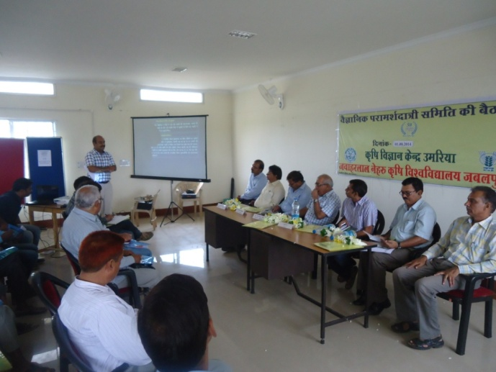 | 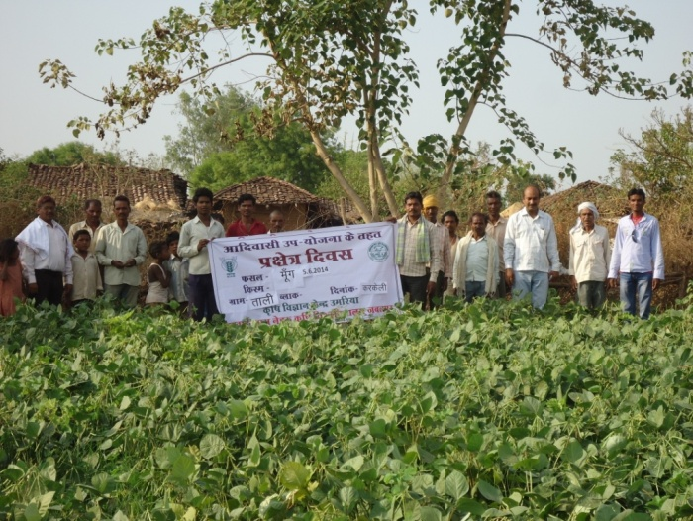 | 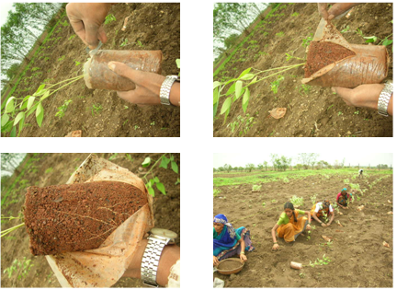
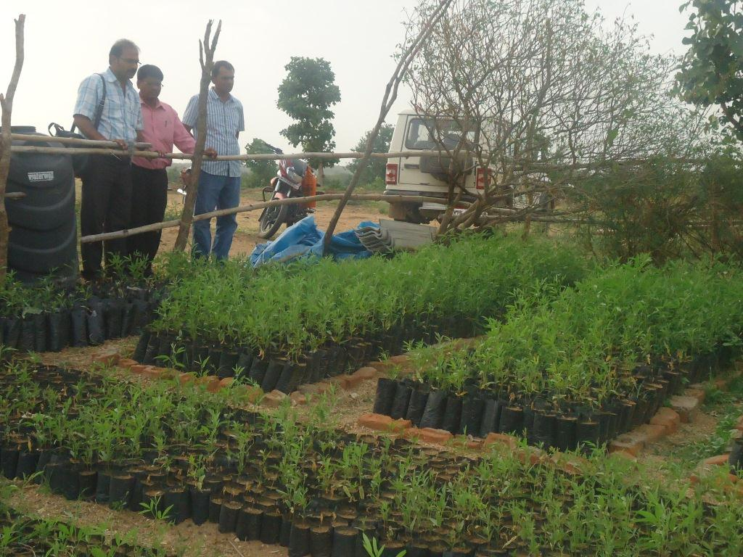 | 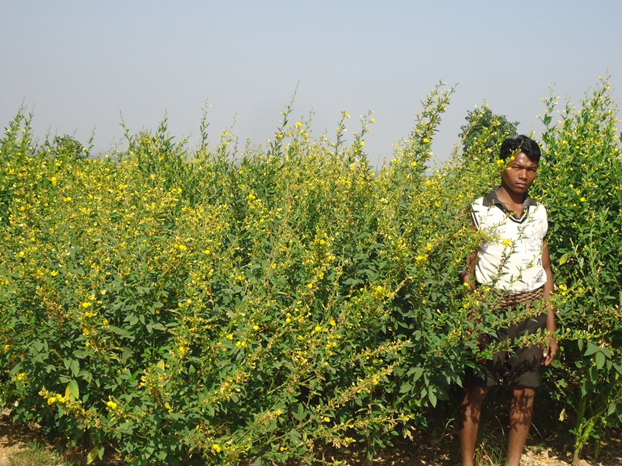 | 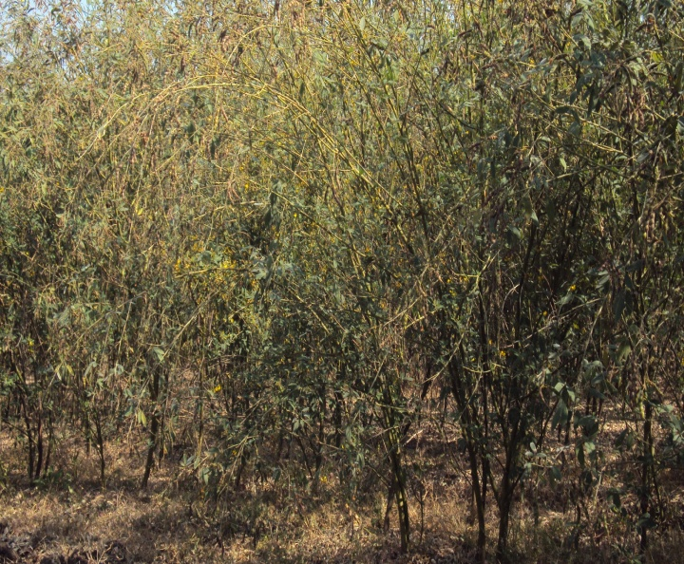
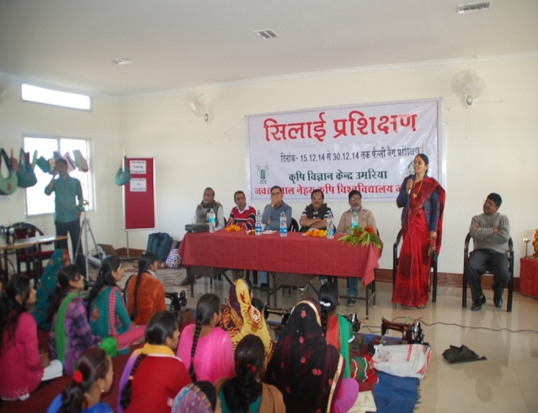 | 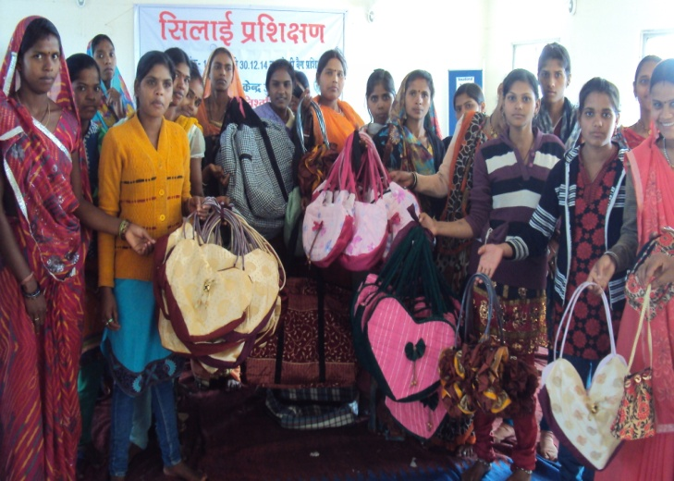 | 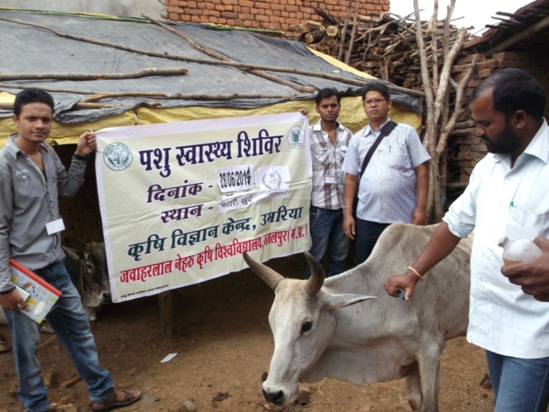
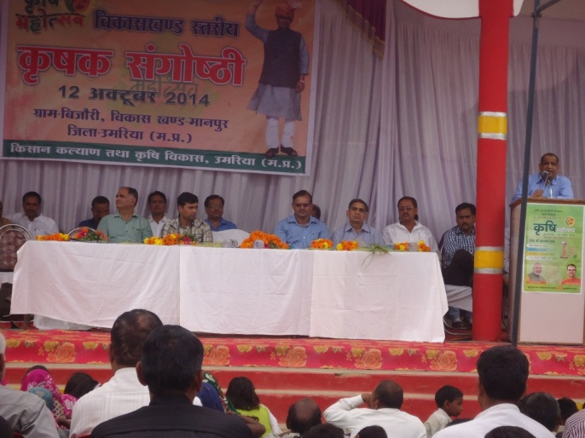 | 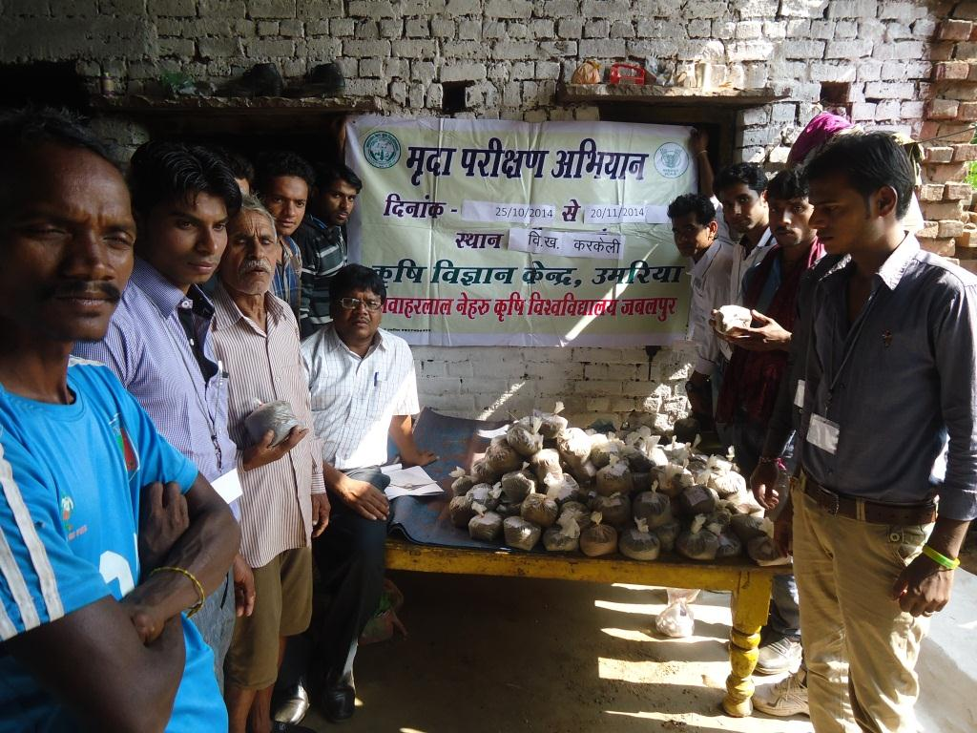 | 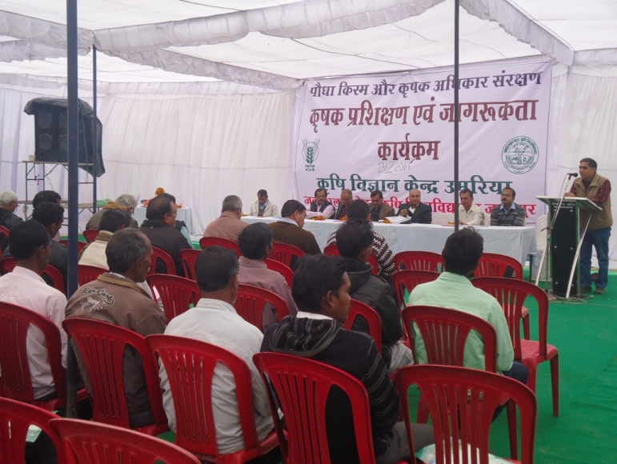
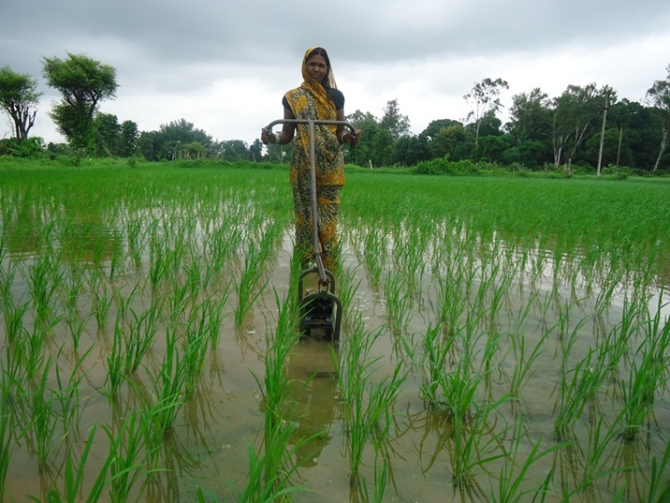 | 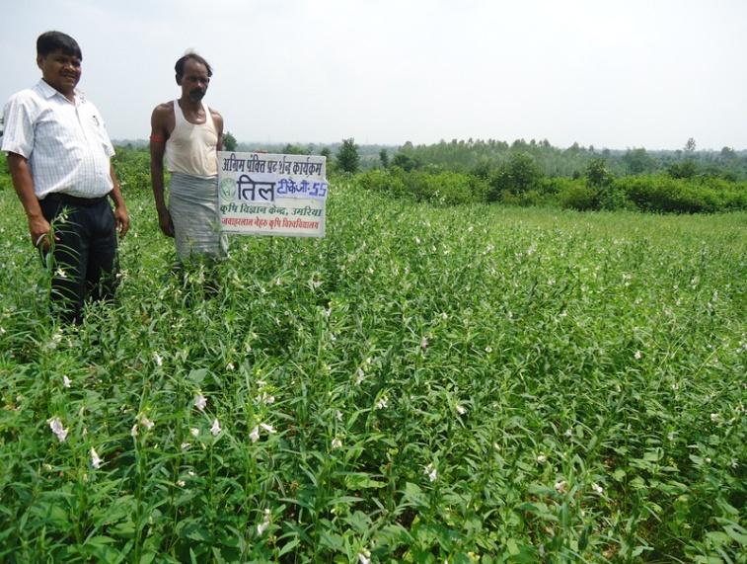 | 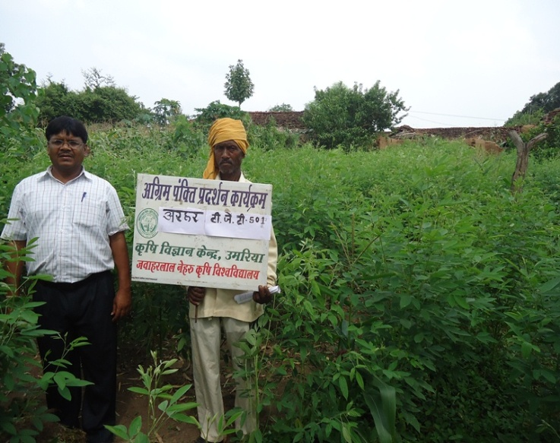
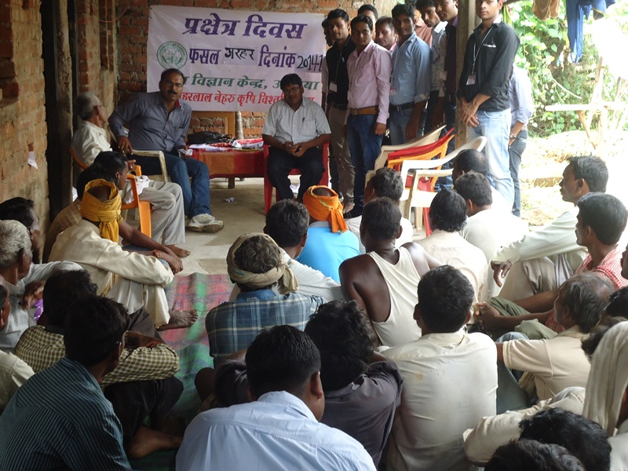 | 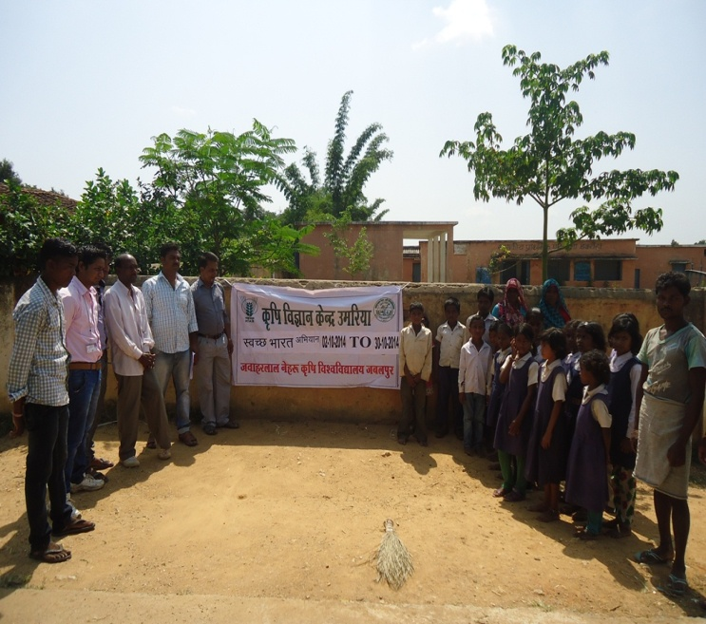 | 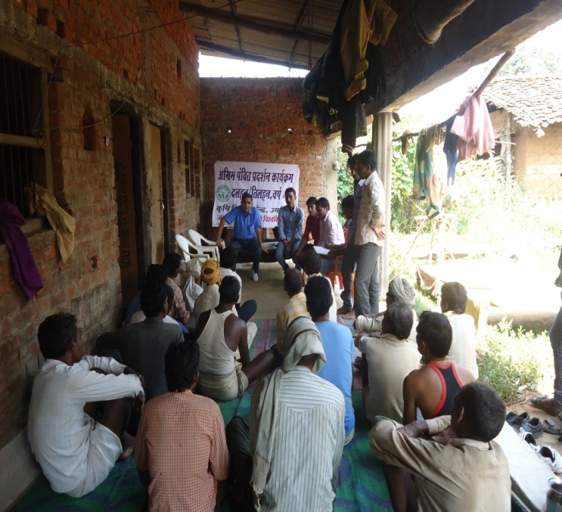
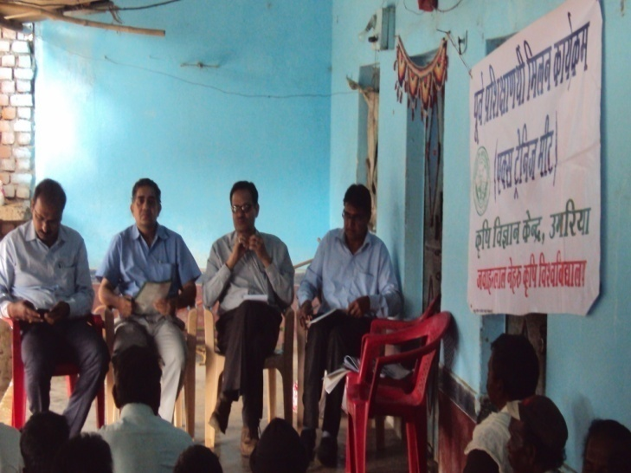 | 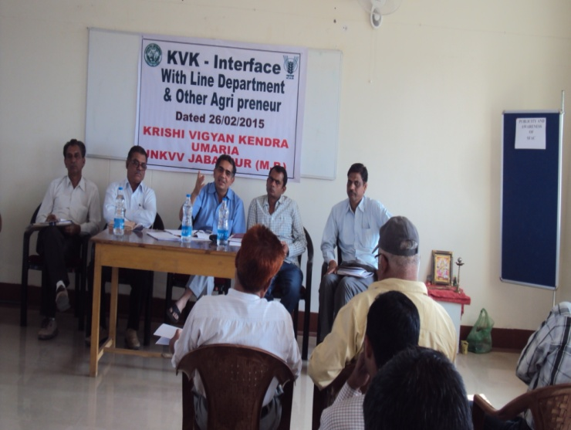 | 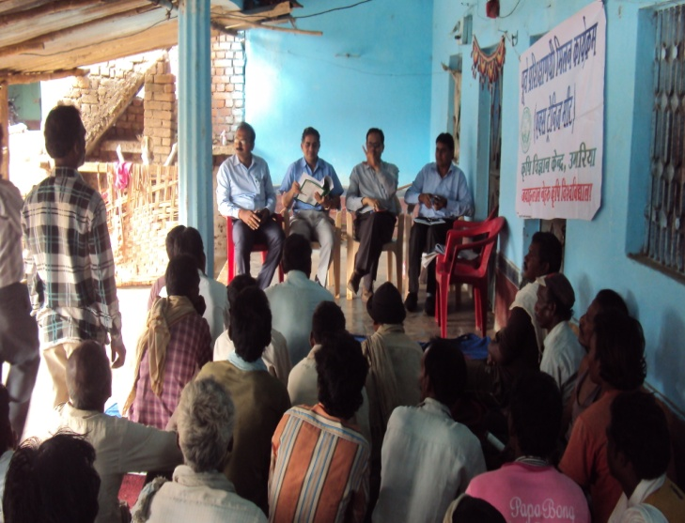
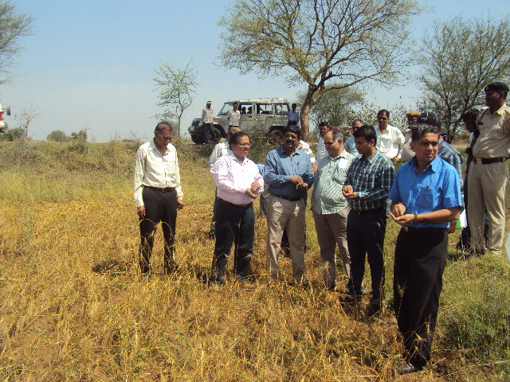 | 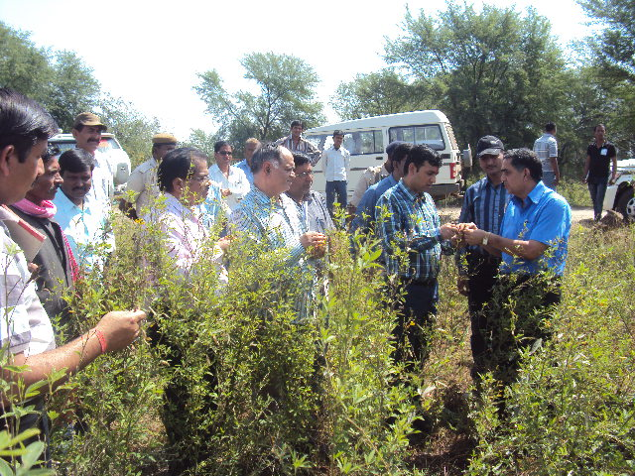 | 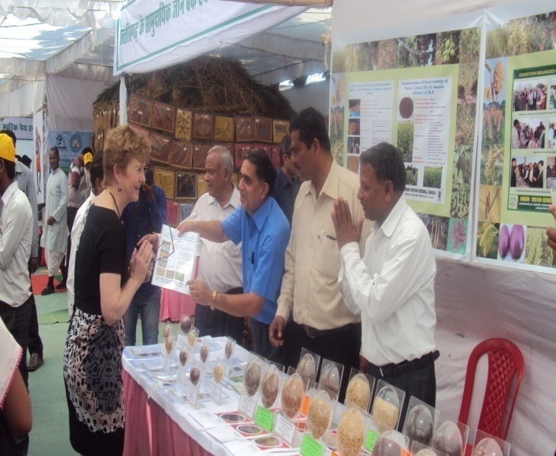
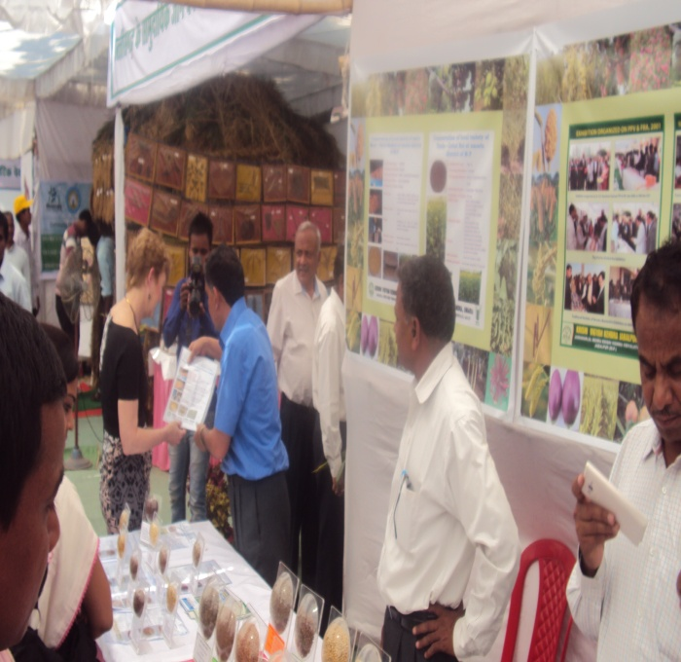 | 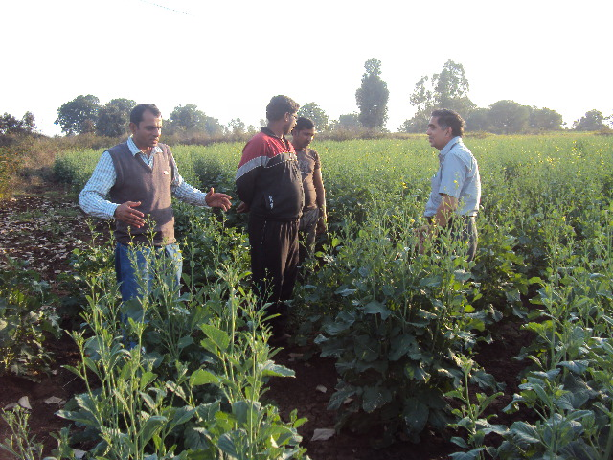 | 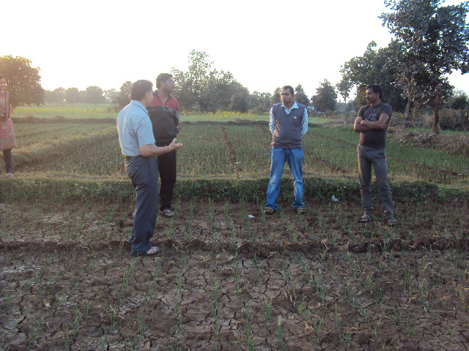
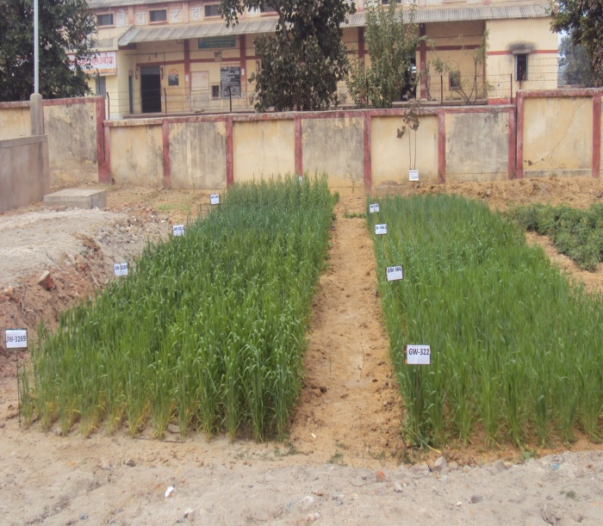 | 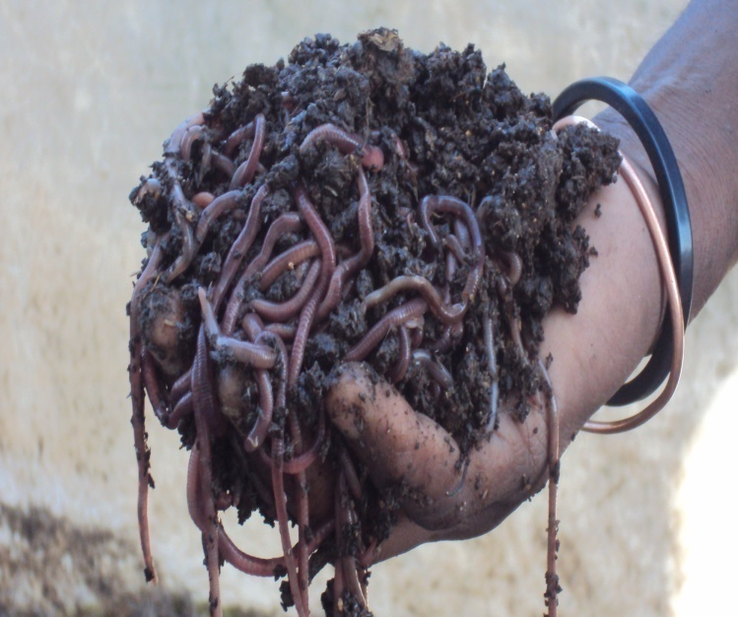 | 