ANNUAL PROGRESS REPORT
April 2013 to March 2014
Krishi Vigyan Kendra, Umaria

Contents
Sl. No. | Particular | Page No
 | Instructions for Filling the Format | 3
 | Summary of KVK Annual Report (Quantifiable Achievement) for the year 2013-14 | 4-6
1 | General Information | 7-9
2 | On Farm Testing | 10-16
3 | Achievements of Frontline Demonstrations | 17-24
4 | Documentation of the need assessment conducted by the KVK for the training programme | 25-30
5 | Training programmes | 31
6 | Extension Activities | 32
7 | Literature Developed/Published (with full title, author & reference) | 33
8 | Production and supply of Technological products | 33
9 | Activities of Soil and Water Testing Laboratory | 34
10 | Rainwater Harvesting | 34
11 | Utilization of Farmer Hostel facilities | 35
12 | Utilization of Staff Quarter facilities | 35
13 | Details of SAC Meeting | 35
14 | Status of Kisan Mobile Advisory | 35
15 | Status of Convergence with agricultural schemes | 35
16. | Status of Revolving Funds | 36
17. | Awards & Recognition | 36
18. | Details of KVK Agro-technological Park | 36
19. | Farm Innovators | 38
20. | KVK interaction with progressive farmers | 38
21. | Outreach of KVK | 38
22. | Technology Demonstration under Tribal Sub Plan on Pulses/ Programme on Harnessing Pulses/ Quality Protein Maize | 38
23. | KVK Ring | 39
24. | Important visitors to KVK | 40
25. | Status of KVK Website | 40
26. | Status of E-connectivity | 40
27. | Status of RTI | 40
28. | Status of Citizen Charter | 40
29. | Attended HRD activities organized by ZPD | 40
30. | Attended HRD activities organized by DES | 41
31. | Attended HRD activities by KVK Staff | 41
32 | Agri Alert report | 41
33. | Details of Technological Week Celebration | 41
34. | Interventions on Drought Mitigation | 42
35. | Proposal of NICRA | 42
36. | Proposed works under NAIP | 43
37. | Case study / Success Story to be developed | 44
38. | Action Photographs | 47-50
Instructions for Filling the Format

- Do not change/modify/ delete any column of any of the table. However, additional rows can be created, if required.
- Do not merge columns, rows.
- Please repeat the name of KVK in each table in the column “Name of KVK”
- Do not fill the non-numerical values in numeric field
- Do not repeat the unit while reporting data as it is already mentioned in the heading row
- Strictly fill the data in desired unit only. If it is reported in other unit, convert it in the desired unit
- Please mention only standard English names of crops (Do not mention Urd, Arhar, Til, Kulthi, Moong, Bajra, etc.)
- Additional relevant information may be provided at the end of Format by creating heading “Additional Information”
- Also read the instructions mentioned just below the table
- Your suggestions for improvement in the format for your simplicity as well as data compilation may be given at the end of the format
- Do not press any Enter Key in any of the columns while making entry in the columns of the table. Use only arrow key /Tab key/ mouse pointer while movement from one column/row to another.
- Gray color cells in summary table need not to be filled.
- Crop name should be spelled correct and standard English name should be used i.e Cereals, Pulses, Oilseed:- Rice (not use Paddy), Wheat, Barley, Kodo, Kutki, Maize, Jwar, Bajra, Pigeon pea (not use Tur, Arhar, Red gram), Blackgram (not use Urd), Greengram (not use Moong/Moongbean), Chickpea (not use Horse gram, Gram, Chana), Field pea, Horse gram (Kulthi), Lentil, Mustard (not use Rai, Sarsoan), Soybean, Linseed, Groundnut, Sesame (not use Til), Niger (not use Ram Til), Safflower (not use Kusum).
Vegetable :- Vegetable pea, Bottle guard, Bitter guard, Okra (not use Bhindi or Ladies finger).
Fruits :- Mango, Guava, Custard apple, Pear etc.
Spices :- Black Peeper, Turmeric, Ginger, Cardamom etc.

REPORTING PERIOD – April 2013 to March 2014
Summary of KVK Annual Report (Quantifiable Achievement) for the year 2013-14
S.N. | Quantifiable Achievement | Number | Beneficiaries (nos.)
1 | On Farm Testing
 | Proposed OFT | 17 | 3747
 | On Going OFT | 4 | 3641
 | Technologies assessed (Completed OFT) | 12 | 106
 | Technologies refined | - | -
 | On farm trials conducted | 16 | -
2 | Frontline demonstrations
 | Proposed Frontline demonstrations | 15 | 146
 | On Going Frontline demonstrations | 2 | 16
 | FLDs conducted on crops | 12 | 126
 | Area under crops (ha.) | 39.6 | 126
 | FLD on farm implement and tools | 1 | 8
 | FLD on livestock/ AH enterprises (Dairy/ Sheep and Goat/Poultry/ Duckery/ Piggery etc.) | 2 | 20
 | FLD on Fisheries - Finger lings | - | -
 | FLD on other enterprises (Bee keeping, lac, mushroom, sericulture, value addition, vermi compost, etc.) | - | -
 | FLD on Women in Agriculture - ( Nutritional garden, Income generation, Value addition, Drudgery reduction, etc.) | - | -
3 | Training programmes | No. of Course | Duration (days) | Participants
 | Farmers | 71 | 72 | 1980
 | Farm women | 1 | 1 | 43
 | Rural youth | 1 | 2 | 30
 | Extension personnel/ In service | 4 | 4 | 85
 | Vocational trainings | 3 | 90 | 60
 | Sponsored Training | 12 | 15 | 614
 | Total | 92 | 183 | 2812
 |  | No. of programmes | Participants
4 | Extension Programmes | 408 | 7769
5 | Production of technology inputs etc | Qty | Beneficiaries (nos.)
 | Seed (qt.) | 16.22 | 190
 | Planting material produced (nos.) | 590 | 26
6 | Livestock | Qty | Beneficiaries (nos.)
 | Livestock strains ( Nos)
 | Milk Yield - Cow, Buffelo etc. (in liter)
 | Fish (Kg.)
 | Fingerlings (nos.)
 | Poultry-Eggs (nos.)
 | Ducks (nos.)
 | Chicks etc. (nos.)
7 | Bio Products | Qty | Beneficiaries (nos.)
 | Bio Agents -Earth worm (Kg.) | 0.1 | 10
 | Trichoderma (kg.)
 | Bio Fertilizers- Vermi compost, Rhizobium, PSB , BGA , Mycorriza , Azotobacter , Azospirillum etc. (Kg.) | 9.54 | 51
 | Bio Pesticide-Panchgavya, Neem Extract , Neem oil etc.(lit.) | - | -
8 | Any other significant achievement in the Zone | Nos. | Participants/ beneficiaries
 | Award (Best KVK award and scientist and farmer’s award) | - | -
 | Publications ( Res. Paper/ pop. Art./Bulletin,etc.) | 9 | 2390
 | KVK News letter | 4 | 2000
 | SAC Meetings conducted | 2 | 67
 | Soil sample tested | 80 | 80
 | Water sample tested | - | -
 | RWH System (Special training and field visit on RWH structure and MIS in KVKs)
 | KVK-KMA (Message and beneficiaries) | 50 | 3600
 | Convergence programmes
 | Sponsored programmes | 12 | 614
 | KVK Progressive Farmers interaction | 1 | 5
 | No. of Technology Week Celebrations | 1 | 76
 | Attended HRD activities organized by ZPD | 3 | 3
 | Attended HRD activities organized by DES | 1 | 1
 | Attended HRD activities by KVK Staff(Refresher /Short course, Training programme etc. ) | 2 | 2
9 | Current status of Revolving Funds ( Amt. in Rs.) | 487472
10 |  | No. of blocks | No. of villages
 | Outreach of KVK in the District | 3 | 54
11 |  | ICAR | SAU | Others
 | No. of important visitors to KVK (nos.) | 3 | 10 | 0
12 |  | Working (Yes/No) | No. of Update
 | Status of KVK Website | Yes | -
13 |  | Application received | Application disposed
 | Status of RTI (nos.) | -- | -
14 |  | Query received | Query dissolved
 | Citizen Charter (nos.) | - | -
15 |  | Working (Yes/No) | No. of programme viewed
 | E-connectivity | No | -
16 |  | Filled | Vacant
 | Staff Position | 7 | 9
17 | Workshop/ Seminar/ Conference attended by staff of KVK ( nos) | 6
18 | Publication received from ICAR /other organization (nos.) | 84
 |  | Particulars | Organization
19 | Agri alerts (epidemic, high serious nature problem, Cyclone etc. reported first time to ZPD, SAU, Agri. Deptt. and ICAR) | 4 | Direction Extension Services, Jabalpur by Mail

GENERAL INFORMATION

1.1. Staff Position (as on date)

Summary of Staff position in KVKs on March, 2014

Name of KVK | Sanctioned  Posts | PC (1) |  | SMS (6) |  | PA (3) |  | Admn. (6) |  | Total
Name of KVK | Sanctioned  Posts | Sanc. | Filled | Sanc. | Filled | Sanc. | Filled | Sanc. | Filled | Sanc. | Filled
Umaria | 16 | 1 | 0 | 6 | 4 | 3 | 1 | 6 | 2 | 16 | 7

Name of KVK | Sanction post | Name of the incumbent | Discipline | Higist degree | Subject of specilization | Pay scale | Present pay | Date of joiing | Per./Temp. | Category
Umaria | Programme Coordinator | Vacant | - | - | - | - | - | - | - | -
Umaria | Subject Matter Specialist1 | Dr. Aashutosh Sharma | Agroforestry | Ph.D. NET | Agroforestry | 15600-39100+ GP | 27260 | 25/01/07 | Permanent | Gen.
Umaria | Subject Matter Specialist2 | Shri K. Sahare | Ext. Education | M.Sc., NET | Ext. Education | -do- | 25050 | 5/05/07 | Permanent | Sc
Umaria | Subject Matter Specialist3 | Dr. B. K. Tiwari | Agronomy | Ph.D., NET | Agronomy | -do- | 27260 | 2/07/07 | Permanent | Gen.
Umaria | Subject Matter Specialist4 | Dr. R.R. Singh | LPM | Ph.D. | LPM | -do- | 21600 | 13/10/11 | Permanent | Gen
Umaria | Subject Matter Specialist5 | - | - | - | - | - | - | - | - | -
Umaria | Subject Matter Specialist6 | - | - | - | - | - | - | - | - | -
Umaria | Programme Assistant | - | - | - | - | - | - | - | - | -
Umaria | Farm Manager | - | - | - | - | - | - | - | - | -
Umaria | Computer Programmer | Shri Arun Kumar Rajak | Computer | MCA | COMPUTER SCINECE | 9300-34800 +GP 3600 | 16060 | 08-04-2008 | Permanent | OBC
Umaria | Accountant / superintendent | - | - | - | - | - | - | - | - | -
Umaria | Stenographer | - | - | - | - | - | - | - | - | -
Umaria | Driver | Shri R.K. Vishwakarma |  | 12th passed |  | 5200-20200 + GP 1900 | 8550 | 10/07/08 | Permanent | OBC
Umaria | Driver | Shri S.K. Vaishya |  | 12th Passed |  | 5200-20200 + GP 1900 | 8550 | 11/07/08 | Permanent | SC
Umaria | Supporting staff | - | - | - | - | - | - | - | - | -
Umaria | Supporting staff | - | - | - | - | - | - | - | - | -

1.2. DISTRICT PROFILE (detail of geographical area, cultivation, Land, resources, opportunities, irrigation, populations etc.)–

KVK Name | Agro-climatic zone | No . of Blocks | No. of Panchayats | Population | Literacy | SC and ST Population | No. of farmers | Average land holding
Umaria | Zone -III Kaymore Plantuo & Satpura Hill | 3 | 234 | 516963 | 59.10% | SC:- 35126  ST:- 227250 | 88909 | 1.16

1.3. DETAILS OF ADOPTED VILLAGE during the reporting period (Approved by competent Authority in meetings/workshops)
KVK Name | Village Name | Year of adoption | Block Name | Distance from KVK | Population | Number of farmers  (having land in the village)
Umaria | Pathari Khurd | 2013 | Karkeli | 25 | 730 | 200

1.4. THRUST AREAS identified by KVK (Approved by competent Authority in meetings/workshop)
KVK Name | THRUST AREA
Umaria | Varietal Diversification- Availability of quality seed through seed production technology and Seed replacement.
Umaria | Technological diversification
Umaria | Crop diversification
Umaria | Rainwater and irrigation management
Umaria | Integrated nutrient management
Umaria | Integrated pest management
Umaria | Promotion of organic farming along with balanced nutrition.
Umaria | Strengthen of linkage between farmer’s and extension system
Umaria | Farm mechanization and drudgery reduction
Umaria | Development of rural entrepreneurship for income and employment generation like Bee Keeping and mushroom cultivation
Umaria | Increasing productivity of vegetables
Umaria | Integrated livestock management
Umaria | Nutritional security at household level and Development of nutritional garden

1.4. PROBLEM IDENTIFIED by KVK (Approved by competent Authority in meetings/workshop)

KVK Name | Problem identified | Methods of problem identification | Location Name of Village & Block
 | Lack of agro technical knowledge, | PRA, Group discussion | Pathari Khurd, Karkeli
Umaria | Low seed replacement rate, | PRA, Group discussion | Pathari Khurd, Karkeli
Umaria | Traditional method of cropping, | PRA, Group discussion | Pathari Khurd, Karkeli
Umaria | No use of improved farm implements, | PRA, Group discussion | Pathari Khurd, Karkeli
Umaria | Mono cropping, | PRA, Group discussion | Pathari Khurd, Karkeli
Umaria | No knowledge of shaded cropping technology, | PRA, Group discussion | Pathari Khurd, Karkeli
Umaria | Lack of awareness about improved milch animals and their feeding habits, | PRA, Group discussion | Pathari Khurd, Karkeli
Umaria | No knowledge of disease and insect pest management, | PRA, Group discussion | Pathari Khurd, Karkeli
Umaria | No knowledge about women drudgery reduction and their lean period utilization | PRA, Group discussion | Pathari Khurd, Karkeli
Umaria | No knowledge about soil test basis cropping system | PRA, Group discussion | Pathari Khurd, Karkeli
Umaria | No knowledge about poultry, fish and goatery management, | PRA, Group discussion | Pathari Khurd, Karkeli
Umaria | Lack of awareness about soil and water conservation measures | PRA, Group discussion | Pathari Khurd, Karkeli

2. On Farm Testing
Note-
* Thematic area should be spelled correct and follow standard pattern i.e. Integrated Nutrient Management in place of INM or Inte. Nutrient Mngt. Etc.
*Crop name should be spelled correct and standard English name should be used i.e Chick pea in place of gram/chana , Paddy in place of Rice/chawal , brinjal in place of egg plant/bhata/baigan etc.
*Don’t press enter key to navigate among column use arrow or tab key
*don’t add space before or after statement within the table cell
2.1 Information about OFT

KVK name | Year | Season | Problem diagnose | Title of OFT | Category of technology (Assessment/ Refinement) | Thematic Area | Crop/ enterprise | Farming Situations | No. of trials | Results (q/ha) |  | Net Returns (Rs./ha) |  | Recommendations
 |  |  |  |  |  |  |  |  |  | FP (T₁) | RP (T₂) | FP (T₁) | RP (T₂) | Recommendations
Umaria | 2013-14 | Kharif | Low productivity in paddy | Assessment of high yielding variety Sahbhagi rice | Assessment | Crop Management | Crop | Rainfed | 15 | 31.25 | 59.2 | 21778 | 57033 | Recommended for large scale testing
Umaria | 2013-14 | Kharif | Weed Problem in Black Gram | Assessment of Imazethapyr @100 gm ai/ha DAS 20-25 in black gram | Assessment | Crop Management | Crop | Rainfed | 8 | 6.8 | 9.8 | 7028 | 17788 | Recommended for large scale testing
Umaria | 2013-14 | Kharif | Intercultural operation in transplantation in rice | Assessment of Cono weeder for intercultural operation in transplanted rice | Assessment | Crop Management | Crop | Rainfed | 8 | 47.6 | 61.8 | 41533 | 55343 | Recommended for large scale testing
Umaria | 2013-14 | Kharif | No use of Intercropping in Plantation | Assessment of intercropping of Black Gram in Guava Plantation | Assessment | Crop Management | Crop | Rainfed | 4 | 6.8 | 5.65 | 9128 | 6275 | Recommended for large scale testing
Umaria | 2013-14 | Kharif | Dewarming in lactating Buffalo | Assessment of Ivermactine for dewarming in lactating buffalo | Assessment | LPM | Enterprise | All type | 10 | 1 liter (Milk) | 1.11 | 1800 | 2164 | Recommended for large scale testing
Umaria | 2013-14 | Kharif | No practices of Azolla to feed lactating buffalo | Assessment of Azolla feeding to increase the milk yield of lactating buffalo | Assessment | LPM | Enterprise | All type | 5 | 1 liter (Milk) | 1.19 | 1800 | 2229 | Recommended for large scale testing
Umaria | 2013-14 | Kharif & Rabi | Lack of Knowledge about BIG | Assessment of BIG | Assessment | Group management | Enterprise | 20 (1 Group) | group | - | - | - |  | Recommended for large scale testing
Umaria | 2013-14 | Kharif & Rabi | Lack of Knowledge about KMA | Assessment of KMA | Assessment | Agriculture information through KMA | Enterprise | 3600 | Cont. | Cont. | - | - |  | Recommended for large scale testing
Umaria | 2013-14 | Rabi | No practices of mustard in SMI | Assessment of SMI in mustard variety Pusa Tarak | Assessment | Crop Management | Crop | Rainfed | 22 | 6.5 | 5.25 | 7045 | 1035 | Recommended for again assessing with new long duration variety
Umaria | 2013-14 | Rabi | No use IPM in mustard | Assessment IPM in mustard | Assessment | Crop Management | Crop | Rainfed | 8 | 7.8 | 11.2 | 11580 | 21618 | Recommended for large scale testing
Umaria | 2013-14 | Rabi | Low yield in wheat | Assessment of HYV GW- 322 Wheat | Assessment | Crop Management | Crop | Irrigated | 8 | 31.45 | 43.61 | 27191 | 42750 | Recommended for large scale testing
Umaria | 2013-14 | Rabi | Low milk yield | Assessment of Mineral mixture feeding to increase the milk in lactating cow | Assessment | LPM | Enterprise | All type | 5 | 1  Liter/ animal | 1.09  Liter / Animal | 1800 | 1932.5 | Recommended for large scale testing
Umaria | 2013-14 | Rabi | Irregular heating problem | Assessment of herbal heat inducer for occurrence of heat @ 1 tablet / animal in six month | Assessment | LPM | Enterprise | All type | 5 | 0 | 100 | - | 100% | Recommended for large scale testing
Umaria | 2013-14 | Kharif | No use of High density plantation in Mango | Assessment of High density plantation of Mango (Ambrapali 3x3 meter) | Assessment | Horticulture | Fruits | Irrigated | 6 | - | - | - | - | Final result awaited
Umaria | 2013-14 | Rabi | Low yield of pea | Assessment of pea variety AP-3 | Assessment | Horticulture | Vegetable | Irrigated | 8 | 30.37 | 42.87 | 25430 | 41430 | Recommended for large scale testing
Umaria | 2013-14 | Rabi | Low yield of Papaya | Assessment of Papaya variety Kurg honey dew | Assessment | Horticulture | Fruits | Irrigated | 5 | Awaited | Awaited | Awaited | Awaited | Final result awaited

  - Economic Performance
KVK name | OFT Title | Parameters |  |  | Average Cost of cultivation (Rs/ha) |  |  | Average Gross Return (Rs/ha) |  |  | Average Net Return (Rs/ha) |  |  | Benefit-Cost Ratio (Gross Return / Gross Cost)
KVK name | OFT Title | Name and unit of Parameter | FP (T₁) | RP (T₂) | FP (T₁) | RP (T₂) | Refined Practice, if any (T₃) | FP (T₁) | RP (T₂) | Refined Practice, if any (T₃) | FP (T₁) | RP(T₂) | Refined Practice, if any (T₃) | FP (T₁) | RP (T₂) | Refined Practice, if any (T₃)
Umaria | Assessment of high yielding variety Sahbhagi dhan | No. of effective tillers / m² | 223 | 295 | 21547 | 24027 |  | 43325 | 81060 |  | 21778 | 57033 |  | 2.01 | 3.37
Umaria | Assessment of Imazethapyr @100 gm ai/ha DAS 20-25 in black gram | Weed intensity no. / m² | 13 | 113 | 14672 | 16512 |  | 21700 | 34300 |  | 7028 | 17788 |  | 1.47 | 2.07
Umaria | Assessment of Cono weeder for intercultural operation in transplanted paddy | No. of effective tillers / Plants | 284 | 308 | 24047 | 29247 |  | 65580 | 84590 |  | 41533 | 55343 |  | 2.72 | 2.89
Umaria | Assessment of intercropping of Black Gram in Guava Plantation | No. of pods / Plants | 47.5 | 41.25 | 14672 | 13500 |  | 23800 | 19775 |  | 9128 | 6275 |  | 1.62 | 1.46
Umaria | Assessment of Ivermactine for dewaring in lactating buffalo | Milk yield liter/ animal | 1 | 1.11 | 1800 | 1832 |  | 3600 | 3996 |  | 1800 | 2164 | - | 2 | 2.18
Umaria | Assessment of Azolla feeding to increase the milk yield of lactating buffalo | Milk yield liter/ animal | 1 | 1.19 | 1800 | 1800 |  | 3600 | 4029.12 |  | 1800 | 2229.12 |  | 2 | 2.23
Umaria | Assessment of BIG | In progress
Umaria | Assessment of KMA | In progress
Umaria | Assessment of SMI in mustard variety Pusa Tarak | No of Siliquae / plant | 200 | 562 | 14730 | 16552 |  | 21775 | 17587 |  | 7045 | 1035 |  | 1.47 | 1.06
Umaria | Assessment IPM in mustard | No of infested twing/ plants | 4.06 | 00 | 14550 | 15902 |  | 26130 | 37520 |  | 11580 | 21618 |  | 1.79 | 2.35
Umaria | Assessement of HYV GW- 322 Wheat | No.Tillers / m² | 270 | 372 | 22334 | 25865 | - | 49525 | 68615 | - | 27191 | 42750 | - | 2.21 | 2.65 | -
Umaria | Assessment of Mineral mixture feeding to increase the milk in lactating cow | Milk yield / liter/ animal | 1 | 1.09 | 1800 | 1991.48 | - | 3600 | 2924 | - | 1800 | 1932.52 | - | 2 | 1.97 | -
Umaria | Assessment of herbal heat inducer for occurrence of heat @ 1 tablet / animal in six month | Occurring heat | - | - | 1800 | 1992 | - | 0 | 100 | - | - | - | - | - | - | -
Umaria | Assessment of High density plantation of Mango (Ambrapali 3x3 meter) | Plant height in cm | 114 | 105 | 55550  (50 Plants) | - | - | - | - | - | - | - | - | - | - | -
Umaria | Assessment of pea variety AP-3 | No.of pod / Plants | 5 | 6.37 | 20875 | 22875 | - | 46305 | 64305 | - | 25430 | 41430 | - | 2.21 | 2.81 | -
Umaria | Assessment of Papaya variety Kurg honey dew | Survival percentage | 75 | 86.4 | 32000 | 40000 | - | - | - | - | - | - | - | - | - | -

2.3 Information about Home Science OFT: Not applicable

KVK Name | Year | Season | Problem diagnose | Title of OFT | Category of technology (Assessment/ Refinement) | Thematic Area | Details of Technology Selected for Assessment | Characteristics of Technology / Variety / Product / Enterprise | Farming / Enterprise Situation | No. of trials | Recommendations
Umaria
Umaria
Umaria
Umaria

2.4 Economic Performance Home Science OFT: Not Applicable

KVK name | OFT Title | Performance Indicator / Parameter
KVK name | OFT Title | Output m2/h |  | Est. Energy Expenditure kj/min. |  | WHR beat/min |  | % reduction in drudgery |  | % increase in efficiency |  | Production per unit |  | Cost of input |  | Incremental income |  | Yield(Kg/ha) |  | Net Return |  | Saving in Rs | BC ratio
KVK name | OFT Title | T1 | T2 | T1 | T2 | T1 | T2 | T1 | T2 | T1 | T2 | T1 | T2 | T1 | T2 | T1 | T2 | T1 | T2 | T1 | T2 | Saving in Rs | BC ratio
Umaria
Umaria
Umaria
Umaria
Umaria

  - Feedback from KVK to Research System
Name of KVK | Feedback
Umaria | Wilt resistant variety of Gram, Pigeon pea and Yellow vein mosaic resistant variety of Black Gram are desired
Umaria | Sedge nut weed management chemical control of Sedge nut
Umaria | Short duration Pigeon pea& frost resistance variety are needed
Umaria | Rain fed high yielding variety of wheat
Umaria | Drought and wasteland suitable eucalyptus clones
Umaria | Leaf curl resistant variety in tomato Fruit & shoot borer resistant variety of brinjal are required by farmers.
Umaria | Wilt resistant variety of Gram, Pigeon pea and Yellow vein mosaic resistant variety of Black Gram are desired
Umaria | Sedge nut weed management chemical control of Sedge nut

3. Achievements of Frontline Demonstrations

3.1. Follow-up for results of FLDs implemented during previous years

List of technologies demonstrated and popularized during previous years and recommended for large scale adoption in the district
KVK Name | Crop/  Enterprise | Thematic Area | Technology demonstrated | Details of popularization methods suggested to the Extension system | Horizontal spread of technology
 |  |  |  |  | No. of villages | No. of farmers | Area in ha
Umaria | INM | Paddy | Demonstration of INM in paddy | Personal contact,  Group meeting, Kisan mela. KMS, Training & News paper, News letter etc. | 4 | 2500 | 500
Umaria | Varietal | Pigeon pea | Demonstration of HYV TJT-501 of pigeon pea | Personal contact,  Group meeting, Kisan mela. KMS, Training & News paper, News letter etc. | 5 | 100 | 300
Umaria | Varietal | Paddy | Demonstration of HYV JRH-8 of paddy in SRI system` | Personal contact,  Group meeting, Kisan mela. KMS, Training & News paper, News letter etc. | 5 | 200 | 60
Umaria | IPM | Gram | Demonstration of IPM in gram | Personal contact,  Group meeting, Kisan mela. KMS, Training & News paper, News letter etc. | 10 | 500 | 800
Umaria | Horticulture – Vegetable Crops | Brinjal | Demonstration on management of fruit & shoot bover in brinjal | Group meeting, Kisan mela, In service training and farmers training | 3 | 50 | 07
Umaria | Horticulture – Vegetable Crops | Onion | Demonstration on Kharif onion | Group meeting, Kisan mela, Personal contact, In service training and farmers training | 3 | 50 | 20
Umaria | Horticulture – Vegetable Crops | Okra | Demonstration of okra variety PA-4 | Group meeting, Kisan mela, Personal contact, In service training and farmers training | 5 | 250 | 65
Umaria | Horticulture – Vegetable Crops | Tomato | Demonstration of tomato variety Kashi Vishesh | Group meeting, Kisan mela, Personal contact, In service training and farmers training | 5 | 225 | 30
Umaria | Varietal | Sesame | Demonstration of variety TKG-22 of sesame | Group meeting, Kisan mela, Personal contact, In service training and farmers training | 5 | 150 | 60
Umaria | Component {NPK} | Black gram | Demonstration of NPK@20:60:20 on Black Gram | Group meeting, Kisan mela, Personal contact, In service training and farmers training | 3 | 100 | 60
Umaria | Varietal | Gram | Demonstration of Gram variety JG-16 | Group meeting, Kisan mela, Personal contact, In service training and farmers training | 6 | 150 | 150
Umaria | Varietal | Mustard | Demonstration of Mustard Varity Pusa Tarak | Group meeting, Kisan mela, Personal contact, In service training and farmers training | 5 | 90 | 150
Umaria | Livstock | Chicks | Demonstration of Jabalpur dwikaji in back yard system of poultry production | Group meeting, Kisan mela, Personal contact, In service training and farmers training | 4 | 20 | 20
Umaria | Livestock | Bufflao | Demonstration of mineral mixture in bofflao | Group meeting, Kisan mela, Personal contact, In service training and farmers training | 4 | 15 | 20

Note-
* Thematic area should be spelled correct and follow standard pattern i.e. Integrated Nutrient Management in place of INM or Inte. Nutrient Mngt. Etc.
*Crop name should be spelled correct and standard English name should be i.e Chick pea in place of gram, Paddy in place of Rice , brinjal in place of egg plant etc.
*Don’t press enter key to navigate among col use arrow or tab key
*don’t add space before or after statement within the table cell

3.2 Details of FLDs implemented

KVK Name | year | Season | Thematic area | Technology demonstrated | Name of Crop/ Enterprise | Name of Variety/Technology/Entreprizes | Crop- Area (ha) / Entrep - No. | Results (q/ha) |  | % change | No. of farmers
 |  |  |  |  |  |  |  | FP (T₁) | RP (T₂) | % change | SC | ST | Others | General | Total
Umaria | 2013-14 | Kharif | IPM | Demonstration of IPM in rice | Rice | Shahbhagi | 3.2 | 31.05 | 43.39 | 40 | 9 | 1 | 0 | 0 | 10
Umaria | 2013-14 | Kharif | Crop Management | Demonstration of Imazethapyr @100 gm ai/ha 25-30 in pigeon pea | Pigeon pea | Local | 3.2 | 5.25 | 8.8 | 66.6 | 4 | 1 | 1 | 3 | 9
Umaria | 2013-14 | Kharif | Varietal | Demonstration of HYC Black gram variety T-9 | Black Gram | T-9 | 5 | 4.12 | 7.4 | 79 | 13 | - | - | - | 13
Umaria | 2013-14 | Kharif | Varietal | Demonstration of HYC sesame variety TKG-22 | Sesame | TKG-22 | 5 | 4.20 | 6.20 | 47.61 | 13 | - | - | - | 13
Umaria | 2013-14 | Kharif | Varietal | Demonstration of HYV VRO-6 of Okra | Okra | VRO-6 | 1 | 15.68 | 20.80 | 30 | 8 | - | - | - | 8
Umaria | 2013-14 | Kharif | Varietal | Demonstration of Kharif onion variety ADR-1 | Onion | ADR-1 | 1 | Crop damage | Crop damage | Crop damage | 8 | - | - | - | 8
Umaria | 2013-14 | Kharif | Varital | Demonstration of Clonal Eucalyptus | Eucalyptus | Clonal | 1 | Awaited | Awaited | Awaited | 4 | 2 | - | - | 6
Umaria | 2013-14 | Kharif | LPM | Demonstration of probiotic in buffalo calves to increase wt. | Buffalos calves | Enterprise | 10 | 4.7 kg / calves | 9.6 kg/ calves | 104.25 | 5 | - | - | 5 | 10
Umaria | 2013-14 | Rabi | LPM | Demonstration of probiotic in cow calves to increase wt in cow calves | Cow calves | Enterprise | 10 | Awaited | awaited |  | 5 | - | - | 5 | 10
Umaria | 2013-14 | Rabi | IPM | Demonstration of IPM in brinjal | Brinjal | Local | 1 | 169 | 261 | 54.43 | 5 | 4 |  |  | 9
Umaria | 2013-14 | Rabi | Varital | Demonstration of HYV GW 366 of wheat | Wheat | GW 366 | 3.2 | 30.45 | 42.6 | 39.9 | 8 | - | - | - | 8
Umaria | 2013-14 | Rabi | INM | Demonstration of INM in wheat | Wheat | Local | 3.2 | 30.2 | 41.08 | 36 | 8 | -- |  | - | 8
Umaria | 2013-14 | Rabi | Crop Management | Demonstration of Sulfosulfuron + metsulfuron in wheat for weed control | Wheat | Local | 3.2 | 29.3 | 39.0 | 33 | 6 | - | - | 2 | 8
Umaria | 2013-14 | Rabi | Varital | Demonstration of HYV Gram JG-130 | Gram | JG-130 | 5 | 5.56 | 7.0 | 26 | 13 | - | - | - | 13
Umaria | 2013-14 | Rabi | Varital | Demonstration of HYV mustard Pusa Tarak | Mustard | Pusa Tarak | 5 | 7.87 | 11.26 | 43 | 13 | - | - | - | 13

3.3 Economic Impact of FLD

KVK Name | Technology demonstrated | Name of Crop/ Enterprise | Parameters |  |  | Cost of cultivation (Rs/ha) |  | Gross Return (Rs/ha) |  | Average Net Return (Rs/ha) |  | Benefit-Cost Ratio (Gross Return / Gross Cost)
KVK Name | Technology demonstrated | Name of Crop/ Enterprise | Name and unit of Parameter | FP (T₁) | RP (T₂) | FP (T₁) | RP (T₂) | FP (T₁) | RP (T₂) | FP (T₁) | RP (T₂) | FP (T₁) | RP (T₂)
Umaria | Demonstration of IPM in paddy | Paddy | No. dead heart / m² | 6.6 | 2.24 | 25900 | 28400 | 44158 | 58950 | 18558 | 30550 | 1.70 | 2.07
Umaria | Demonstration of Imazethapyr @100 gm ai/ha 25-30 in pigeon pea | Pigeon pea | Weed intensity / m² | 106 | 11 | 15672 | 17512 | 18900 | 31680 | 3228 | 14168 | 1.20 | 14.80
Umaria | Demonstration of HYC Black gram variety T-9 | Black Gram | No. of pod / plants | 37.61 | 56.21 | 10665 | 12417 | 14420 | 25900 | 3755 | 13483 | 1.35 | 2.08
Umaria | Demonstration of HYC sesame variety TKG-22 | Sesame | No. of Capsule / plants | 42.96 | 67.96 | 10115 | 11149 | 18900 | 31000 | 8785 | 19851 | 1.86 | 2.78
Umaria | Demonstration of HYV VRO-6 of Okra | Okra | No. of Capsule / Plants | 13.96 | 20.6 | 40642 | 42560 | 94080 | 122280 | 53438 | 79720 | 2.31 | 2.87
Umaria | Demonstration of Kharif onion variety ADR-1 | Onion | Crop failure | Crop failure | Crop failure | Crop failure | Crop failure | Crop failure | Crop failure | Crop failure | Crop failure | Crop failure | Crop failure
Umaria | Demonstration of Clonal Eucalyptus | Eucalyptus | Awaited | Awaited | Awaited | Awaited | Awaited | Awaited | Awaited | Awaited | Awaited | Awaited | Awaited
Umaria | Demonstration of probiotic in buffalo calves to increase wt in buffalo calves | Buffalos calves | Body wt/calf | 4.7 | 9.6 | 800 | 944
Umaria | Demonstration of probiotic in cow calves to increase wt in cow calves | Cow calves
Umaria | Demonstration of IPM in brinjal | Brinjal | Insect damage fruits / plants | 7.72 | 1.72 | 41200 | 53500 | 169300 | 261000 | 127800 | 207500 | 4.10 | 4.87
Umaria | Demonstration of HYV GW 366 of wheat | Wheat | No of tiller / m² | 261 | 373 | 22334 | 25865 | 47925 | 66950 | 25591 | 41085 | 2.14 | 2.58
Umaria | Demonstration of INM in wheat | Wheat | No of tiller / m² | 264 | 351 | 22334 | 25865 | 47563 | 64508 | 25229 | 38643 | 2.12 | 2.49
Umaria | Demonstration of Sulfosulfuron + metsulfuron in wheat for weed control | Wheat | Weed intensity / m² | 153 | 18.62 | 22334 | 25865 | 46150 | 61400 | 23816 | 35535 | 2.0 | 2.37
Umaria | Demonstration of HYV Gram JG-130 | Gram | No of pods/ plants | 15 | 22 | 15679 | 17874 | 17792 | 22400 | 2113 | 4526 | 1.13 | 1.25
Umaria | Demonstration of HYV mustard Pusa Tarak | Mustard | No. of siliqua / plants | 12 | 16 | 14550 | 15902 | 26365 | 37721 | 11815 | 21819 | 1.81 | 2.87

3.4 Information about Home Science FLDs : - Nil

KVK name | Year | Season | Thematic Area | Problem Identified | Technology to be Demonstrated as Solution to the Identified Problem | Crop/ Enterprise (In which crop Enterprise or Farming Activity) | Name of Variety/Technology/Entreprizes | Farming Situation | Proposed area (ha) | No. of Beneficiaries
Umaria

3.5 Economic Performance Home Science FLDs: Nil

KVK name | Technology to be Demonstrated | Performance Indicator / Parameter
KVK name | Technology to be Demonstrated | Output m2/h |  | Est. Energy Expenditure kj/min. |  | WHR beat/min |  | % reduction in drudgery |  | % increase in efficiency |  | Production per unit |  | Cost of input |  | Incremental income |  | Yield(Kg/ha) |  | Net Return |  | Saving in Rs | BC ratio
KVK name | Technology to be Demonstrated | T1 | T2 | T1 | T2 | T1 | T2 | T1 | T2 | T1 | T2 | T1 | T2 | T1 | T2 | T1 | T2 | T1 | T2 | T1 | T2 | Saving in Rs | BC ratio
Umaria

3.6 Training and Extension activities proposed under FLD
KVK Name | Crop | Activity | No. of activities organized | Number of participants | Remarks
Umaria | Sesame | Training | 2 | 44
Umaria | Black Gram | Training | 3 | 57
Umaria | Gram | Training | 2 | 48
Umaria | Mustard | Training | 4 | 83
Umaria | Sesame | Sanghosthi | 1 | 18
Umaria | Gram | Sanghosthi | 2 | 72
Umaria | Sesame | Field day | 2 | 65
Umaria | Black gram | Field day | 2 | 44
Umaria | Gram | Field day | 2 | 61
Umaria | Mustard | Field day | 2 | 50

3.7 Details of FLD on crop hybrids:- Nil

S. No. | Name of the KVK | Name of the Crop | Name of the Hybrids | Source of Hybrid (Institute/Firm) | No. of farmers | Area in ha.
Umaria

4. Feedback System
4.1. Feedback of the Farmers to KVK

Name of KVK | Feedback
Name of KVK | Technology appropriations | Methodology used | Benefits of OFT/FLD | Future Adoption
Umaria | Introduction of conoweeder | Farm Implements | OFT | Will be adopted
Umaria | Weed management in black gram | Imezathepher | FLD | Will be adopted
Umaria | IPM in paddy | Trichoderma + carbofuron +Neem oil | FLD | Will be adopted
Umaria | IPM in brijel | NPV+ pheromentrap + insecticide | FLD | Will be adopted
Umaria | HYV of wheat GW-366 | Wheat GW-366 | FLD | Will be adopted
Umaria | INM in wheat | Nutrient management | FLD | Will be adopted
Umaria | Weed management in wheat | Sulfosulfuron + metsulfuron in wheat for weed control | FLD | Will be adopted
Umaria | HYV of gram | JG-130 | FLD | Will be adopted
Umaria | HYV of mustard | Pusa Tarak | FLD | Will be adopted
Umaria | HYV of Sesame | TKG-22 | FLD | Will be adopted
Umaria | HYV of paddy | Sahbhagi dhan | OFT | Will be adopted
Umaria | Weed management in Black gram | Imezathepher @ 100 gm ai | OFT | Will be adopted
Umaria | Azolla for animal feeding | 1.5 kg / animal / day | OFT | Will be adopted

4.2. Feedback from KVK to Research System.
Name of KVK | Feedback basic of OFT on Technology Tested
Umaria | Wilt resistant variety of Gram, Pigeon pea and Yellow vein mosaic resistant variety of Black Gram are desired
Umaria | Sedge nut weed management chemical control of Sedge nut
Umaria | Short duration Pigeon pea& frost resistant variety are needed
Umaria | Rain fed high yielding variety of wheat
Umaria | Drought and wasteland suitable eucalyptus clones
Umaria | Leaf curl resistant variety in tomato Fruit shoot borer resistant variety of brinjal are required by farmers.

4. Documentation of the need assessment conducted by the KVK for the training programme
Name of KVK | Category of the training | Methods of need assessment | Date and place | No. of participants involved
Umaria | Farmers training | PRA | 11/12/2012 , Pathari Khurd | 25
Umaria | Farmers training | PRA & Data Collection | 26/01/2013 , Kohka | 27
Umaria

5. TRAINING PROGRAMMES
1. Training programmes should be strictly covered under above mentioned thematic areas only,
2. For category, training type and thematic area, mention code/abbreviations only

Table 5.1. Details of Training programmes conducted by the KVKs

Name of KVK | Cate-gory | Training  Type | Thematic area | Training Title | No. of  Courses | Duration (Days) | Participants
 |  |  |  |  |  |  | Gen |  | SC |  | ST |  | Others
 |  |  |  |  |  |  | M | F | M | F | M | F | M | F
1 | 2 | 3 | 4 | 5 | 7 | 8 | 9 | 10 | 11 | 12 | 13 | 14 | 15 | 16
Umaria | farmers | Off Campus | HOP | Selection of plants and their planting technique | 1 | 1 | 0 | 0 | 0 | 0 | 15 | 8 | 0 | 0
Umaria | farmers | Off campus | HOF | Selection of fruit plants their planting technique | 1 | 1 | 0 | 0 | 0 | 0 | 16 | 0 | 1 | 0
Umaria | farmers | On Campus | CRP | Soybean cultivation technology | 1 | 1 | 6 | 0 | 0 | 0 | 07 | 0 | 8 | 0
Umaria | farmers | Off Campus | CRP | Importance of deep ploughing | 1 | 1 | 9 | 0 | 0 | 0 | 11 | 0 | 2 | 0
Umaria | farmers | Off Campus | HOF | Planting technique of fruit plants | 1 | 1 | 0 | 0 | 3 | 0 | 8 | 0 | 7 | 0
Umaria | farmers | Off Campus | LPM | Feeding & Management of Milch animals | 1 | 1 | 0 | 0 | 22 | 9 | 0 | 0 | 0 | 0
Umaria | farmers | Off Campus | LPM | Poultry farming system | 1 | 1 | 0 | 0 | 22 | 0 | 0 | 0 | 0 | 0
Umaria | farmers | Off Campus | HOP | Intercropping in plantation area. | 1 | 1 | 0 | 0 | 0 | 0 | 15 | 3 | 0 | 0
Umaria | farmers | Off Campus | CBD | Motivation to farmers are sesame cultivation | 1 | 1 | 0 | 0 | 18 | 0 | 0 | 0 | 07 | 0
Umaria | farmers | Off Campus | CRP | Training on SRI Sytsem | 1 | 1 | 0 | 0 | 20 | 0 | 0 | 0 | 1 | 0
Umaria | farmers | On Campus | CRP | Cultivation Technique of Arhar | 1 | 1 | 0 | 0 | 16 | 1 | 0 | 0 | 1 | 0
Umaria | farmers | Off Campus | OTH | Nutrient management in pulses | 1 | 1 | 0 | 0 | 18 | 0 | 0 | 0 | 0 | 0
Umaria | farmers | Off Campus | CBD | Motivation for pulses crop Black gram | 1 | 1 | 0 | 0 | 16 | 0 | 0 | 0 | 04 | 0
Umaria | farmers | Off Campus | LPM | Management of animal disease | 1 | 1 | 0 | 0 | 20 | 0 | 0 | 0 | 3 | 0
Umaria | farmers | Off campus | PLP | IPM in arhar | 1 | 1 | 0 | 0 | 23 | 1 | 0 | 0 | 0 | 0
Umaria | farmers | Off Campus | CRP | Cultivation of Arhar | 1 | 1 | 0 | 0 | 24 | 01 | 00 | 0 | 0 | 0
Umaria | farmers | Off Campus | CBD | Motivation for oil Seed crops | 1 | 1 | 0 | 0 | 18 | 0 | 0 | 0 | 1 | 0
Umaria | farmers | Off Campus | LPM | Fodder production technique | 1 | 1 | 0 | 0 | 21 | 2 | 0 | 0 | 0 | 0
Umaria | farmers | Off Campus | PLP | Management of new plantation | 1 | 1 | 0 | 0 | 15 | 7 | 0 | 0 | 0 | 0
Umaria | farmers | Off Campus | CBD | Motivation to pest management in Black gram | 1 | 1 | 0 | 0 | 17 | 5 | 0 | 0 | 0 | 0
Umaria | farmers | Off Campus | HOV | Cultivation of Okra | 1 | 1 |  |  | 14 | 0 | 00 | 0 | 0 | 0
Umaria | farmers | Off Campus | PLP | Plantation technique of new plants | 1 | 1 | 0 | 0 | 16 | 4 | 00 | 0 | 0 | 0
Umaria | farmers | Off Campus | LPM | Disease of animal | 1 | 1 | 0 | 0 | 7 | 0 | 7 | 0 | 4 | 0
Umaria | farmers | Off Campus | PLP | Disease management in paddy | 1 | 1 | 0 | 0 | 20 | 0 | 0 | 0 | 3 | 0
Umaria | farmers | Off Campus | CBD | Awareness to farmer about parthenium | 1 | 1 | 0 | 0 | 6 | 0 | 4 | 0 | 17 | 0
Umaria | farmers | Off Campus | PLP | Plantation technique of new plants | 1 | 1 | 0 | 0 | 6 | 0 | 8 | 0 | 2 | 0
Umaria | farmers | Off Campus | PLP | Weed management in arhar | 1 | 1 | 0 | 0 | 20 | 0 | 0 | 0 | 0 | 0
Umaria | farmers | Off Campus | CBD | Awareness about plant protection in black gram | 1 | 1 | 0 | 0 | 15 | 0 | 0 | 0 | 0 | 0
Umaria | farmers | Off Campus | LPM | Importance of Azolla in animals | 1 | 1 | 0 | 0 | 20 | 0 | 0 | 0 | 0 | 0
Umaria | farmers | Off Campus | PLP | IPM in paddy | 1 | 1 | 0 | 0 | 12 | 06 | 0 | 0 | 5 | 0
Umaria | farmers | Off Campus | PLP | Pest control in kharif arhar | 1 | 1 | 0 | 0 | 24 | 0 | 0 | 0 | 3 | 0
Umaria | farmers | Off Campus | CBD | Awareness to use of bio fertilizer | 1 | 1 | 0 | 0 | 11 | 6 | 00 | 0 | 3 | 0
Umaria | farmers | Off Campus | HOV | IPM in okra | 1 | 1 | 0 | 0 | 11 | 8 | 0 | 0 | 2 | 0
Umaria | farmers | Off Campus | LPM | Importance of azolla in animals | 1 | 1 | 0 | 0 | 22 | 0 | 0 | 0 | 0 | 0
Umaria | farmers | Off Campus | HOV | Cultivation of Tomato crops | 1 | 1 | 0 | 0 | 19 | 0 | 0 | 0 | 0 | 0
Umaria | farmers | Off Campus | CBD | Motivation to farmers for mustard cultivation | 1 | 1 | 0 | 0 | 18 | 6 | 0 | 0 | 0 | 0
Umaria | farmers | Off Campus | LPM | Care & management of animal | 1 | 1 | 0 | 0 | 18 | 4 | 00 | 0 | 0 | 0
Umaria | farmers | Off Campus | CRP | Cultivation technique of pea | 1 | 1 | 0 | 0 | 18 | 0 | 00 | 00 | 0 | 0
Umaria | farmers | Off Campus | CBD | Training on motivation of IPM of mustard crops | 1 | 1 | 0 | 0 | 18 | 0 | 00 | 0 | 0 | 0
Umaria | farmers | Off Campus | CBD | Motivation for lac cultivation | 1 | 1 | 0 | 0 | 0 | 0 | 27 | 2 | 00 | 0
Umaria | farmers | Off Campus | CBD | Motivation for cultivation of gram crops | 1 | 1 | 0 | 0 | 20 | 4 | 0 | 0 | 0 | 0
Umaria | farmers | Off Campus | CRP | Training on mustard SMI | 1 | 1 | 0 | 0 | 15 | 3 | 0 | 0 | 0 | 0
Umaria | farmers | Off Campus | CRP | Training of INM in wheat | 1 | 1 | 0 | 0 | 26 | 0 | 00 | 0 | 0 | 0
Umaria | farmers | Off Campus | CBD | Training on motivation for aphid control in mustard | 1 | 1 | 0 | 0 | 17 | 0 | 0 | 0 | 0 | 0
Umaria | farmers | Off Campus | PLP | Training IWM in wheat | 1 | 1 | 0 | 0 | 15 | 0 | 0 | 0 | 0 | 0
Umaria | farmers | Off Campus | LPM | Care & management of new calves | 1 | 1 | 0 | 0 | 14 | 0 | 0 | 0 | 0 | 0
Umaria | farmers | Off Campus | CRP | Weed management in wheat | 1 | 1 | 0 | 0 | 15 | 4 | 01 | 0 | 0 | 0
Umaria | farmers | Off Campus | PLP | Integrated pest management in mustard | 1 | 1 | 0 | 0 | 15 | 4 | 1 | 0 | 0 | 0
Umaria | farmers | Off Campus | CBD | Awareness to the farmers for aphid control mustard | 1 | 1 | 0 | 0 | 15 | 9 | 0 | 0 | 0 | 0
Umaria | farmers | Off Campus | CBD | Awareness to farmers for IPM in Gram | 1 | 1 | 0 | 0 | 15 | 9 | 0 | 0 | 0 | 0
Umaria | farmers | Off Campus | LPM | Importance of Azolla feeding to milch animals | 1 | 2 | 0 | 0 | 11 | 10 | 0 | 0 | 0 | 0
Umaria | farmers | Off Campus | LPM | Importance of Azolla in milch animals | 1 | 1 | 0 | 0 | 16 | 0 | 0 | 0 | 0 | 0
 | IS | On Campus | CRP | Kharif crop cultivation | 1 | 1 | 8 | 0 | 8 | 0 | 3 | 0 | 4 | 3
 | IS | On Campus | CBD | PRA Technique & tool | 1 | 1 | 7 | 0 | 2 | 0 | 1 | 0 | 2 | 3

Table 5.2. Details of Vocational training programmes for Rural Youth conducted by the KVKs
Name of KVK | Training title | Crop / Enterprise | Identified Thrust Area | Duration of training (days) | Number of Beneficiaries
 |  |  |  |  | Gen |  | SC |  | ST |  | Others
 |  |  |  |  | M | F | M | F | M | F | M | F
Umaria | Lac production technique | Enterprise | NRM | 2 |  |  |  |  | 24 | 4 | 2 | 0
Umaria | Oil seed pulse production technique | Crop |  | 15 | 8 | 0 | 1 | 0 | 4 | 2 | 5 | 0
 | Repair maintains of filed operation of tillage equipment | Enterprise |  | 25 | 8 | 0 | 1 | 0 | 4 | 2 | 5 | 0
Umaria | Agroforestry | Crop | NRM | 50 | 13 | 0 | 1 | 0 | 4 | 2 | 0 | 0

Table 5.3. Details of training programme conducted for livelihood security in rural areas by the KVKs

Name of KVK | Training title | Self employed after training |  |  | Number of persons employed else where
Name of KVK | Training title | Type of units | Number of units | Number of persons employed | Number of persons employed else where

Table 5.4. Sponsored Training Programmes

Name of KVK | Title | Thematic area (as given in abbreviation table) | Sub-theme (as per column no 5 of Table T1) | Client  (FW/ RY/ IS) | Dura-tion (days) | No. of courses | No. of Participants |  |  |  |  |  |  |  |  | Sponsoring Agency |  | Fund received for training (Rs.)
 |  |  |  |  |  |  | Gen |  | Others |  | SC |  |  | ST |  |  |  | Fund received for training (Rs.)
 |  |  |  |  |  |  | M | F | M | F | M | F | M |  | F
Umaria | Roll women in Agriculture | CBD |  | FW | 1 | 1 |  |  |  |  |  |  | 0 |  | 43 | NGO | 0
Umaria | Importance deep ploughing & soil sample | OTH |  | F | 1 | 1 | 3 | 0 | 0 | 0 | 0 | 0 | 52 |  | 0 | Forest
Umaria | Control of yellow ben mosaic in soybean | PLP |  | F | 1 | 1 | 2 | 0 | 34 | 0 | 1 | 0 | 2 |  | 0 | Agriculture Dptt. | 0
Umaria | SRI System of paddy | CRP |  | F | 1 | 1 | 04 |  | 26 | 0 | 31 | 7 | 5 |  | 0 | Agriculture Dptt. | 0
Umaria | Mosaic management of Black gram | PLP |  | F | 1 | 1 | 0 | 0 | 0 | 0 | 0 | 0 | 20 |  | 0 | Agriculture Dptt. | 0
Umaria | Importance of Bio Fertilizers | OTH |  | F | 1 | 1 | 0 | 0 | 34 | 1 | 13 | 2 | 0 |  | 0 | Agriculture Dptt. | 0
Umaria | Training on IPM | PLP |  | F | 1 | 1 | 0 | 0 | 15 | 0 | 0 | 0 | 39 |  | 0 | Agriculture Dptt. | 0
Umaria | IPM on paddy | PLP |  | F | 1 | 1 |  |  |  |  | 3 | 0 | 24 |  | 0 | NGO
Umaria | IPM on paddy | PLP |  | F | 1 | 1 | 17 | 0 | 18 | 0 | 4 | 0 | 9 |  | 3 | Agriculture Dptt.
Umaria | Cultivation of mustard | CRP |  | F | 1 | 1 | 0 | 0 | 1 | 0 | 1 | 0 | 29 |  | 5 | Agriculture Dptt. | 0
Umaria | Awareness for IFS cultivation | OTH |  | F | 1 | 1 |  |  | 7 | 0 | 20 | 0 | 31 |  | 10 | Agri. Eng. | 0
Umaria | IPM in mustard | PLP |  | F | 1 | 1 | 4 | 0 | 14 | 0 | 3 | 0 | 47 |  | 0 | Agriculture Dptt. | 0
Umaria | Insect pest management in Rabi crop | PLP |  | Fw | 1 | 1 | 0 | 0 | 0 | 0 | 0 | 10 | 0 |  | 11 | Agriculture Dptt. | 0
Umaria | Pest control in mustrad | PLP |  | Fw | 1 | 1 | 0 | 0 | 0 | 0 | 0 | 0 | 0 |  | 18 | Agriculture Dptt. | 0
Umaria | Rabi crop management | PLp |  | F | 1 | 1 | 1 | 0 | 0 | 0 | 2 | 1 | 70 |  | 1 | Agriculture Dptt. | 0
Umaria | Collabrative training | OTH |  | F | 1 | 1 | 0 | 0 | 0 | 0 | 0 | 0 | 27 |  | 2 | Agriculture Dptt. | 0
Umaria | Collabrative training | OTH |  | F | 1 | 1 | 0 | 0 | 0 | 0 | 1 | 0 | 254 |  | 24 | Agriculture Dptt. | 0
Umaria | Collabrative training | OTH |  | F | 1 | 1 | 0 | 0 | 0 | 0 | 0 | 0 | 45 |  | 8 | Agriculture Dptt. | 0
Umaria | Collabrative training | OTH |  | F | 1 | 1 | 0 | 0 | 0 | 0 | 0 | 0 | 48 |  | 0 | Agriculture Dptt. | 0
Umaria | Rabi crop management | CRP |  | F | 1 | 1 | 0 | 0 | 0 | 0 | 0 | 0 | 54 |  | 0 | Agriculture Dptt. | 0
Umaria | Sumer green gram cultivation | CRP |  | F | 1 | 1 | 0 | 0 | 1 | 0 | 1 | 0 | 43 |  | 21 | TSP | 3000
Umaria | Sumer green gram cultivation | CRP |  | F | 1 | 1 | 0 | 0 | 0 | 0 | 0 | 0 | 17 |  | 33 | TSP | 3000
Umaria | Sumer green gram cultivation | CRP |  | F | 1 | 1 | 0 | 0 | 24 | 1 | 0 | 0 | 25 |  | 1 | TSP | 3000
Umaria | Production technique of summer okra | CRP |  | F | 1 | 1 | 0 | 0 | 0 | 0 | 0 | 0 | 37 |  | 16 | TSP | 3000
Umaria | Production technique of summer okra | CRP |  | F | 1 | 1 | 0 | 0 | 0 | 0 | 0 | 0 | 36 |  | 6 | TSP | 3000
Umaria | Production technique of summer okra | CRP |  | F | 1 | 1 | 0 | 0 | 0 | 0 | 0 | 0 | 28 |  | 12 | TSP | 3000
Umaria | Production technique of summer okra | CRP |  | F | 1 | 1 | 0 | 0 | 0 | 0 | 0 | 0 | 47 |  | 3 | TSP | 3000
Umaria | Production technique of summer okra | CRP |  | F | 1 | 1 | 0 | 0 | 0 | 0 | 0 | 0 | 42 |  | 12 | TSP | 3000
Umaria | Production technique of summer okra | CRP |  | F | 1 | 1 | 0 | 0 | 0 | 0 | 0 | 0 | 46 |  | 12 | TSP | 3000
Umaria | Agroforestry, planting technique of fruit plants and production technique of okra as intercropping crop | CRP |  | F | 2 | 1 | 0 | 0 | 0 | 0 | 0 | 0 | 50 |  | 0 | TSP- AF | 20000
Umaria | Production technique of Rabi crop | CRP |  | F | 1 | 2 | 0 | 0 | 31 | 7 | 5 | 0 | 7 |  | 0 | MPWSRP | 131230
Umaria | Water Management in Rabi Crop | CRP |  | F | 1 | 2 | 00 | 0 | 37 | 9 | 0 | 0 | 3 |  | 1 | MPWSRP | -
Umaria

Table 5.5 Training Programmes for Panchayatiraj Institutions Office-bearers & members :- Nil
Name of KVK | Title | Thematic area (as given in abbreviation table) | Sub-theme (as per column no 5 of Table T1) | Client  (FW/ RY/ IS) | Dura-tion (days) | No. of courses | No. of Participants |  |  |  |  |  |  |  |  | Sponsoring Agency |  | Fund received for training (Rs.)
 |  |  |  |  |  |  | Gen |  | Others |  | SC |  |  | ST |  |  |  | Fund received for training (Rs.)
 |  |  |  |  |  |  | M | F | M | F | M | F | M |  | F
Umaria
Umaria

Table 5.6 Evaluation/Follow up & Impact of the training programmes conducted by the KVK (all types of trainings) :- Nil
Name of KVK | Title of the training | No. of trainees | Change in knowledge  (Score) |  | Change in Production (q/ha) |  | Change in Income (Rs) |  | Impact on  - Area expanded (ha)  - No. of farmers adopted (no.)  - % change in knowledge, production & Income
Name of KVK | Title of the training | No. of trainees | Before | After | Before | After | Before | After
Umaria

6. EXTENSION ACTIVITIES
Name of the KVK | Activity | No. of activities  (Targeted) | No. of activities  (Achieved) | Detail of Participants |  |  |  |  |  | Remarks
 |  |  |  | Farmers (Others) |  | SC/ST (Farmers) |  | Extension Officials
 |  |  |  |  |  |  |  |  |  | Purpose | Topic s | Crop Stages
 |  |  |  | M | F | M | F | M | F | Purpose | Topic s | Crop Stages
Umaria | Field Day | 10 | 8 | 17 | 4 | 150 | 64 | - | - | To extension | - | Flowering to Maturity stage
Umaria | Kisan Mela | 2 | 1 | 469 | - | 461 | 25 | 10 | - | To Extension | -
Umaria | Kisan Ghosthi | 8 | 8 | 6 | - | 164 | 16 | - | - | To Extension | - | -
Umaria | Exhibition | 1 | 3 | 569 | - | 461 | 25 | 156 | 4
Umaria | Film Show | 12 | 30 | 48 | 15 | 108 | 65 | 17 | 2
Umaria | Method Demonstrations | 5 | 5 | 27 | - | 56 | 4 | - | - |  | - | -
Umaria | Farmers Seminar | 1
Umaria | Workshop | 2 | 3 | 72 | - | 83 | 11 | 218 | 7
Umaria | Group meetings | 4 | -- | - | - | -- | - | - | - | - | - | -
Umaria | Lectures delivered as resource persons | 12 | 76 | 2718 | 92 | 125 | 65 | 12 | 3
Umaria | Newspaper coverage | 24 | 25 | Mass | Mass | Mass | Mass | Mass | Mass
Umaria | Radio talks | 8 | -
Umaria | TV talks | 2 | -
Umaria | Popular articles | 4 | -
Umaria | Extension Literature | 8 | 13 | Mass | Mass | Mass | Mass | Mass | Mass
Umaria | Farm advisory Services | 40 | 90 | 75 | - | 15 | - | - | -
Umaria | Scientific visit to farmers field | 60 | 124 | 96 | - | 230 | - | - | -
Umaria | Farmers visit to KVK | 20 | 4 | 10 | - | 186 | 3 | - | -
Umaria | Diagnostic visits | 8 | 5 | 68 | - | 70 | -
Umaria | Exposure visits | 1 | 10 | 74 | 3 | 176 | 9 | - | - | -
Umaria | Ex-trainees Sammelan | 2 | 1 | 15 | 2 | 14 | -
Umaria | Soil health Camp | 1 | - | - | - | - | - | - | - | -
Umaria | Animal Health Camp | 1 | 2 | 5 | - | 63 | 2 | - | - | - | - | -
Umaria | Agri mobile clinic | 1 | - | - | - | - | - | - | - | - | - | -
Umaria | Soil test campaigns | 1 | 1 | - | - | 70 | 10 | -- | -
Umaria | Farm Science Club conveners meet | 1
Umaria | Self Help Group conveners meetings | 1
Umaria | Mahila Mandals conveners meetings | -
Umaria | Celebration of important days  (World environment day) | 2 | 4 | 72 | 187 | 72 | - | - | - | -

- Literature Developed/Published (with full title, author & reference)

7.1 KVK Newsletters

KVK Name | Date of start | Periodicity | Number of copies printed | Number of copies distributed
Umaria | 01-04-2008 | Quarterly | 500 | 500

7.2 Literature developed/published
KVK Name | Type | Title | Author’s name | Number of copies
Umaria | Newsletter | Bandhav Grarh Krishi Sandesh-19 | Shri K.V Sahare Dr. A.Sharma, , Dr. B.K Tiwari, Dr. R.R Singh | 500
Umaria | Newsletter | Bandhav Grarh Krishi Sandesh-20 | Shri K.V Sahare Dr. A.Sharma, , Dr. B.K Tiwari, Dr. R.R Singh | 500
Umaria | Newsletter | Bandhav Grarh Krishi Sandesh-21 | Shri K.V Sahare Dr. A.Sharma, , Dr. B.K Tiwari, Dr. R.R Singh | 500
Umaria | Newsletter | Bandhav Grarh Krishi Sandesh-22 | Shri K.V Sahare Dr. A.Sharma, , Dr. B.K Tiwari, Dr. R.R Singh | 500
Umaria | Planner | KVK, Umaria Year Planer 2013-14 | Shri K.V Sahare Dr. A.Sharma, , Dr. B.K Tiwari, Dr. R.R Singh | 500
Umaria | At a Glance | KVK at a Glance 2013-14 | Shri K.V Sahare Dr. A.Sharma, , Dr. B.K Tiwari, Dr. R.R Singh | 500
Umaria | Folder | Pasuon ke pramookh Sankramak rog – Karan Avam Nivaran Vistar Patrak Kramank -1 | Dr. R.R Singh Shri K.V Sahare Dr. A.Sharma, , Dr. B.K Tiwari, | 500
Umaria | Folder | Matar ki Vaigyanic Kheti Vishtar Patrak Kramank -2 | Dr. A.Sharma, R Singh Shri K.V Sahare, Dr. B.K Tiwari, | 500
Umaria | Folder | Sabjiyon mein kharpatwar Prabandhan | Dr. B.K Tiwari, Shri K.V Sahare Dr. A.Sharma | 1000
Umaria | Folder | Genhu mein karpatwar Prabandhan | Dr. B.K Tiwari Shri K.V Sahare Dr. A.Sharma , | 1000
Umaria | Krishi Bulatin | Krishi Vaniki Markdarsika | Dr. A.Sharma,Shri K.V Sahare, Dr. B.K Tiwari, | 100
Umaria | Krishi Bulatin | Beej Utpadan Takniqi | Dr. B.K Tiwari, Shri K.V Sahare Dr. A.Sharma , | 100
Umaria | Krishi Bulatin | Tilhan Avam Dalhan Utpadan Takniqi | Dr. B.K Tiwari, Shri K.V Sahare Dr. A.Sharma | 95
Umaria | Krishi Bulatin | Krishi mein yantron ki upyogita | Dr. B.K Tiwari, Dr. A.Sharma Shri K. V Sahare | 100
Umaria | Pocket Booklet | Krishak Labharthi Yojnaye | Dr. B.K Tiwari, Dr. A.Sharma Shri K. V Sahare | 500

7.3 Details of Electronic Media Produced:- Nil
KVK Name | Type of media (CD / VCD / DVD / Audio-Cassette) | Title of the programme | Number
Umaria | - | - | -
Umaria

8. Production and supply of Technological products
8.1 SEED production

KVK Name | Major group/class | Crop | Variety | Quantity (qt.) | Value (Rs.) | Provided to No. of Farmers | Expected area coverage (ha.)
Umaria | Oilseed at KVK, Farm | Sesame | TKG-22 | 1.49 | 17880 | 70 | 30
Umaria | Oilseed at KVK, Farm | Niger | JNC-6 | 3.42 | 23940 | 25 | 68
Umaria | Oil seed | Sesame | TKG -22 | 0.25 | 3000 | 13 | 5
Umaria | Oil seed | Mustard | Pusatark | 0.26 | 1820 | 13 | 5
Umaria | Pulses | Black gram | T-9 | 1 | 8000 | 13 | 5
Umaria | pulses | Gram | JG-130 | 3.90 | 18525 | 13 | 5
Umaria | Cereals | Paddy | Shahbhagi | 0.3 | 2400 | 15 | 6
Umaria | Cereals | Wheat | GW-366 | 3.2 | 9168 | 8 | 3.20
Umaria | Cereals | Wheat | GW-322 | 1.6 | 4104 | 6 | 3.0
Umaria | Vegetables | Okra | VRO-6 | 0.6 | 480 | 6 | 2.5
Umaria | Vegetables | Onion | ADR | .20 | 500 | 8 | 1
Umaria | Plants | Clonal Eucalyptus | Clonal | 2500 | 12500 | 6 | 2

8.2 Planting Material production
KVK Name | Major group/class | Crop | Variety | Nos. | Value (Rs.) | Provided to No. of Farmers | Expected area coverage (ha.)
Umaria | Fruits | Papaya | Kurg Honey dew | 590 | 5900 | 10 | 1

8.3 Production Units (bio-agents / bio pesticides/ bio fertilizers etc.) * Name of product should follow same pattern and spelled correct

KVK Name | Major Group Bio agent/Bio fertilizers/Bio Pesticides | Name of the Product | Qty (In Kg) | Qty (In No) | Value (Rs.) | Provided to No. of Farmers | Expected area coverage (ha.)
Umaria | Bio Agents
Umaria | Bio Agents
Umaria | Bio Fertilizer | AZOLLA | 54 | - | 1620 | 31
Umaria | Bio Fertilizer | Vermicompost | 9000 |  | 27000 | 20 | 20
Umaria

8.4 Livestock and fisheries production - Nill
KVK Name | Name  of the animal / bird / aquatics | Breed | Type of Produce | Qty. (kg/qt./litre ) | Value (Rs.) | No. of Beneficiaries
Umaria
Umaria

9. Activities of Soil and Water Testing Laboratory - Nil
9.1 Details of soil samples analyzed so far :

KVK Name | Status of establishment of Lab | Year of establishment | Details | No. of Samples | No. of Farmers | No. of Villages | Amount realized | Soil report distributed to the farmers (Nos)
Umaria |  | `

9.2 Details of water samples analyzed so far : Nill

KVK Name | Status of establishment of Lab | Year of establishment | Details | No. of Samples | No. of Farmers | No. of Villages | Amount realized | Water report distributed to the farmers (Nos)
Umaria |  | `

10. Rainwater Harvesting - Nill
Training programmes conducted by using Rainwater Harvesting Demonstration Unit
Name of KVK | Date | Title of the training course | Client (PF/RY/EF) | No. of Courses | No. of Participants including SC/ST |  |  | No. of SC/ST Participants
 |  |  |  |  | Male | Female | Total | Male | Female | Total
Umaria

11. Utilization of Farmers Hostel facilities:- NIL

KVK Name | Months | Year | Title of the training course | Duration of training | No. of trainees stayed | Trainee days (days stayed) | Reason for short fall (if any) | Accommodation available (No. of beds)
Umaria

12. Utilization of Staff Quarters facilities:- NIL
KVK Name | Year of construction | Year of allotment | No. of quarters occupied | No. of quarters vacant | Reasons for vacant quarters, if any
Umaria | - | - | - | - | -

13. Details of SAC Meeting
KVK Name | Date of SAC meeting | No. of SAC members attended | Major recommendations
Umaria | 30/07/2013 | 32 | Find out Suitable variety of mustard through SMI for Umaria district, Use of Azolla in paddy crop, to feed animal , organized farmer training depending on situation , Prepare to farmers for IFS cultivation
Umaria | 13/12/2013 | 35 | Cultivation of vegetable along with lac cultivation on palash tree , contact more farmer to adopt IFS cultivation in remot area and sheded farming , to available azolla for farmers

14. Status of Kisan Mobile Advisory (KVK-KMA)

KVK Name | No. of messages sent | No. of beneficiary |  | Sponsoring agency (NIC, Farmers Portal, etc.) | Major recommendations
Umaria | 50 | Farmers | Ext. Pers.
Umaria |  | 3500 | 100 | Farmers Portal | Timely information depending on situation

15. Status of Convergence with various agricultural schemes (Central & State sponsored): Nil

KVK Name | Name of scheme | Name of Agency (Central/state) | Funds received (Rs.) | Activities organized | Operational Area | Remarks
Umaria
Umaria

16. Status of Revolving Funds (Rs.)

KVK Name | Account No. | Opening balance (Rs.) | Closing balance (Rs.) | Current status (Rs.)
Umaria | 30114275226

17. Awards & Recognitions:- NIL
KVK Name | Name of award /awardee | Type of award (Ind./Group/Inst./Farmer) | Awarding Organizations | Amount received
Umaria | NILL

18. Details of KVK Agro-technological Park .

a) Have you prepared layout plan, where sent?
S .No. | Name of KVK | Technology park proposal developed(yes/no) | If yes, where sent ? (ZPD/DES/any other, pl. sp.)
1 | Umaria | Yes | ZPD and DES

b) Details about Technology Park
Name of KVK | Name of Component of Park | Detail Information (If established)
Umaria | Crop Cafeteria
  Crops | Variety
  Paddy | Geetanjali, Dhani, Badalphool, Varshvikas, PS-3, Ratna, JR-201 , Danteshwari, IR-64, Satyanbhama, MTU-1010, Vandana, Shahbhagi, Paddy –(767, 966,960,692,840,842,844,849,828)
  Soybean | JS-9560, JS-335,JS-9305, JS-2034, JS-2035,
  Sesame | TKG-8, TKG-22, TKG-21
  Black Gram | IPU-94-1, PU-35, TAS- 054, LBG-20 , KU-300 , PU-3, PU-98 , T-9,
  Green Gram | Sammrat, JM-3 , JM-72, Ganga-8, HUM-1
  Kodo Millet | JKJ-439, JKJ-136, JKJ-155, JKJ-65, JKJ-13
  Little Millet | Sawa RBM-19, RAGI, Local, JK-8 , JK-36 ,
  Pegeon Pea | TJT-501,
  OKRA | PA-4 , VRO-6
Umaria | Technology Desk | Lac cultivation on palash and ber, Disease based medicinal exhibition, Eucalyptus based intercropping model, Multi storey demonstration of Aonla, Papaya, pigeon pea & Turmeric. Aonla based intercropping module. Teak intercropping model, Mango high density orchard, Guava based meadow orchard
Umaria | Visitors Gallery | Lac cultivation on palash and ber, Disease based medicinal exhibition, Eucalyptus based intercropping model, Multi storey demonstration of Aonla, Papaya, pigeon pea & Turmeric. Aonla based intercropping module. NADEP, Teak intercropping model, Mango high density orchard, Guava based meadow orchard, Vermi compost production unit,
Umaria | Technology Exhibition | SRI system, SRI marker, Lac cultivation in Palash and Ber
Umaria | Technology Gate-Valve | Dabroha farm of KVK Umaria- Guava based meadow orchard- Mango high density orchard,- Aonla based intercropping module- Vermi compost production unit- NADEP - Eucalyptus based intercropping model- Multi storey demonstration of Aonla, Papaya, pigeon pea & Turmeric- Crop Cafeteria etc.

c). Crop Cafeteria-
Sr. No. | Theme of Crop Cafeteria | No. of Crop Cafeteria
1 | Crop Cultivation and variety | 1

19. Farm Innovators- list of 10 Farm Innovators from the District
Sr. No. | Name of KVK | Name of Farm Innovator | Name of the Innovation | Address of the farmer with Mobile No.
1 | Umaria | Unus khan | IFS Model | Village Chandaniya, Block Pali, Dist- Umaria,
2 | Umaria | Ram Pratap Kushwaha | IFS Model | Village- Ghughuti, Block Pali, Dist- Umaria,
3 | Umaria | Harish Chandra Tiwari | SMI Mustard | Village – Dubbar, Block Karkeli, Dist- Umaria
4 | Umaria | Deepak Soni | Conservative technique | Village – Mahaman, Block Manpur, Dist Umaria
5 | Umaria | Sunil Tiwari | Agroforestry System | Village – Dubbar, Block Karkeli, Dist- Umaria
6 | Umaria | Premlal Singh | Integrated Farming System | Village – Tamannara, Block Karkeli, Dist- Umaria
7 | Umaria | Anurag Shukla | Integrated Farming System | Village – chotti pali, Block Karkeli, Dist- Umaria

20. KVK interaction with progressive farmers

Sr. No. | Date and month of interaction programme with progressive farmers | No. of progressive farmers to be participated
1 | 10/08/2013, Workshop on organic farming | 5

21. Outreach of KVK
Name of KVK | Number of Blocks |  | Number of Villages
Name of KVK | Intensive | Extensive | Intensive | Extensive
Umaria | 1 | 2 | 9 | 45
Intensive- OFTs, FLDs etc
Extensive- Literatures, Publications, Awareness programmes etc.

22. Technology Demonstration under Tribal Sub Plan on Pulses/ Programme on Harnessing Pulses/ Quality Protein Maize, if applicable.: Nil
Sr. No. | Name of crop under Technology demonstration | Area under the programme | No. of Extension Activities | Remarks / Lessons learnt
1 | Nil

23. KVK Ring
Sr. No. | Name of Ring Partner | Sharing Activity | Lessons learnt/ Experiences gained.
1 | Umaria, Shahdol, Dindori | Resource person in VTP training (Umaria and Shahdol) | Knowledge sharing
2 | Umaria, Shahdol, Dindori | Exposure visit (Umaria VTP farmers to KVK Shahdol) | Knowledge sharing
3 | Umaria, Shahdol, Dindori | Technology sharing (Dindori type Light trap) | Knowledge sharing
4 | Umaria, Shahdol, Dindori | Planting material sharing (Dindori to Umaria) | Material sharing

24. Important visitors to KVK
Name of KVK | Name of Visitor | Date of Visit | ICAR | SAUs | Others | Remarks
Umaria | Hon’able Vice chancellor Prof. V.S Tomar, Dr S.S Tomar & Dr. S.K Rao | 07/04/2013 |  | JNKVV, Jabalpur |  | SMI visit at Damna village
Umaria | Dr. M.A Alam, Professor, Dean, CoA, Rewa | 16/04/2013 |  | Dean, College of Agriculture , Rewa |  | KVK, Visit
Umaria | Dr. S.K Pandey & Team | 1/05/2013 |  | Dean, College of Agriculture , Rewa |  | KVK, Visit
Umaria | Dr. Anupam Mishra & Dr. Prem Chandra | 19/06/2013 | Zonal Project Director, Zone -VII |  |  | KVK, Visit
Umaria | Dr. D.P Sharma, JDE, Dr. S.K Pandey, Dr. S.K Tripathi | 30/07/2013 |  | JNKVV, Jabalpur |  | SAC, Meeting
Umaria | Dr. S.K Tripathi, Dr. M.R Dhingra, Dr. Sathwani | 27/08/2013 |  | JNKVV,Jabalpur |  | Diagnostic Visit at Umaria
Umaria | Dr. M.S. Baghel | 3/09/2013 |  | Dean, College of Agriculture, Rewa |  | KVK, Visit
Umaria | Dr. A.P Dwivedi | 04/10/2013 | ZPD, Zone – VII, Jablapur |  |  | Monitoring of KVK, activities
Umaria | Dr. N.K Seth, Dr. S.K Pandey , Dr. S.K Tripathi | 13/12/2013 |  | JNKVV,Jabalpur |  | SAC , Meeting
Umaria | Dr. S.K Pandey, Dr. S.K Tripathi | 01/01/2014 |  | JNKVV, Jabalpur |  | KVK, Visit
Umaria | Dr. A.P Dwivedi | 04/01/2014 | ZPD, Zone – VII, Jablapur |  |  | Monitoring of KVK, activities
Umaria | Dr. S.K Pandey, Dr. S.K Tripathi, Dr. D.P Dubey, Dr. C.M Mishra | 23/01/2014 |  | JNKVV, Jabalpur |  | Monitoring of KVK, activities
Umaria | Hon’able Vice chancellor & Dr. P.K Mishra, Director Extension Services, Jabalpur | 25/02/2014 |  | JNKVV, Jabalpur |  | Farmers field & KVK visit

25. Status of KVK Website:
Sr. No. | Name of KVK | Date of start of website | No. of updates since inception | No. of visitors
 | Umaria | Under new construction guideline by ZPD, Zone-VII, Jabalpur | None | None

26. E-CONNECTIVITY:- NIL
Name of KVK | Number and Date of Lecture delivered from KVK Hub |  |  |  | No. of lectors organized by KVK | Brief achievements | Remarks
Name of KVK | Date | No. of Staff attended | No. of call received from Hub | No. of Call mate to Hub by KVK | No. of lectors organized by KVK | Brief achievements | Remarks
Umaria

27. Status of RTI :- None
Sr. No. | Name of KVK | No. of RTI applications received | No. of RTI appeals | Remarks

28. Status of Citizen Charter:- Nil
Sr. No. | Name of KVK | Query received( Nos) | Query Disposed( Nos) | Remarks
 | Umaria
29. Attended HRD Programmes organized by ZPD:-
Name of KVK | Name of Staff | Post held | Programme attended (Nos) | Remarks
Umaria | Dr. R.R Singh | SMS (LPM) | 1
Umaria | Dr. B.K Tiwari | SMS(Agronomy) | 2
Umaria | Total |  | 3

Name of KVK | Total Number of staff Attended HRD Programme organized by ZPD (nos) | Total Number of Programme attended (Nos)
Umaria | 2 | 3

30. Attended HRD Programmes organized by DES:-
Name of KVK | Name of Staff | Post held | Programme attended (Nos) | Remarks
Umaria | Dr. Aashutosh Sharma | SMS (Agroforestry) | 1 | -

Name of KVK | Total Number of staff Attended HRD Programmes organized by DES (nos) | Total Number of Programmes attended (Nos)
Umaria | 1 | 1

31. Attended HRD Programmes by KVK Staff (Refresher course, Short course, Training programme etc.) :-
Name of KVK | Name of Staff | Post held | Programmes attended (Nos) | Remarks
Umaria | Dr. B.K.Tiwari | SMS (Agronomy) | 1 | 21 days summer school on soil science at Soil science, Jabalpur
Umaria | Dr. Aashutosh Sharma | SMS (Agroforestry) | 1 | One week Weed management training at DWSR Jabalpur

Name of KVK | Total Number of staff Attended HRD Programmes by KVK staff (nos) | Total Number of Programmes attended (Nos)
Umaria | 2 | 2

32. Agri alert report (Epidemic, high serious nature problem, Cyclone etc. reported first time to ZPD, SAU, Agri. Deptt. and ICAR)

Name of KVK | Alert observed | Particulars | Reported to organization
Umaria | Strom & hail | By Mail | Director Extension Services, JNKVV, Jabalpur
Umaria
Umaria

33. DETAILS OF TECHNOLOGY WEEK CELEBRATIONS
Name of KVK | Types of Activities | No. of  Activities | Number of  Participants | Related crop/livestock technology
Umaria | Farmers visit at farm to see technological park & Crop Cafetaria 16-22 September 2013 | 2 | 76 | Crop Technology
34. INTERVENTIONS ON DROUGHT MITIGATION

Introduction of alternate crops/varieties
Name of KVK | Crops/cultivars | Area (ha) | Number of beneficiaries
Umaria | Paddy / Sahbhagi dhan , Sesame / TKG -22, , Gram / JG-130, Black Gram / T-9 | 18.2 | 47

Major area coverage under alternate crops/varieties
Name of KVK | Crops | Area (ha) | Number of beneficiaries
Umaria | Black Gram | 1.6 | 8
 | Rice | 3.2 | 10
 | Pigeon Pea | 3.2 | 9
 | Eucalyptus Clonal | 1 | 7
 | Black Gram T-9 | 5 | 13
 | Sesame TKG-22 | 5 | 13
 | Brinjal | 1 | 9
 | Wheat GW-366 | 3.2 | 8
 | Wheat | 3.2 | 8
 | Wheat | 3.2 | 8
 | Gram JG-130 | 5 | 13
 | Mustard Pusa Tarak | 5 | 13
 | Okra, VRO-6 | 1 | 8
 | Kharif Onion ADR-1 | 1 | 8

Farmers-scientists interaction on livestock management:- Nil
Name of KVK | Livestock components | Number of interactions | No. of participants
Umaria
Umaria
Umaria
Umaria

Animal health camps organized
Name of KVK | Number of camps | No.of animals | No.of farmers
Umaria | 2 | 203 | 70

Seed distribution in drought hit states
Name of KVK | Crops | Quantity (qtl) | Coverage of area (ha) | Number of farmers
Umaria | Black Gram | 1.00 | 5 | 13
 | Sesame | 0.25 | 5 | 13
 | Gram | 3.75 | 5 | 13
 | Mustard | 0.25 | 5 | 13

Seedlings and Saplings distributed
Name of KVK | Crops | Quantity (No.s) | Coverage of area (ha) | Number of farmers
Saplings
Umaria | Papaya | 590 | 1 | 26

Bio-control Agents
Name of KVK | Bio-control Agents | Quantity (q) | Coverage of  Area (ha) | No. of farmers
Umaria

Bio-Fertilizer
Name of KVK | Bio-Fertilizer | Quantity (kg) | Coverage of Area (ha) | No. of farmers
Umaria | Azolla | 54 | - | 31
 | Vermi Compost | 9000 | 20 | 20

Verms Produced
Name of KVK | Verms Produced | Quantity (q) | Coverage of  Area (ha) | No. of Farmers
Umaria | Produced | 0.10 | - | 10

Large scale adoption of resource conservation technologies
Name of KVK | Crops/cultivars and gist of resource conservation technologies introduced | Area (ha) | Number of farmers
Umaria | Cultivation of Azolla to use for fodder and feed management of animals and to be used in rice cultivation for saving nitrogenous fertilizer | 10 | 5
Umaria
Umaria

Awareness campaign
Name of KVK | Meetings |  | Gosthies |  | Field days |  | Farmers fair |  | Exhibition |  | Film show
 | No. | No. of farmers | No. | No. of farmers | No. | No. of farmers | No. | No. of farmers | No. | No. of farmers | No. | No. of farmers
Umaria | 4 | 263 | 8 | 175 | 8 | 220 | 1 | 955 | 3 | 1215 | 30 | 255

35. Proposal of NICRA:- Nil
1. Technologies to be Demonstrated
Name of Technology | Name of Crop | Area (ha.) | Yield | % change in Yield | No. of farmers benefitted

2. Proposed Extension Activities in NICRA Village:- NIL
Name of Activity | Number of Participants/Beneficiaries to be Covered
Name of Activity | Farmers | Farm Women | Official | Total

3. Proposed Training Activities in NICRA Village:- Nil
Name of Activity | Number of Participants/Beneficiaries to be Covered
Name of Activity | Farmers | Farm Women | Official | Total

4. Proposed Activities for Fodder Bank
Established (Years) | Capacity | Current Status

5. Proposed Activities for Seed Bank: NIL
Established (Years) | Capacity | Current Status

6. Public Representative/District Administration Visited in NICRA Village
Name of Representative/Officer | Designation | Date of Visit | Any Special Remark by Visitors

7. Feedback of Farmers for future improvement, if any.: Adoption of at least 5 villages in each block in the district.

36. Proposed works under NAIP (in NAIP monitoring format) : Nil

37. Case study / Success Story to be developed – Two best only in the following format
Success Story :1
Name of KVK:- Umaria
Title:- Integrated farming system with shed farming .
Introduction:- The farmer of Unus Khan living in Village Devgawa , Dist- Umaria his education is B.A and has only 2 ha cultivated land . He has grown crop and horticulture crops from his field.
KVK Intervention:- initially farmer was not ready to adopt the technology as his prejudice about no crop growing is possible under shed of plants. After KVK, Scientist efforts through OFT programme he was motivated to adopt the technology
Output:- Successfully grown the turmeric under the shed of old fruits plants.
Out come:- Other farmers were also motivated by using the result of turmeric growth and yield performance
Impact:- After seeing the result of shed cropping of turmeric under the shed of fruits plantation. Now he is not only growing the crop like turmeric zinger chilli under his plantation but also motivating other farmers to adopt the technology in their field
Success Story:- 2
Name of KVK:- Umaria
Title:- Back yard high density based cropping system with vegetable .
Introduction:- farmers shri Prem Lal Singh living at village tamannara Dist- Umaria . His education 8th and having 1 ha area in back yard and grown only kharif crops , light soil and irrigation facility very poor .
KVK Intervention:- Initially farmer were given high density fruit plantation based agro forestry system so he has been advised to go for fruit based cultivation with drip irrigation system instead of traditionally growing of pegion pea and maize to get maximum return from his labour of bringing water to his field. KVK advised to farmers adopting new technology in his farm and demonstrate the tribal community about improve planting technique of fruits plants and growing of vegetable , high value crops in inter space of fruits plants
Out come:- Farmer has adopted high desity fruit plantation in 0.1 ha area in interspaces were shown with high value vegetable crop like tomato , chilli , Kharif Onion and brinjal .
Impact:- Farmer has adopted and spread the technology in his own back yard area of .25 ha with increasing fruits plants and vegetable looking to the success of this system at joining village farmers are adopting the same technology
Sr. no. | Name of KVK | No. of success stories | No. of case studies
 | Umaria | 2 | -

38. Well labeled Photographs for each activity of the KVK (Soft copies as well as hard copy- specially for all OFT along with the problem) –

ON FARM TRAILS (OFT’s)

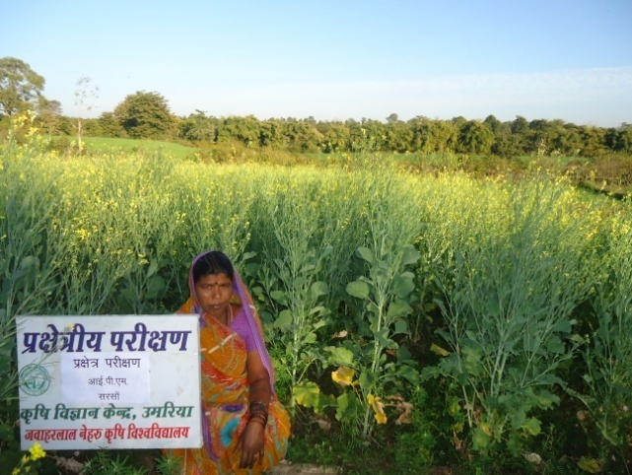  OFT on IPM in Mustard | 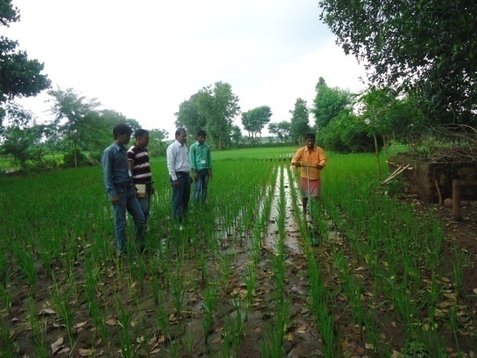  OFT on Conoweeder in Paddy | 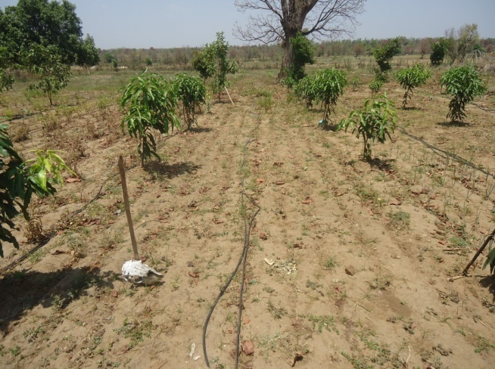  OFT on high density plantation of Mango (Amrapli)
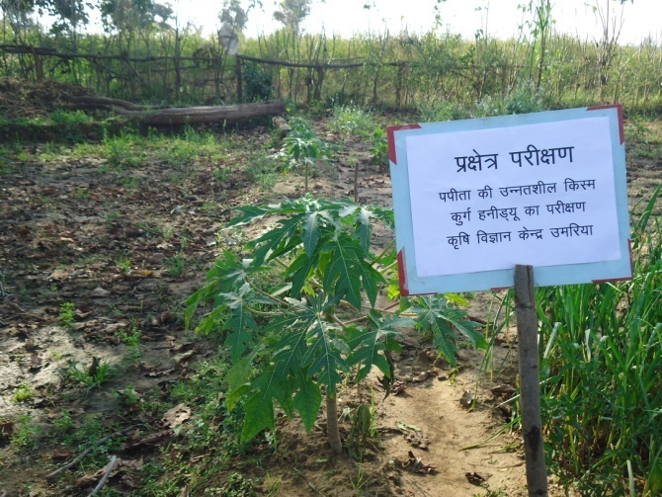  OFT on Papaya (Kurg Honey dew) | 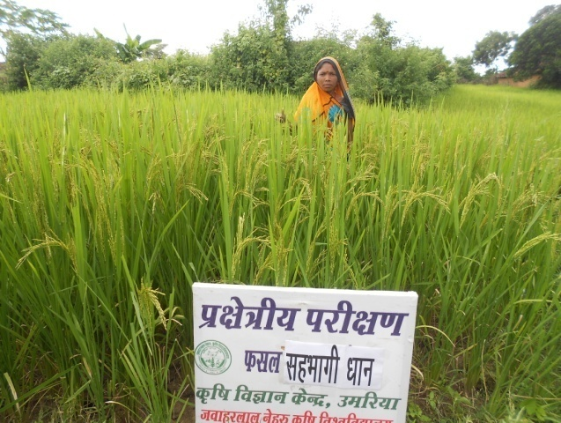  OFT on Paddy (Sahbhagi Dhan) | 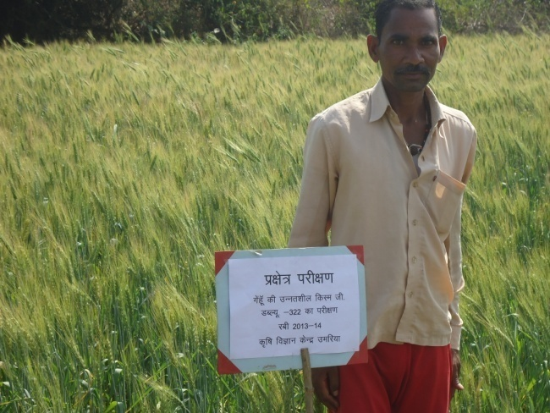  OFT on Wheat (GW-322)
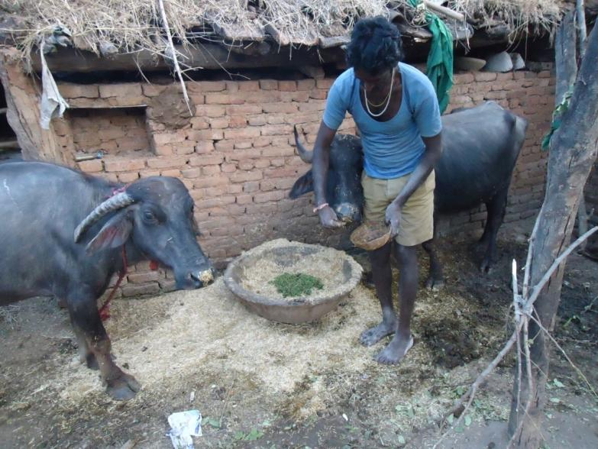  OFT on Azolla feeding | 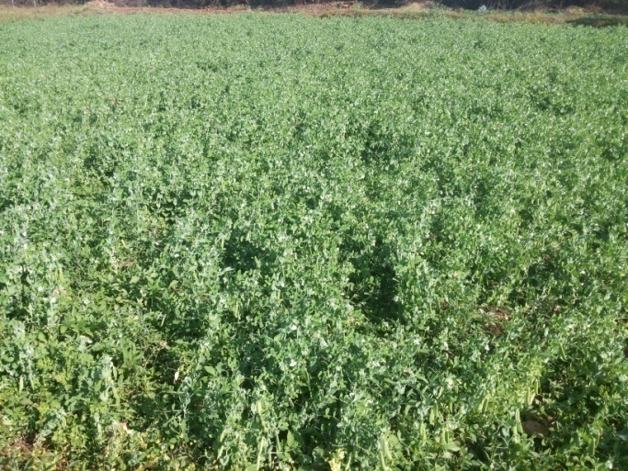  OFT on Pea (AP-3) | 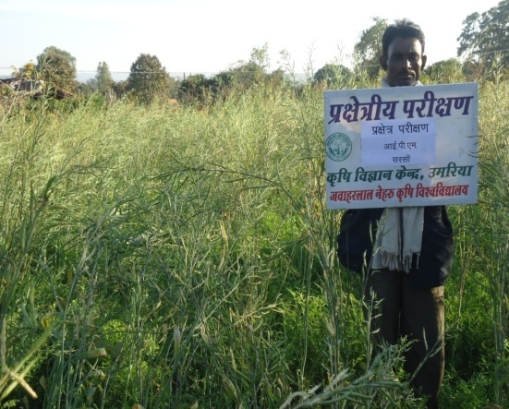  OFT on IPM in Mustard
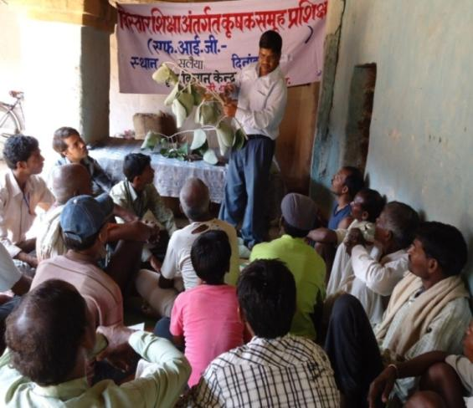  OFT on BIG | 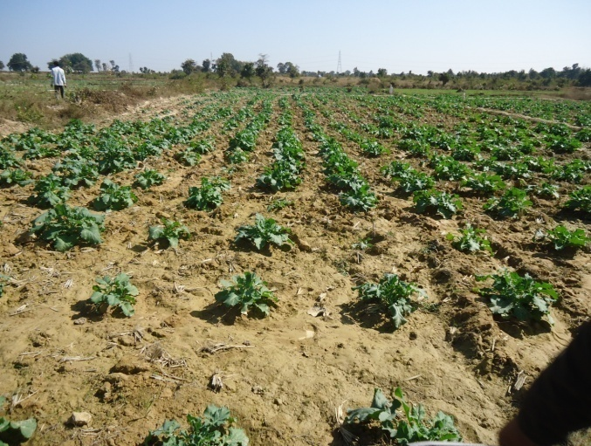  OFT on Mustard (SMI) | 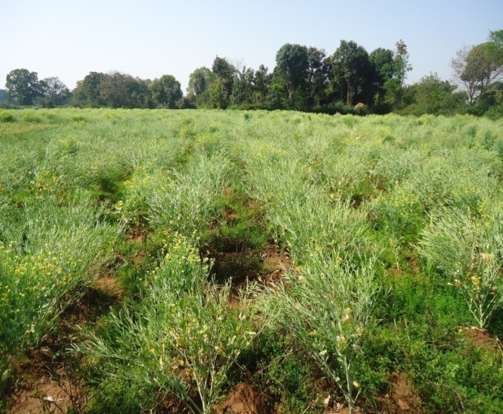  OFT On Mustard (SMI)

Front Line Demonstration

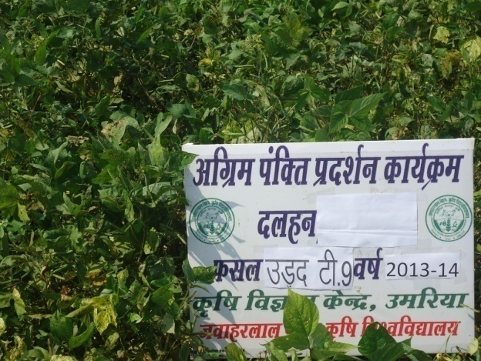  FLD on Black Gram(T-9) | 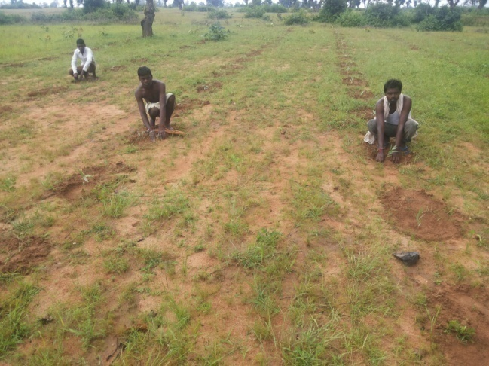  FLD on Clonal Eucalyptus | 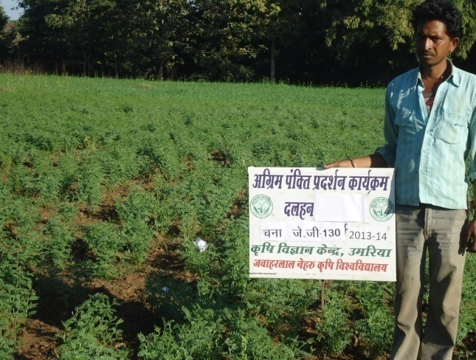  FLD on Gram (JG-130)
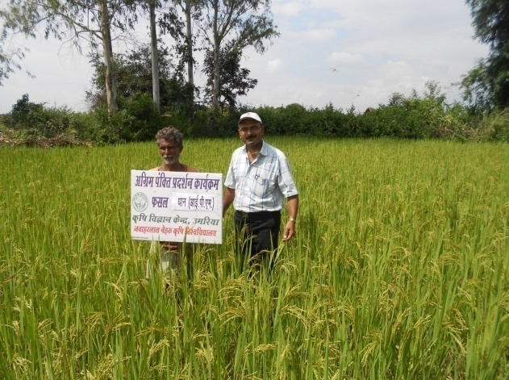  FLD on IPM (Paddy) | 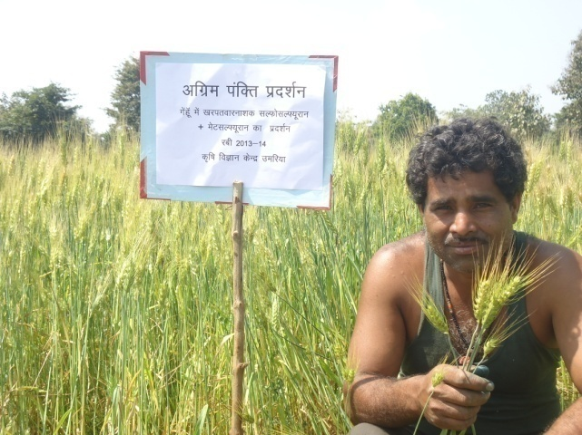  FLD on IPM (Wheat) | 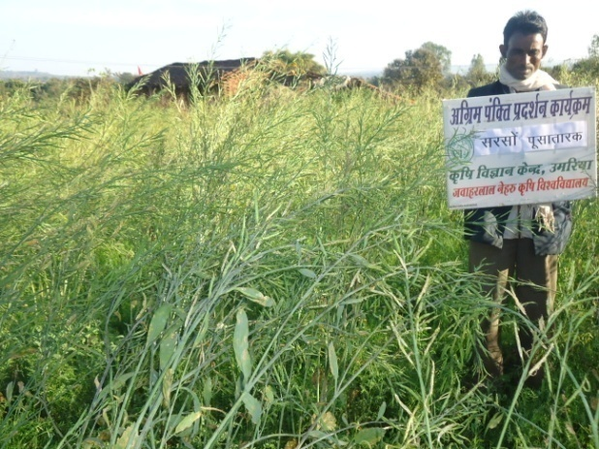  FLD on Mustard (Pusatark)
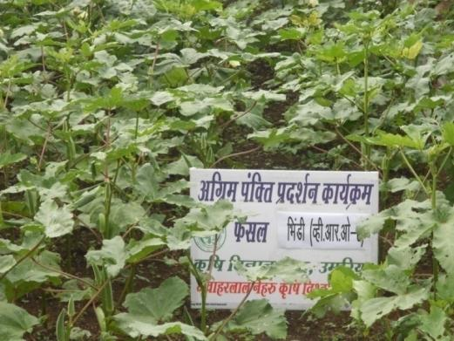  FLD on Okra (VRO-6) | 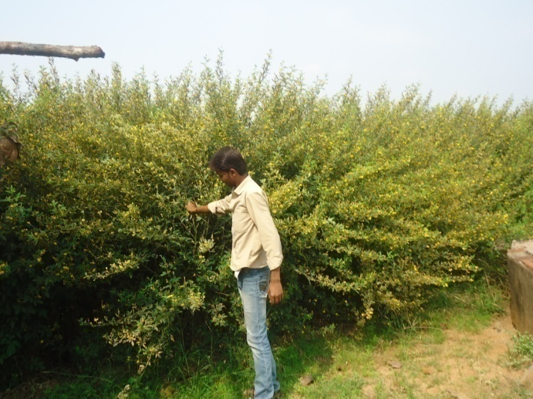  FLD on Pigeon pea (weed management) | 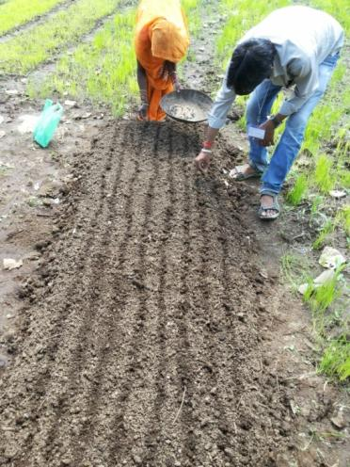  FLD on Kharif onion (ADR-1)
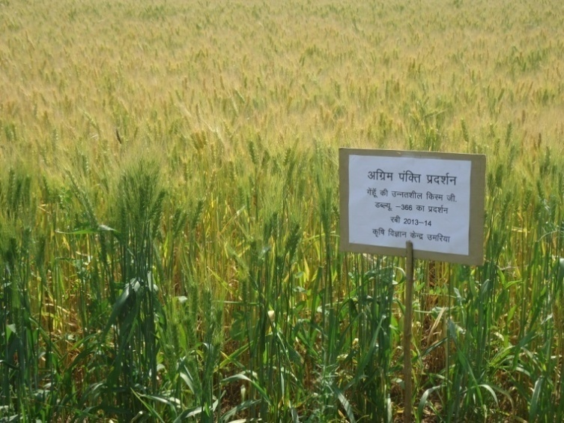  FLD on Wheat (GW-366) | 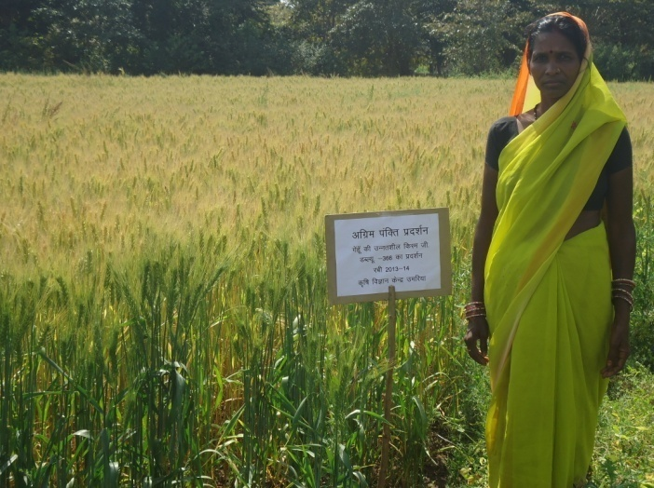  FLD on wheat (INM) | 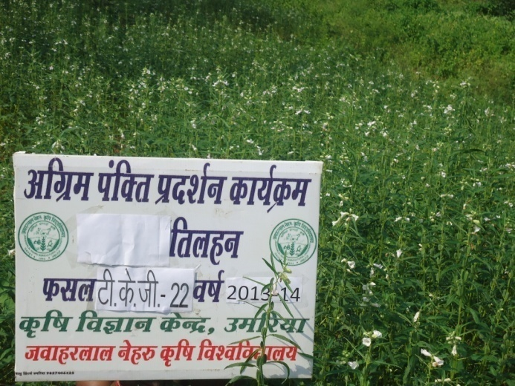  FLD on Sesame (TKG-22)

Trainings:-
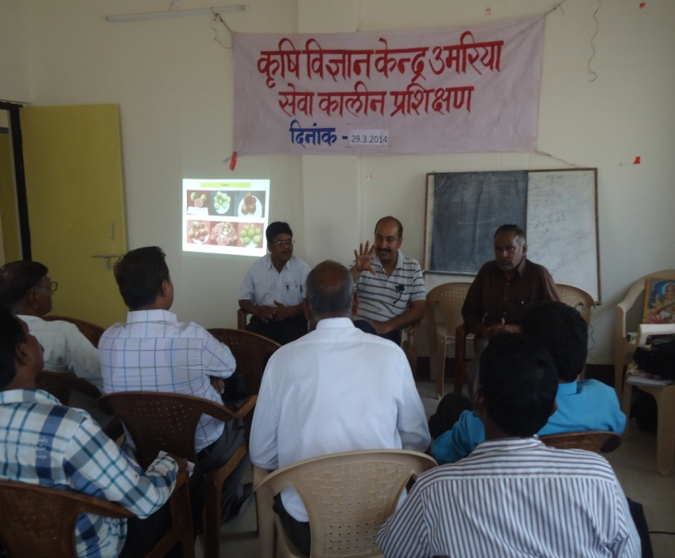 | 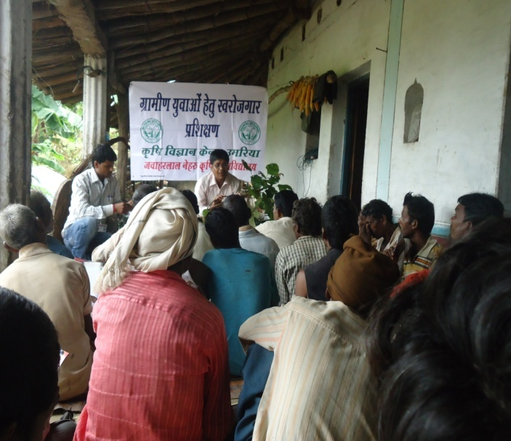 | 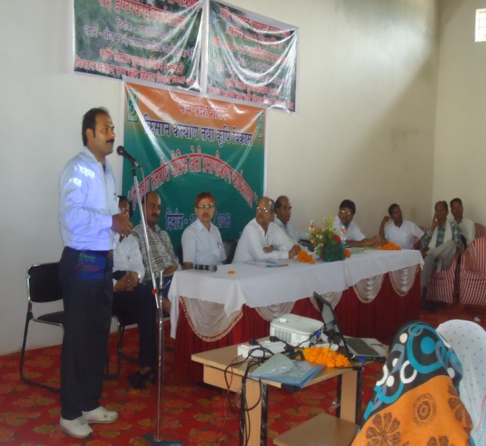
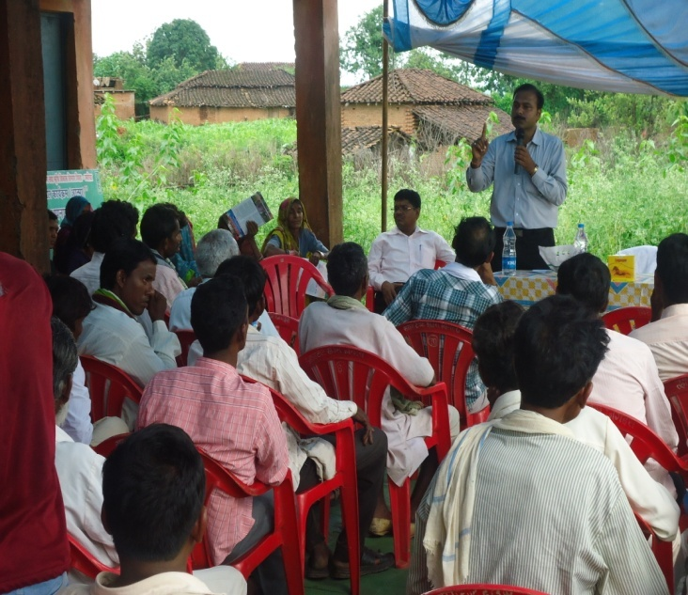 | 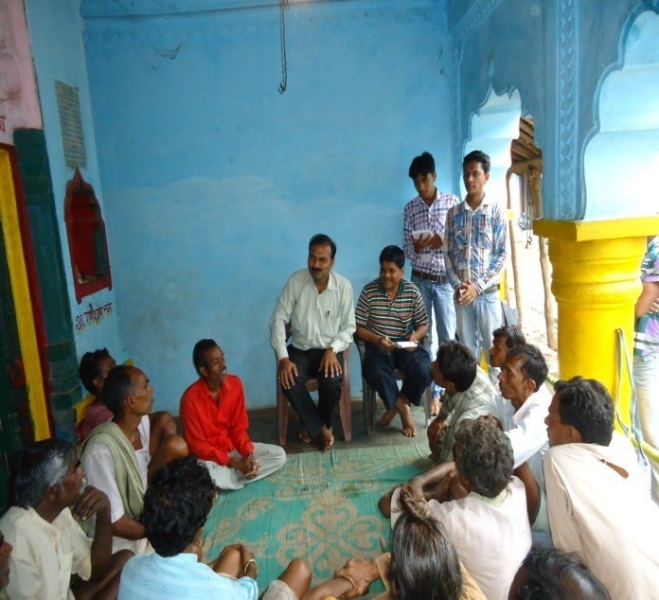 | 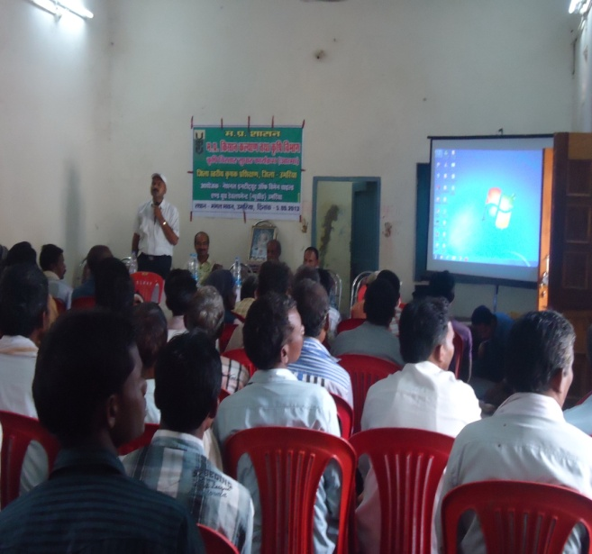

Extension Activities
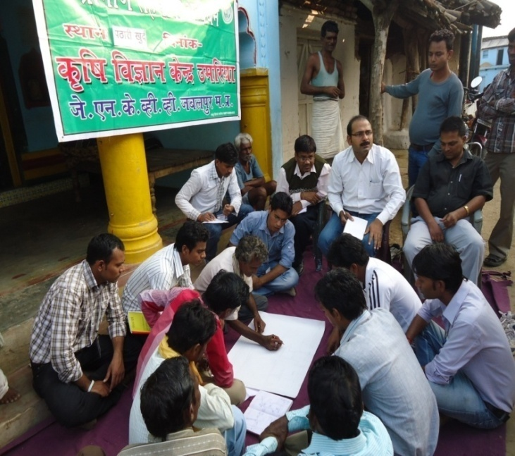 | 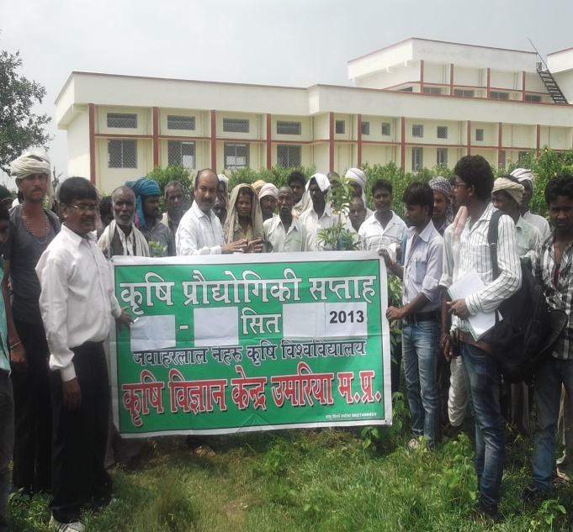 | 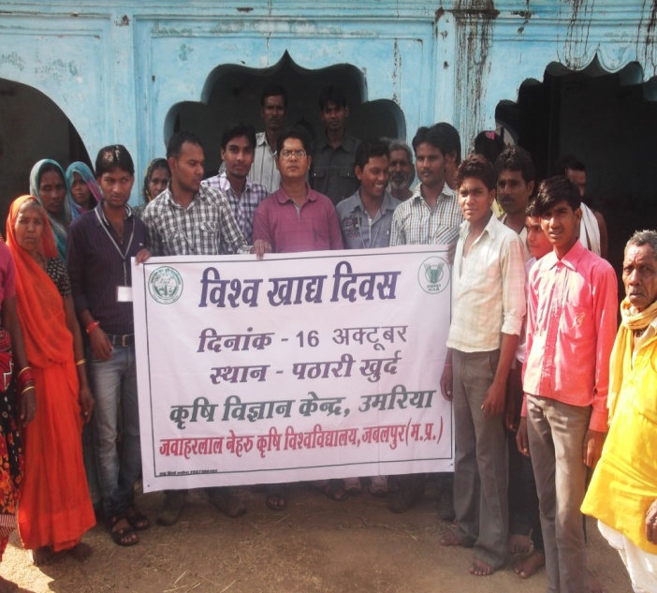
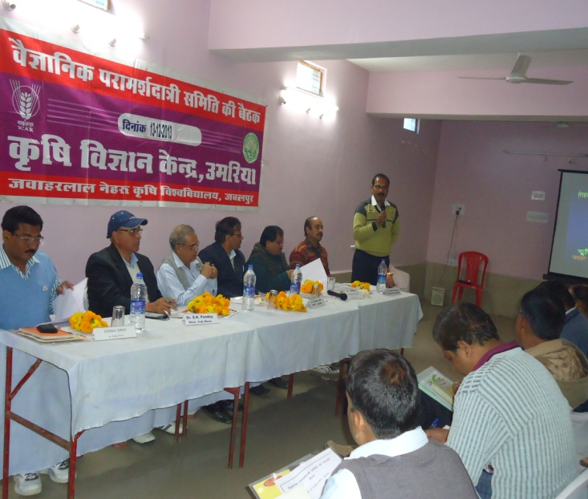 | 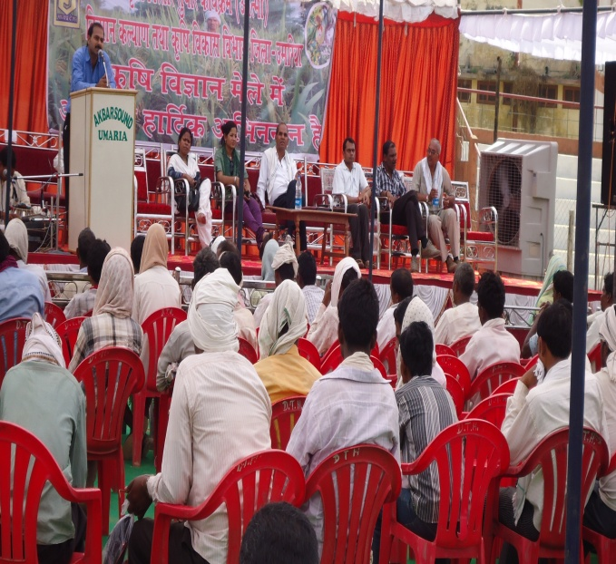 | 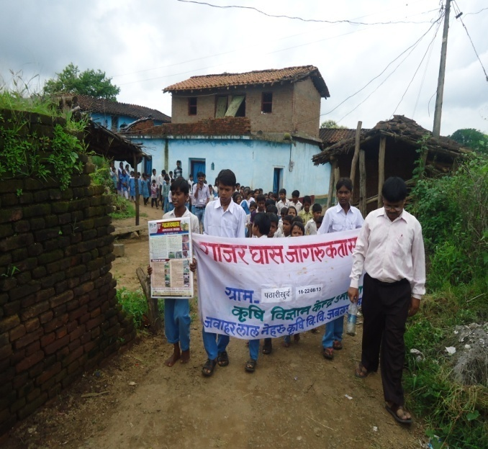

Training on Vocational Training Programme (VTP)

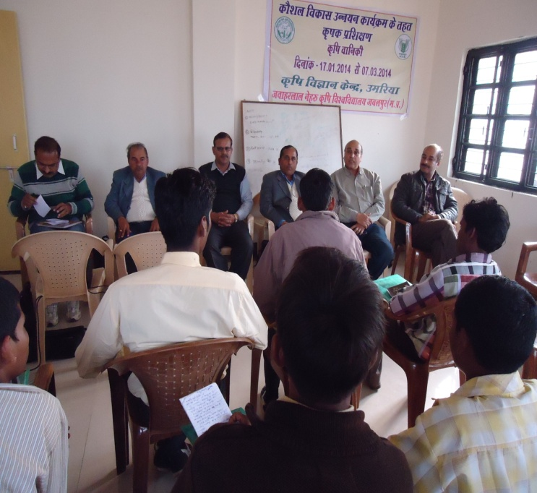 | 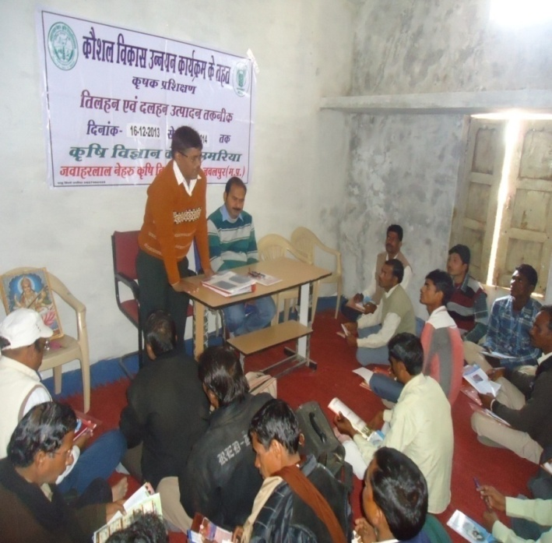 | 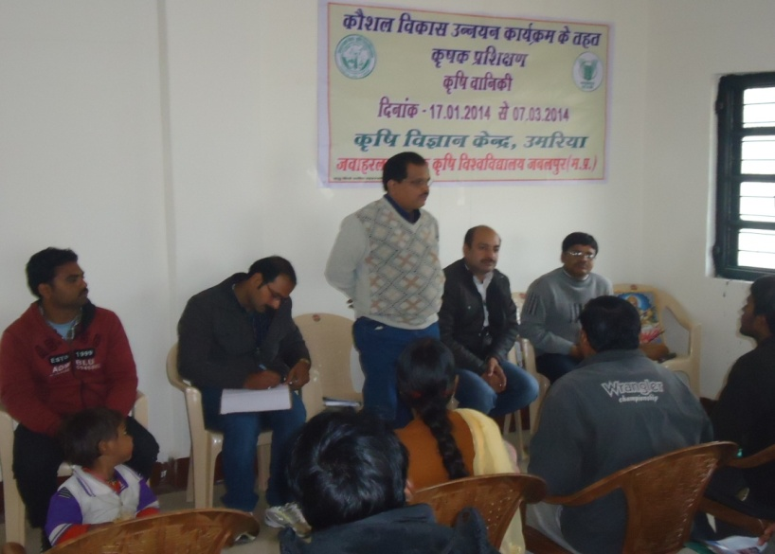
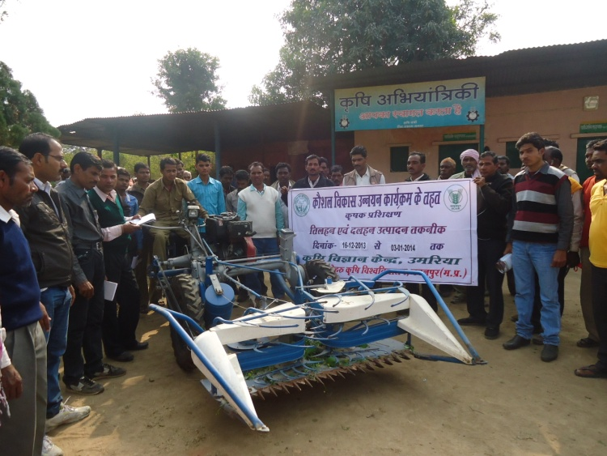 | 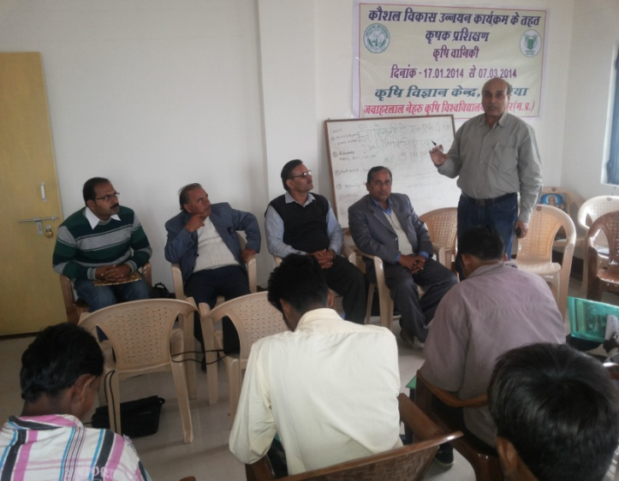 | 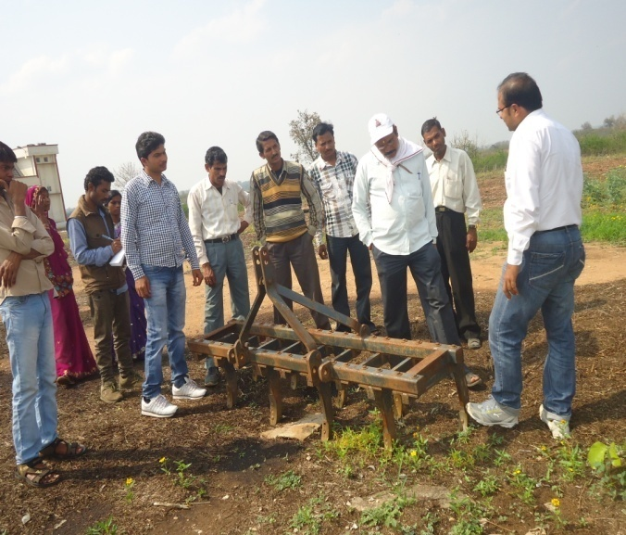
Training on Tribal Sub Plan (TSP)

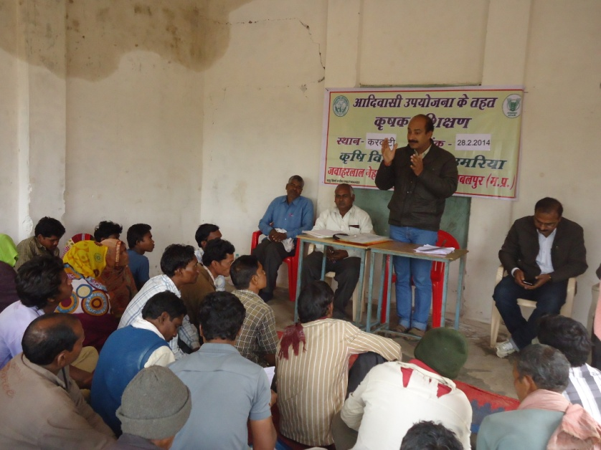 | 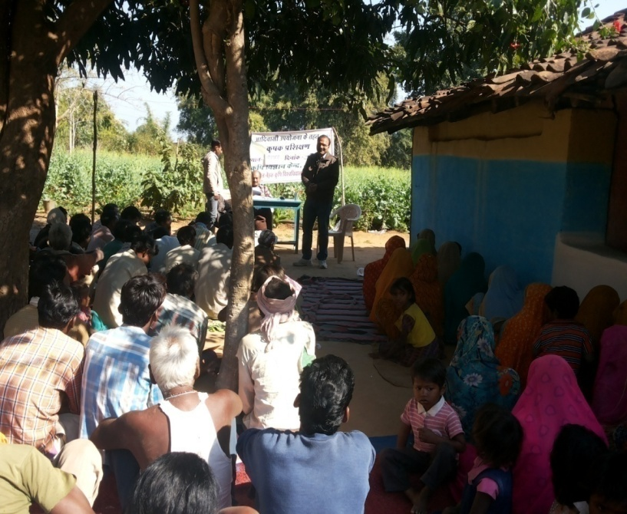 | 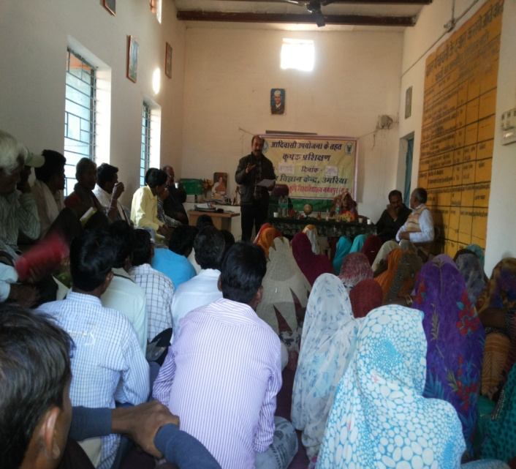
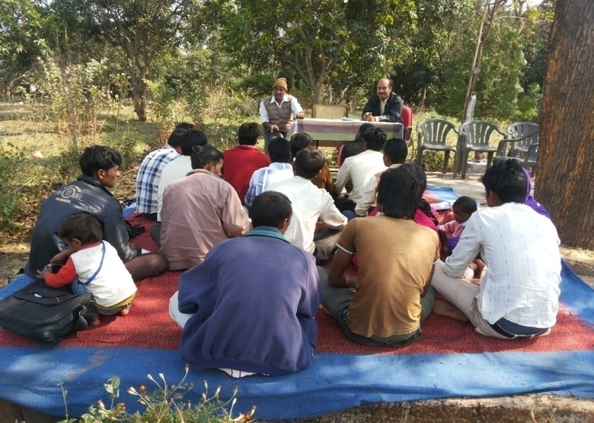 | 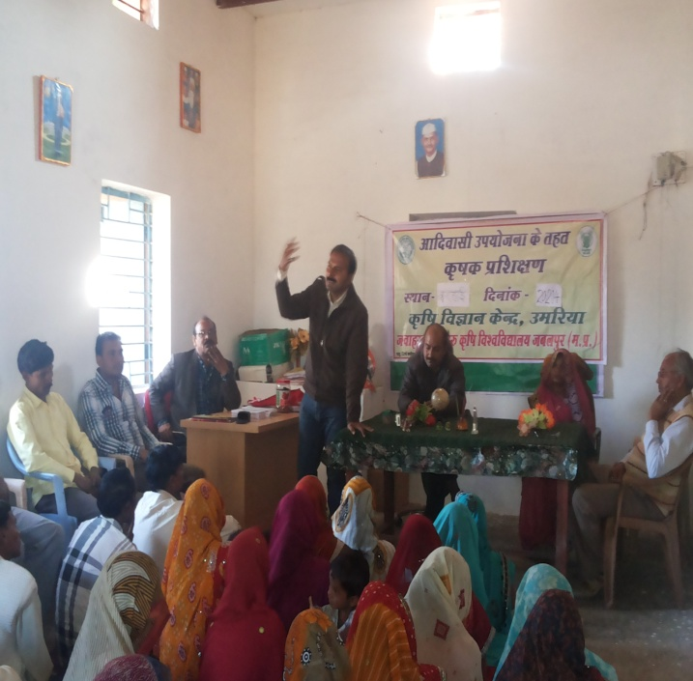 | 