ANNUAL PROGRESS REPORT
April 2018 to March 2019

Contents
S. No. | Particular | Page No
 | Instructions for Filling the Format
 | Summary of KVK Annual Report (Quantifiable Achievement) for the year 2018-19
1 | General Information
2 | On Farm Testing
3 | Achievements of Frontline Demonstrations
4 | Documentation of the need assessment conducted by the KVK for the training programme
5 | Training programmes
6 | Extension Activities
7 | Literature Developed/Published (with full title, author & reference)
8 | Production and supply of Technological products
9 | Activities of Soil and Water Testing Laboratory
10 | Rainwater Harvesting
11 | Utilization of Farmer Hostel facilities
12 | Utilization of Staff Quarter facilities
13 | Details of SAC Meeting
14 | Status of Kisan Mobile Advisory
15 | Status of Convergence with agricultural schemes
16. | Status of Revolving Funds
17. | Awards & Recognition
18. | Details of KVK Agro-technological Park
19. | Farm Innovators
20. | KVK interaction with progressive farmers
21. | Outreach of KVK
22. | Technology Demonstration under Tribal Sub Plan on Pulses/ Programme on Harnessing Pulses/ Quality Protein Maize
23. | KVK Ring
24. | Important visitors to KVK
25. | Status of KVK Website
26. | Status of E-connectivity
27. | Status of RTI
28. | Status of Citizen Charter
29. | Attended HRD activities organized by ZPD
30. | Attended HRD activities organized by DES
31. | Attended HRD activities by KVK Staff
32 | Agri Alert report
33. | Details of Technological Week Celebration
34. | Interventions on Drought Mitigation
35. | Satellite Village on Doubling Farmer’s Income
36. | Nutri Smart Village
37. | Sansad Adarsh Gram
38. | Proposal of NICRA
39. | Proposed works under NAIP
40. | Case study / Success Story to be developed
41. | Action Photographs
Instructions for Filling the Format

- Do not change/modify/ delete any column of any of the table. However, additional rows can be created, if required.
- Do not merge columns, rows.
- Please repeat the name of KVK in each table in the column “Name of KVK”
- Do not fill the non-numerical values in numeric field
- Do not repeat the unit while reporting data as it is already mentioned in the heading row
- Strictly fill the data in desired unit only. If it is reported in other unit, convert it in the desired unit
- Please mention only standard English names of crops (Do not mention Urd, Arhar, Til, Kulthi, Moong, Bajra, etc.)
- Additional relevant information may be provided at the end of Format by creating heading “Additional Information”
- Also read the instructions mentioned just below the table
- Your suggestions for improvement in the format for your simplicity as well as data compilation may be given at the end of the format
- Do not press any Enter Key in any of the columns while making entry in the columns of the table. Use only arrow key /Tab key/ mouse pointer while movement from one column/row to another.
- Grey color cells in summary table need not to be filled.
- Crop name should be spelled correct and standard English name should be used i.e Cereals, Pulses, Oilseed:- Rice (not use Paddy), Wheat, Barley, Kodo, Kutki, Maize, Jwar, Bajra, Pigeon pea (not use Tur, Arhar, Red gram), Blackgram (not use Urd), Greengram (not use Moong/Moongbean), Chickpea (not use Gram, Chana), Field pea, Horse gram (Kulthi), Lentil, Mustard (not use Rai, Sarsoan), Soybean, Linseed, Groundnut, Sesame (not use Til), Niger (not use Ram Til), Safflower (not use Kusum).
Vegetable:- Vegetable pea, Bottle guard, Bitter guard, Okra (not use Bhindi or Ladies finger).
Fruits:- Mango, Guava, Custard apple, Pear etc.
Spices:- Black Peeper, Turmeric, Ginger, Cardamom etc.

REPORTING PERIOD – April 2018 to March 2019
Summary of KVK Annual Report (Quantifiable Achievement) for the year 2018-19

S.N. | Quantifiable Achievement | Number | Beneficiaries (nos.)
1 | On Farm Testing
 | Proposed OFT | 22 | 205
 | On Going OFT | - | -
 | Technologies assessed (Completed OFT) | 20 | 135
 | Technologies refined | - | -
 | On farm trials conducted | 20 | 135
2 | Frontline demonstrations
 | Proposed Frontline demonstrations | 11 | 264
 | On Going Frontline demonstrations | - | -
 | FLDs conducted on crops | 07 | 234
 | Area under crops (ha.) | 94.6 | 234
 | FLD on farm implement and tools | - | -
 | FLD on livestock/ AH enterprises (Dairy/ Sheep and Goat/Poultry/ Duckery/ Piggery etc.) | 04 | 27
 | FLD on Fisheries - Finger lings | - | -
 | FLD on other enterprises (Bee keeping, lac, mushroom, sericulture, value addition, vermi compost, etc.) | 01 | 10
 | FLD on Women in Agriculture - (Nutritional garden, Income generation, Value addition, Drudgery reduction, etc.) | 02 | 15
3 | Training programmes | No. of Course | Duration (days) | Participants
 | Farmers | 27 | 27 | 240
 | Farm women | 10 | 10 | 335
 | Rural youth | 05 | 19 | 144
 | Extension personnel/ In service | 03 | 03 | 128
 | Vocational trainings | 05 | 19 | 144
 | Sponsored Training | 11 | 65 | 886
 | Total | 61 | 143 | 1877
 |  | No. of programmes | Participants
4 | Extension Programmes | 273 | 14842
5 | Production of technology inputs etc | Qty | Beneficiaries (nos.)
 | Seed (qt.) | 2.02 | 15
 | Planting material produced (nos.) | 29350 | 80
6 | Livestock | Qty | Beneficiaries (nos.)
 | Livestock strains ( Nos) | 0 | 0
 | Milk Yield - Cow, Buffelo etc. (in liter) | 457.75 | 10
 | Fish (Kg.)
 | Fingerlings (nos.)
 | Poultry-Eggs (nos.)
 | Ducks (nos.)
 | Chicks etc. (nos.)
7 | Bio Products | Qty | Beneficiaries (nos.)
 | Bio Agents -Earth worm (Kg.) | 95.5 | -
 | Trichoderma (kg.) | - | -
 | Bio Fertilizers- Vermi compost, Rhizobium, PSB , BGA , Mycorriza , Azotobacter , Azospirillum etc. (Kg.) | 20370 | 350
 | Bio Pesticide-Panchgavya, Neem Extract , Neem oil etc.(lit.) | - | -
8 | Any other significant achievement in the Zone | Nos. | Participants/ beneficiaries
 | Award (Best KVK award and scientist and farmer’s award) | 01 | 01
 | Publications ( Res. Paper/ pop. Art./Bulletin,etc.) | 04 | mass
 | KVK News letter | 04 | mass
 | SAC Meetings conducted | 01 | 26
 | Soil sample tested | 463 | 2304
 | Water sample tested | 0 | 0
 | RWH System (Special training and field visit on RWH structure and MIS in KVKs) | - | -
 | KVK-KMA (Message and beneficiaries) | 35 | 18203
 | Convergence programmes | 04 | -
 | Sponsored programmes | 04
 | KVK Progressive Farmers interaction | 04 | 197
 | No. of Technology Week Celebrations | 01 | 1636
 | Attended HRD activities organized by ZPD | 08 | 04
 | Attended HRD activities organized by DES
 | Attended HRD activities by KVK Staff(Refresher /Short course, Training programme etc. ) | 01 | 01
9 | Current status of Revolving Funds ( Amt. in Rs.) | 1082304
10 |  | No. of blocks | No. of villages
 | Outreach of KVK in the District | 3 | 629
11 |  | ICAR | SAU | Others
 | No. of important visitors to KVK (nos.) | - | 10 | -
12 |  | Working (Yes/No) | No. of Update
 | Status of KVK Website | yes | 12
13 |  | Application received | Application disposed
 | Status of RTI (nos.) | - | -
14 |  | Query received | Query dissolved
 | Citizen Charter (nos.) | - | -
15 |  | Working (Yes/No) | No. of programme viewed
 | E-connectivity | - | -
16 |  | Filled | Vacant
 | Staff Position | 8 | 8
17 | Workshop/ Seminar/ Conference attended by staff of KVK ( nos) | 02
18 | Publication received from ICAR /other organization (nos.) | -
-19 |  | Particulars | Organization
 | Agri alerts (epidemic, high serious nature problem, Cyclone etc. reported first time to ZPD, SAU, Agri. Deptt. and ICAR) | 01 | SAU
20 | Activities performed in Satellite Village on DFI | Nos. of Activities | Participants/ beneficiaries
 |  | 45 | 785
21 | Activities performed in Nutri Smart Village | Nos. of Activities | Participants/ beneficiaries
 |  | 42 | 742
22 | Activities performed in Sansad Adarsh Gram | Nos. of Activities | Participants/ beneficiaries
 |  | - | -

GENERAL INFORMATION
1.1. Staff Position (as on date)
Summary of Staff position in KVKs on March, 2019
Name of KVK | Sanctioned  Posts | PC (1) |  | SMS (6) |  | PA (3) |  | Admn. (6) |  | Total
Name of KVK | Sanctioned  Posts | Sanc. | Filled | Sanc. | Filled | Sanc. | Filled | Sanc. | Filled | Sanc. | Filled
Umaria | 16 | 1 | 1 | 6 | 3 | 3 | 2 | 6 | 2 | 16 | 8

Name of KVK | Sanction post | Name of the incumbent | Discipline | Highest degree | Subject of specialization | Pay scale | Present pay | Date of joining | Per./Temp. | Category
Umaria | Senior Scientist and Head | Dr. K.P. Tiwari | Agronomy | Ph.D | Agronomy | 37400-67000 | 60600 | 22/9/14 | Permanent | Gen
Umaria | Scientist | Dr Vinita Singh | Home Science | NET,Ph.D | Food and Nutrition | 15600-39100 | 34780 | 07/02/2007 | Permanent | Gen
Umaria | Scientist | Dr. R.R. Singh | LPM | Ph.D. | LPM | 15600-39100 | 26590 | 13/10/11 | Permanent | Gen
Umaria | Scientist | Shri Vivek Walke | Agril Engineering | NET | Agril Engineering | 15600-39100 | 21600 | 18/8/2017 | Permanent | ST
Umaria | Scientist | Vacant | - | - | - | - | - | - | - | -
Umaria | Scientist | Vacant | - | - | - | - | - | - | - | -
Umaria | Programme Assistant | Sh. K.K. Rana | Extension Education | MSc | Extension Education | 9300-34800 | 42700 | - | - | -
Umaria | Farm Manager | Vacant | - | - | - | - | - | - | - | -
Umaria | Programme Assistant (Computer ) | Shri Arun Kumar Rajak | Computer | MCA | Computer Science | 9300-34800 +GP 4200 | 59100 | 08-04-2008 | Permanent | OBC
Umaria | Accountant / superintendent | Vacant | - | - | - | - | - | - | - | -
Umaria | Stenographer | Vacant | - | - | - | - | - | - | - | -
Umaria | Driver | Shri Raju. Vishwakarma |  | 12th passed |  | 5200-20200 + GP 1900 | 27800 | 10/07/08 | Permanent | OBC
Umaria | Driver | Sandeep Chourasiya | - | 12th passed | - | 5200-20200 + GP 1900 | 27800 | 10/07/08 | Permanent | OBC
Umaria | Supporting staff | Vacant | - | - | - | - | - | - | - | -
Umaria | Supporting staff | Vacant | - | - | - | - | - | - | - | -

1.2. DISTRICT PROFILE (detail of geographical area, cultivation, Land, resources, opportunities, irrigation, populations etc.)–
KVK Name | Agro-climatic zone | No . of Blocks | No. of Panchayats | Population | Literacy |  | SC and ST Population | No. of farmers |  | Average land holding
Umaria |  | 03 | 234 | 432880 | 56.50 |  | 54.50 | 800037
Particulars |  |  |  |  |  | Madhya Pradesh |  |  | Umaria
Population (2011) |  |  |  |  |  | 72,597,565 |  |  | 644758
Decadal Population Growth Rate(2001-11) |  |  |  |  |  | 20.30% |  |  | 24.70%
Population Density Per Sq.km(2011) |  |  |  |  |  | 236 |  |  | 158
Level of Urbanization(2011) |  |  |  |  |  | 27.60% |  |  | 17.20%
Proportion of ST Population(20011) |  |  |  |  |  | 20.30% |  |  | 44.00%
Contribution to State Economy(2008-09) - |  |  |  |  |  | - |  |  | 0.59%
Per Capita Income(INR), Current Prices(2008-09) |  |  |  |  |  | 24,709 |  |  | 17,313
Contribution of Primary Sector to Economy(2008-09) |  |  |  |  |  | 31.50% |  |  | 29.00%
Contribution of Secondary Sector to Economy(2008-09) |  |  |  |  |  | 22.90% |  |  | 29.70%
Contribution of Tertiary Sector to Economy(2008-09) |  |  |  |  |  | 45.60% |  |  | 41.30%

1.2.3. Forest statistics of district Umaria
S. No. | Particulars | Nos.
1 | Geographical area of the district: | 450329 ha
2 | Total forest area | 236714 ha (52.56%)
3 | Reserved forest | 140835 ha (59.5%)
4 | Protected forest | 95869 ha (40.5%)
5 | Forest area consist
 | Teak forest | 2.77 %
 | Sal forest | 43.06 %
 | Mix forest | 37.17 %
 | Other forest | 7.55 %
6 | Forest protection society | 95 Nos (53040.46 ha)
 | Village forest society | 111 Nos. (58187.294 ha)

1.2.4. Cropping pattern -
S. No. | Cropping pattern | Area (ha) | % of Net cultivated area
1. | Kharif crop - Rabi fellow | 45997 | 44.57
2. | Kharif fellow- Rabi crop | 20692 | 20.06
3. | Kharif crop - Rabi crop | 36499 | 35.37
4. | Mono cropped area | 66689 | 64.63

1.3. DETAILS OF ADOPTED VILLAGE during the reporting period (Approved by competent Authority in meetings/workshops)
1.3. DETAILS OF ADOPTED VILLAGE during 1.4.2015 to 31.3.2016 (Approved by competent Authority in meetings/workshops)
KVK Name | Village Name | Year of adoption | Block Name | Distance from KVK | Population | Number of farmers (having land in the village)
UMARIA | Taali-Dhaurkhoh | 2014 | Karkeli | 10 KM | 2779 | 782

1.4. THRUST AREAS identified by KVK (Approved by competent Authority in meetings/workshop)
KVK Name | THRUST AREA
Umaria | Varietal Diversification- Availability of quality seed through seed production technology and Seed replacement.
Umaria | Technological diversification
Umaria | Crop diversification
Umaria | Integrated farming system
Umaria | Rainwater and irrigation management
Umaria | Integrated nutrient management
Umaria | Integrated pest management
Umaria | Promotion of organic farming along with balanced nutrition.
Umaria | Strengthen of linkage between farmer’s and extension system
Umaria | Farm mechanization and drudgery reduction
Umaria | Development of rural entrepreneurship for income and employment generation like Bee Keeping and mushroom cultivation
Umaria | Increasing productivity of vegetables
Umaria | Integrated livestock management
Umaria | Promotion of agriculture based enterprises for farm women

1.5. PROBLEM IDENTIFIED by KVK (Approved by competent Authority in meetings/workshop)

KVK Name | Problem identified | Methods of problem identification | Location Name of Village & Block
Umaria | Lack of knowledge about milch Animals, poultry , fish and goatry management | PRA | Tali and Dhourkho Block Karkeli
Umaria | Lack of agro technical knowledge, | PRA | Tali and Dhourkho Block Karkeli
Umaria | Low seed replacement rate, | PRA | Tali and Dhourkho Block Karkeli
Umaria | Traditional method of cropping, | PRA | Tali and Dhourkho Block Karkeli
Umaria | No use of improved farm implements, | PRA | Tali and Dhourkho Block Karkeli
Umaria | Mono cropping, | PRA | Tali and Dhourkho Block Karkeli
Umaria | No knowledge of shaded cropping technology, | PRA | Tali and Dhourkho Block Karkeli
Umaria | Lack of awareness about improved milch animals and their feeding habits | PRA | Tali and Dhourkho Block Karkeli
Umaria | No knowledge of disease and insect pest management, | PRA | Tali and Dhourkho Block Karkeli
Umaria | No knowledge about women drudgery reduction and their lean period utilization | PRA | Tali and Dhourkho Block Karkeli
Umaria | No knowledge about soil test basis cropping system | PRA | Tali and Dhourkho Block Karkeli
Umaria | No knowledge about poultry, fish and goatery management, | PRA | Tali and Dhourkho Block Karkeli
Umaria | High magnitude of malnutrition among women and children | PRA | Tali and Dhourkho Block Karkeli
Umaria | Low income of farm women due to lack of enterprises | PRA | Tali and Dhourkho Block Karkeli

2. On Farm Testing (OFT)
2.1 Details of OFT on Crop
KVK name | Year/Season | Problem diagnose | Title of OFT | Category of technology | Name of Technology/Variety used |  |  | Thematic Area | Crop Category | Name of Crop | Farming Situations | Target | No. of trials | Results (with parameter) |  |  | Net Returns (Rs./ha)
 |  |  |  |  | T1 | T2 | T3 |  |  |  |  |  |  | FP (T1) | RP (T2) | T3 | FP (T1) | RP (T2) |  | T3
Umaria | Kharif 2018-19 | Poor yield stability and low returns from pigeon pea due to adverse climatic conditions | Assessment of intercropping in transplanted pigeon pea for ensuring higher returns and minimizing risk due to adverse climate in piegon-pea fellow cropping system. | Assessment | Sole crop of Pigeon pea ( transplanted at 5 X 3 feet spacing) | Transplanted Pigeon pea ( Pusa-16/ TJT-501)+ Cowpea( 1:4)/ Blackgram(1:4)/Ginger (1:2)/ Kodo (1:4) | ⁻ | IFS | Pulses | Pigeon pea | Irrigated | 05 | 05 | 8.94+35.16 | 40.34+3.94/24.64 | - | 56520 | 156148 |  | -
Umaria | Kharif 2018-19 | No use of bio decomposer and create pollution through burn of crop residue. | Assessment of bio decomposer on decomposition of crop residues | Assessment | Farmers Practices (Decomposition of crop residue in open hip) | Decomposition of crop residue through bacterial base decomposer @ 500ml for one ton raw material | Decomposition of crop residue through bacterial base decomposer @ 500ml for one ton raw material | RCT | - | - | Irrigated | 05 | 05 | 240 days | 46.6 days | - | - | - |  | -
Umaria | Kharif 2018-19 | Low yield of paddy due to poor nutrient management in Rice- Wheat cropping system | Assessment of economic returns from soil test based nutrient application (As per SHC on Grid based) in transplanted Rice (Rice- Wheat cropping system) | Assessment | NPK 60:40:0 Kg / ha | Soil health card based nutrient application | ⁻ | Soil fertility management | Cereal | Rice- Wheat | Irrigated | 05 | 05 | 27.42 | 35.18 | - | 22638 | 34465 |  | -
Umaria | Rabi 2018-19 | Low yield of paddy due to poor nutrient management in Rice- Wheat cropping system | Assessment of economic returns from soil test based nutrient application (As per SHC on Grid based) in Wheat (Rice- Wheat cropping system) | Assessment | NPK 60:40:0 Kg / ha | Soil health card based nutrient application | ⁻ | Soil fertility management | Cereal | Wheat-Rice | Irrigated | 05 | 05 | 25.72 | 33.22 | - | 23274 | 35174 |  | -
Umaria | Rabi 2018-19 | Low yield due to non suitable variety for late sown area | Assessment of Wheat varieties for late sown condition under Rice-Wheat cropping system | Assessment | Lok-1 | JW 3288 | JW 3336 | Varietal assessment | Cereal | Wheat | Irrigated | 04 | 04 | 25.25 | 23.06 | 30.22 | 23125 | 19402 |  | 31574
Umaria | Summer 2018 | Low yield of Green gram due to growing local varieties | Assessment of HVY PDM 139& SML-668 of green gram during summer season | Assessment | Growing local variety with poor crop management | Growing HYV PDM 139 with proper crop management | Growing HYV SLM 668 with proper crop management | Varietal assessment | Pulses | Green gram | irrigated | 10 | 10 | 7.41 | 12.02 | 12.94 | 15050 | 37300 |  | 41900
Umaria | Rabi  18-19 | Crop damaged by Wild cattle | Assessment of growing safflower around the filed for the protection of wild animal | Assessment | Manual watching | Crop whatching through sowing safflower surround the crop | ⁻ | ICM | Oilseed | Linseed/Safflower | Rainfed | 05 | 05 | 6.06 | 8.92  (7.44+  1.48) | - | 10028 | 20396 | -
Umaria | Rabi  18-19 | Manual decortications of Mahua seed take more time and labor along with deterioration in quality of decorticated seed which gives less selling price. | Primary processing of Mahua seed through mechanical seed decorticator | Assessment | Manual decortications of Mahua seed | Processing of Mahua seed by seed decorticator | ⁻ | RCT | Forest crop | Mahua | - | 05 | 05 | 11.2 labour/q | 1.14  labour/  q | - | - | - | -

KVK name | Year/  Season | Problem diagnose | Title of OFT | Category of technology | Name of Technology/Variety used |  |  |  | Thematic Area | Crop Category | Crop | Farming situation | Target | No. of trials | Results (with parameter) |  |  |  | Net Returns (Rs./ha)
 |  |  |  |  | T1 | T2 | T3 | T4 |  |  |  |  |  |  | FP (T1) | (T2) | T3 | T4 | FP (T1) | (T2) | T3 | T4
Umaria | Kharif 2018-19 | Low yield of soybean crop | Assessment of system HVY JS-20-29& 20-34, 20-69 of soybean with ridge furrow system | Assessment | JS- 335 | JS-20-29 | JS 20-34 | JS 2069 | Varietal assessment | Oilseed | soybean | Rainfed | 05 | 05 | 3.17 | 2.92 | 3.41 | 14.8 | -10454 | -11404 | -9542 | 33740
Umaria | Kharif -2018-19 | Low yield of paddy due to low organic content in soil | Assessment of integrated nutrient management in transplanted paddy under Rice- Chickpea cropping system | Assessment | NPK 60:40:0 Kg / ha | NPK 100:60:0 Kg / ha | Green manuring + 25 % NPK through vermicompost, BGA + 50 % NPK through chemical fertilizer ( STV) | Green manuring through sun hemp + 75% NPK through chemical fertilizers( STV) ( 100:60:40:20) kg | INM | Cereal | Paddy | Irrigated | 05 | 05 | 53.38 | 63.36 | 75.27 | 82.46 | 69070 | 84568 | 103851 | 112610

Recommendations of OFTs
Recommendations
Title of OFT | For Farmers | For Deptt. Personnel
Assessment of intercropping in transplanted pigeon pea for ensuring higher returns and minimizing risk due to adverse climate in pigeon-pea fellow cropping system. | Use of other crops like ginger in irrigated and coriander/radish/green gram in rainfed condition is beneficial in transplanted rice for higher returns
Assessment of bio decomposer on decomposition of crop residues | Bio decomposers can be use for speedy decomposition of crop residues
Assessment of economic returns from soil test based nutrient application (As per SHC on Grid based) in transplanted Rice (Rice- Wheat cropping system) | SHC based nutrient application is economical and beneficial
Assessment of economic returns from soil test based nutrient application (As per SHC on Grid based) in Wheat (Rice- Wheat cropping system) | SHC based nutrient application is economical and beneficial
Assessment of Wheat varieties for late sown condition under Rice-Wheat cropping system | Variety JW 3336 is suitable for paddy wheat crop rotation
Assessment of HVY PDM 139& SML-668 of green gram during summer season | Summer moong SML 668 performed best in the trials and hence can be recommended
Assessment of growing safflower around the filed for the protection of wild animal | Around 20-22% yield is increased due to protection from wild animals and also generated additional income through edible oil
Primary processing of Mahua seed through mechanical seed decorticator | Mahua decorticator should be used over manual operation to improve efficiency
Assessment of system HVY JS-20-29& 20-34, 20-69 of soybean with ridge furrow system | Only JS 20-69 performed well in the trials
Assessment of integrated nutrient management in transplanted paddy under Rice- Chickpea cropping system | INM can be recommended in rice-chick pea cropping system to improve yield

  - Economic Performance
OFT Title | Parameters |  |  |  | Average Cost of cultivation (Rs/ha) |  |  | Average Gross Return (Rs/ha) |  |  | Average Net Return (Rs/ha) |  |  | Benefit-Cost Ratio (Gross Return / Gross Cost)
OFT Title | Name and unit of Parameter | FP (T₁) | RP (T₂) | RP (T3 | FP (T₁) | RP (T₂) | Refined Practice, (T₃) | FP (T₁) | RP (T₂) | Refined Practice (T₃) | FP (T₁) | RP(T₂) | Refined Practice (T₃) | FP (T₁) | RP (T₂) | Refined Practice,  (T₃)
Assessment of intercropping in transplanted pigeon pea for ensuring higher returns and minimizing risk due to adverse climate in piegon-pea fellow cropping system. | Yield/ha | 8.94+35.16 | 40.34+  3.94/  24.64 | - | 39000 | 58600 | - | 95520 | 214748 | - | 56520 | 156148 | - | 2.44 | 3.66 | -
Assessment of bio decomposer on decomposition of crop residues | Days required for decomposition | 240 | 46.6 | - | - | - | - | - | - | - | - | -- | - | - | - | -
Assessment of economic returns from soil test based nutrient application (As per SHC on Grid based) in transplanted Rice (Rice- Wheat cropping system) | No. of tillers/plant | 5.8 | 9 | - | 23976 | 26361 | - | 46614 | 60826 | - | 22638 | 34465 | - | 1.94 | 2.34 | -
Assessment of economic returns from soil test based nutrient application (As per SHC on Grid based) in Wheat (Rice- Wheat cropping system) | No. of tillers/sq m | 208.2 | 285 | - | 20450 | 21300 | - | 43724 | 56474 | - | 23274 | 35174 | - | 2.13 | 2.65 | -
Assessment of Wheat varieties for late sown condition under Rice-Wheat cropping system | No. of tillers /plant | 4.7 | 4.5 | 5.5 | 19800 | 19800 | 19800 | 42925 | 39202 | 51374 | 23125 | 19402 | 31574 | 2.16 | 1.97 | 2.59
Assessment of HVY PDM 139& SML-668 of green gram during summer season | No. of pods/plant | 37 | 52.3 | 60 | 22000 | 22800 | 22800 | 37050 | 60100 | 64700 | 15050 | 37300 | 41900 | 1.68 | 2.63 | 2.83
Assessment of growing safflower around the filed for the protection of wild animal | Yield/ha | 6.06 | 7.44+1.48 | - | 13000 | 13500 | - | 23028 | 33896 | - | 10028 | 20396 | - | 1.77 | 2.51 | -
Primary processing of Mahua seed through mechanical seed decorticator | Labour required/q  Efficiency  Kg/hour | 11.2  8.92 | 1.14  88.58 | -  - | 2240 | 228 | - | - | - | - | - | - | - | - | - | -

OFT Title | Parameters |  |  |  |  | Average Cost of cultivation (Rs/ha) |  |  |  |  |  | Average Gross Return (Rs/ha) |  |  |  | Average Net Return (Rs/ha) |  |  |  | Benefit-Cost Ratio (Gross Return / Gross Cost)
OFT Title | Name and unit of Parameter | FP (T₁) | RP (T₂) | RP (T3) | RP (T₄) | FP (T₁) | RP (T₂) | RP  (T₃) |  | RP  T4 |  | FP (T₁) | RP (T₂) | RP (T₃) | RP (T4) | FP (T₁) | RP  (T₂) | RP (T₃) | RP T4 | FP (T₁) | RP (T₂) | RP (T₃) | RP T4
Assessment of system HVY JS-20-29& 20-34, 20-69 of soybean with ridge furrow system0.49 | No. of pods/plant | 35.60 | 30.5 | 28.75 | 75.40 | 22500 in each |  |  |  |  |  | 12046 | 11096 | 12958 | 56240 | -10454 | -11404 | -9542 | 33740 | -0.53 | -  0.49 | -  0.57 | 2.49
Assessment of integrated nutrient management in transplanted paddy under Rice- Chickpea cropping system | Yield/ha | 53.38 | 63.36 | 75.27 | 82.46 | 21676 | 23144 |  | 24108 |  | 27572 | 90746 | 107712 | 127959 | 140182 | 69070 | 84568 | 103851 | 112610 | 4.18 | 4.65 | 5.30 | 5.05

2.3 Details of OFT on Agriculture Engineering
KVK name | Year/Season | Problem diagnose | Title of OFT | Category of technology (Assessment/ Refinement) | Name of Technology used |  |  | Thematic Area | Crop/Enterprise Category | Crop/ enterprise | Farming Situations | Target | No. of trials | Results (with parameter) |  |  | Net Returns (Rs./ha)
 |  |  |  |  | T1 | T2 | T3 |  |  |  |  |  |  | FP (T₁) | RP (T₂) | T3 | FP (T₁) | RP (T₂) | T3
Umaria | Kharif 2018-19 | labour crises ,less efficiency of labour and time consuming | Assessment of paddy transplanter in rice cropping system | Assessment | Manual transplanting | Paddy transplanting with paddy transplanter | - | Farm mechanization | Crop | Crop | Irrigated | 05 | 05 | Rs. 8060/ha | Rs. 2820/ha | - | 25084 | 40639 | -
Umaria | Rabi2018-19 | Low yield of wheat due to delay sowing | Assessment of Zero Tillage sowing of wheat in paddy- wheat cropping system | Assessment | Sowing of wheat after three ploughing | Sowing of wheat just after harvesting of paddy through zero till machine | - | Farm mechanization | Crop | Crop | Irrigated | 05 | 05 | 24.47 | 30.01 | - | 21677 | 35131 | -
Umaria | Rabi 2018-19 | labour crises , seed losses and time consuming | Assessment of reaper-binder in wheat crop | Assessment | Harvesting with sickle manually | Harvesting of crop with reaper-binder | - | Farm mechanization | Crop | Crop | Irrigated | 05 | 05 | 21.30abour/ha | 2.30 labour/ha | - | 27900 | 30410 | -
Recommendations of OFTs
Recommendations
Title of OFT | For Farmers | For Deptt. Personnel
Assessment of paddy transplanter in rice cropping system | Use of Paddy transplanter reduces transplanting cost around 65% per hectare when compared to manual transplanting and increases yield up to 24%
Assessment of Zero Tillage sowing of wheat in paddy- wheat cropping system | Around Rs. 3000/- decreased in the production cost due to zero till technique , it also increases yield by 17%. Saving of time- 15-20 days
Assessment of reaper-binder in wheat crop | Use of reaper binder reduces cost of harvesting in wheat by around 59% . It also reduces time and labour
2.4 Economic Performance
OFT Title | Parameters |  |  |  | Average Cost of cultivation (Rs/ha) |  |  | Average Gross Return (Rs/ha) |  |  | Average Net Return (Rs/ha) |  |  | Benefit-Cost Ratio (Gross Return / Gross Cost)
OFT Title | Name and unit of Parameter | FP (T₁) | RP (T₂) | (T₃) | FP (T₁) | RP (T₂) | Refined Practice, if any (T₃) | FP (T₁) | RP (T₂) | Refined Practice, if any (T₃) | FP (T₁) | RP(T₂) | Refined Practice, if any (T₃) | FP (T₁) | RP (T₂) | Refined Practice, if any (T₃)
Assessment of paddy transplanter in rice cropping system | Transplanting cost Rs./ha | 8060 | 2820 | - | 23400 | 19660 | - | 48484 | 60299 | - | 25084 | 40639 | - | 2.07 | 3.06 | -
Assessment of Zero Tillage sowing of wheat in paddy- wheat cropping system | Yield/ha | 24.47 | 30.01 | - | 22050 | 18550 | - | 43727.8 | 53681.6 | - | 21677 | 35131 | - | 1.98 | 2.89 | -
Assessment of reaper-binder in wheat crop | Labour required /ha | 21.30 | 2.30 | - | 18000 | 15490 | - | 45900 | 45900 | - | 27900 | 30410 | - | 2.55 | 2.96

2.5 Details of OFT on Animal Science
KVK name | Year/season | Problem diagnose | Title of OFT | Category of technology (Assessment/ Refinement) | Name of Technology used |  |  | Thematic Area | Category of Enterprise | Name of Enterprise | Target | No. of trials | Results (with parameter) |  |  | Net Returns (Rs./ha)
 |  |  |  |  | T1 | T2 | T3 |  |  |  |  |  | FP (T₁) | RP (T₂) | T3 | FP (T₁) | RP (T₂) | T3
Umaria | Rabi 2018-19 | Low milk production from cow due to unavailability of green fodder | Assessment of Azolla feeding as green fodder on milk production in Buffalo | Assessment | Feeding of Buffalo with wheat and Paddy straw without supplementation of green fodder | T ₁ + Azolla @ 1.5 Kg /animal/day | - | Feed management | Enterprise | Dairy | 05 | 05 | 4.4 lit./buffalo/day | 4.816 lit./buffalo/day | - | 8640 | 9993.6 | -
Umaria | Kharifi2018-19 | Protein supplements are costlier | Assessment of De-oiled Mahua seed cake in the ration of lactating Buffalo | Assessment | No feeding of De-oiled Mahua seed cake | 10 % of concentrate are replaced by De-oiled Mahua seed cake (@ 400 gm feed concentrates/lit milk) | - | Feed management | Enterprise | Dairy | 05 | 05 | 4.4 lit./buffalo/day | 4.83 lit./buffalo/day | - | 8640 | 10088 | -
Umaria | Rabi2018-19 | Low weight increase in goat kids | Assessment of probiotic to increase body weight in goat kids | Assessment | No feeding of probiotic | Feeding of probiotic @ 5 gm / 7 days / after interval one week interval | - | Feed management | Enterprise | Goatry | 05 | 05 | 8.64kg | 12 kg | - | - | - | -
Umaria | Rabi2018-19 | No feeding of green fodder & feed | Assessment of Azolla feeding to increase milk & body weight to lactating goat | Assessment | No feeding Azolla | Azolla feeding 250 gm day/goat/ day | - | Feed management | Enterprise | Goatry | 05 | 05 | 1.04lit/goat/day | 1.44lit/goat/day | - | 1944 | 2318.4 | -

Recommendations of OFTs
Recommendations
Title of OFT | For Farmers | For Deptt. Personnel
1.Feeding of Azolla to buffalo (1.5 Kg /animal/day) and goat (250 gm/ day/goat) improved their milk yield | Farmers must use azolla for feeding of milch animals to improve milk yield

2.6 Economic Performance
OFT Title | Parameters |  |  |  | Average Cost of cultivation (Rs/ha) |  |  | Average Gross Return (Rs/ha) |  |  | Average Net Return (Rs/ha) |  |  | Benefit-Cost Ratio (Gross Return / Gross Cost)
OFT Title | Name and unit of Parameter | FP (T₁) | RP (T₂) | (T₃) | FP (T₁) | RP (T₂) | Refined Practice, (T₃) | FP (T₁) | RP (T₂) | Refined Practice, (T₃) | FP (T₁) | RP(T₂) | Refined Practice, (T₃) | FP (T₁) | RP (T₂) | Refined Practice (T₃)
Assessment of Azolla feeding as green fodder on milk production in Buffalo | lit./buffalo  /day | 4.4 | 4.816 | - | 7200 | 7344 | - | 15840 | 17337.6 | - | 8640 | 9993.6 | - | 2.20 | 2.36 | -
Assessment of De-oiled Mahua seed cake in the ration of lactating Buffalo | lit./buffalo/day | 4.4 | 4.83 | - | 7200 | 7300 | - | 15840 | 17388 | - | 8640 | 10088 | - | 2.20 | 2.378 | -
Assessment of probiotic to increase body weight in goat kids | Wt gain (kg) | 8.64 | 12 | - | - | - | - | - | - | - | - | - | - | - | - | -
Assessment of Azolla feeding to increase milk & body weight to lactating goat | lit./goat/day | 1.04 | 1.44 | - | 1800 | 1800 | - | 3740 | 4118.4 | - | 1944 | 2318.4 | - | 2.08 | 2.29 | -

2.7 Details of OFT on Fisheries
KVK Name | Year/ Season | Problem diagnose | Title of OFT | Category of technology (Assessment/ Refinement) | Name of Technology used |  |  | Thematic Area | Category of Enterprise | Name of Enterprise | Target | No. of trials | Results (with parameter) |  |  | Net Returns (Rs./ha)
 |  |  |  |  | T1 | T2 | T3 |  |  |  |  |  | FP (T₁) | RP (T₂) | T3 | FP (T₁) | RP (T₂) | T3
- | - | - | - | - | - | - | - | - | - | - | - | - | - | - | - | - | - | -

Recommendations of OFTs
Recommendations
Title of OFT | For Farmers | For Deptt. Personnel
- | -
- | -

2.8 Economic Performance
OFT Title | Parameters |  |  |  | Average Cost of cultivation (Rs/ha) |  |  | Average Gross Return (Rs/ha) |  |  | Average Net Return (Rs/ha) |  |  | Benefit-Cost Ratio (Gross Return / Gross Cost)
OFT Title | Name and unit of Parameter | FP (T₁) | RP (T₂) | (T₃) | FP (T₁) | RP (T₂) | Refined Practice, if any (T₃) | FP (T₁) | RP (T₂) | Refined Practice, if any (T₃) | FP (T₁) | RP(T₂) | Refined Practice, if any (T₃) | FP (T₁) | RP (T₂) | Refined Practice, if any (T₃)
- | - | - | - | - | - | - | - | - | - | - | - | - | - | - | - | -

2.9 Details of OFT on Agriculture Extension
S.No | KVK Name | Season & Year | Problem identified | Title of OFT | Thematic Area | Name of Technology assessed | Source of Technology (Year) | Farmers Practice (T₁) | Assessed Rec. Practice (T₂) | Refined practice, if Any (T₃) | Variety | No. of Village | No. of Trials (Replication)
1 | Umaria | Kharif 2018-19 | No use of social media for upgrade of knowledge about improved cultivation technique | Assessment of whats app for adoption of improved cultivation techniques | ICT | Whats app |  | No use of whats app for gathering agricultural information | Use of Whats app for adoption of improved technique | - | - | 05 | 30

Recommendations of OFTs
Recommendations
Title of OFT | For Farmers | For Deptt. Personnel
Assessment of whats app for adoption of improved cultivation techniques | Whats app is good in transfer of agricultural technology to the farmers

2.10 Performance of OFT
KVK Name | Name of parameter |  |  |  | Data on the parameter |  |  | Result of assessment
KVK Name | 1 | 2 | 3 |  | 1 | 2 | 3 | Result of assessment
Umaria | Perception | Knowledge | Extent of utilization |  | 86.44% | 84% | 76.27% | Whats app is good in transfer of agricultural technology to the farmers

2.11 Information about Home Science OFT: ( For All Thematic Area)
KVK Name | Year | Season | Problem diagnose | Title of OFT | Category of technology (Assessment/ Refinement) | Thematic Area | Details of Technology Selected for Assessment | Characteristics of Technology / Variety / Product / Enterprise | Farming / Enterprise Situation | No. of trials | Recommendations
Umaria | 2018-19 | Kharif | High magnitude of malnutrition among preschool children | Assessment of use of multigrain flour for management of malnutrition among preschool children | Assessment | Nutritional security | Use of Multigrain flour (50 gram per day | High in protein content, Made up of wheat, gram, jowar, barley, ground nut/linseed) | - | 06 | Multi grain flour can be used in various forms for the management of malnutrition among children
Umaria | 2018-19 | Kharif | High post harvest losses in seeds due to improper storage practices | Assessment of pro super bags for storage of wheat to reduce insect infestation | Assessment | PHM | Use of Pro super bags to reduce insect infestation | Cost/piece- Rs. 40, Double layered storage bag Storage capacity- 40 kg | - | 10 | Pro super bags for storage must be used to avoid insect infestation in seed

2.11 (A) Economic Performance Home Science OFT: (For Drudgery Reduction)
KVK name | OFT Title |  |  |  |  |  |  |  |  | Performance Indicator / Parameter
KVK name | OFT Title | Output kg/h |  |  | Est. Energy Expenditure kj/min. |  |  |  | WHR beat/min |  |  | % reduction in drudgery |  | % increase in efficiency |  | Cardiac Cost of Work |  | % Saving of cardiac Cost
KVK name | OFT Title | T1 | T2 |  | T1 |  | T2 |  | T1 |  | T2 | T1 | T2 | T1 | T2 | T1 | T2 | T1 | T2

2.11(B) Economic Performance Home Science OFT: (For Income Generation)
KVK name | OFT Title | Performance Indicator / Parameter
KVK name | OFT Title | Production per unit |  | Cost of input |  | Incremental income |  | Yield(Kg/ha) |  | Net Return |  | Saving in Rs | BC ratio
KVK name | OFT Title | T1 | T2 | T1 | T2 | T1 | T2 | T1 | T2 | T1 | T2 | Saving in Rs | BC ratio

2.11 (C) Economic Performance Home Science OFT: (For value addition)
KVK name | OFT Title | Performance Indicator / Parameter
KVK name | OFT Title | Composition of product |  | Input used |  | outcome (Kg) |  | Cost of input |  | Incremental income |  | Net Return |  | Saving in Rs | BC ratio
KVK name | OFT Title | T1 | T2 | T1 | T2 | T1 | T2 | T1 | T2 | T1 | T2 | T1 | T2 | Saving in Rs | BC ratio
2.11(D) Economic Performance Home Science OFT: (For Nutritional security)
KVK name | OFT Title | Performance Indicator / Parameter |  |  |  | Nutrient Intake (Unit) |  |  |  |  |  |  |  | Anthropometric measurements
KVK name | OFT Title | Name of vegetable/Fruit/Product |  | Per capita Consumption gm/ day |  | Energy (kcal) |  | Protein (gm) |  | Iron (mg) |  | Calcium (mg) |  | Increase in Weight (Kg)/  3 months |  | Increase in Height (cm ) |  | Increase in BMI (%)
KVK name | OFT Title | T1 | T2 | T1 | T2 | T1 | T2 | T1 | T2 | T1 | T2 | T1 | T2 | T1 | T2 | T1 | T2 | T1 | T2
Umaria | Assessment of multigrain flour for management of malnutrition among preschool children | Wheat flour | Multi grain wheat flour | 25 | 50 | 85 | 176 | 3.02 | 6.5 | 1.22 | 2.75 | 12 | 24 | 0.31 | 0.90 | - | - | - | -
2.12 (E) Economic Performance Home Science OFT: (Post harvest management)
KVK name | OFT Title | Performance Indicator / Parameter
KVK name | OFT Title | Insect infestation % |  | Cost of input |  | Monetary loss due to insect infestation(Rs./q) |  | Yield(Kg/q) |  | Net Return |  | Saving in Rs/q | BC ratio
KVK name | OFT Title | T1 | T2 | T1 | T2 | T1 | T2 | T1 | T2 | T1 | T2 | Saving in Rs/q | BC ratio
Umaria | Assessment of pro super bags for storage of wheat to reduce insect infestation | 15.9 | 4.5 | - | 100/quintal  (Rs.40/piece) | 318 | 91.6 | 84.1 | 95.5 | 1582 | 1810 | 228 | -

  - Feedback from KVK to Research System
Name of KVK | Feedback
Umaria

3. Achievements of Frontline Demonstrations (FLD)

3.1. Follow-up for results of FLDs implemented during previous years
List of technologies demonstrated and popularized during previous years and recommended for large scale adoption in the district

KVK Name | Crop/  Enterprise | Thematic Area | Technology demonstrated | Details of popularization methods suggested to the Extension system | Horizontal spread of technology
 |  |  |  |  | No. of villages | No. of farmers | Area in ha
Umaria  1 | paddy | Crop Management | Demonstration of Cono weeder for the weed management in SRI System of paddy | Group meeting, kisan sangosthi, farmers training programme, field demonstration, folder distribution etc | 2 | 5 | 1
Umaria  .2 | kodo | Crop Management | Demonstration of HYV JK-41 of kodo millet | Group meeting, kisan sangosthi, farmers training programme, field demonstration, folder distribution etc | 2 | 10 | 4
Umaria  3 | Pegioen pea | Crop Management | Demonstration of HYV of Pegioen pea | Group meeting, kisan sangosthi, farmers training programme, field demonstration, folder distribution etc | 2 | 5 | 5
 | Black gram | Crop Management | Demonstration of Black Gram LBG-20 | Group meeting, kisan sangosthi, farmers training programme, field demonstration, folder distribution etc | 2 | 13 | 5
Umaria  6 | Sesame | Crop Management | Demonstration of Sesame variety TKG 55 | Group meeting, kisan sangosthi, farmers training programme, field demonstration, folder distribution etc | 1 | 13 | 5
Umaria  5 | Mustard | Crop Management | Demonstration of variety Pusa tarak of Mustard |  | 1 | 13 | 5
Umaria  6 | Pegioen pea  SPI | Crop Management | Demonstration of HYV TJT – 501 of pigeon pea with full package & practices under NFSM | Group meeting, kisan sangosthi, farmers training programme, field demonstration, folder distribution etc | 3 | 116 | 50
Umaria  .7 | Azolla | Enterprises | Demonstration of Azolla feeding to increase milk yield of lactating cow | Group meeting, kisan sangosthi, farmers training programme, field demonstration, folder distribution etc | 1 | 5 | 5
Umaria  8 | Dewarmer | Enterprises | Demonstration of dewormer to control calf mortality | Group meeting, kisan sangosthi, farmers training programme, field demonstration, folder distribution etc | 1 | 5 | 5
Umaria  9 | Kadaknath | Enterprises | Demonstration of Kadaknath bird two increase body weight in backyard system of poultry production | Group meeting, kisan sangosthi, farmers training programme, field demonstration, folder distribution etc | 2 | 10 | 5
Umaria  10 | Gram | Crop Management | Demonstration of variety JG-63 ,Jg-14,JG-226 of Gram with full package & practices under NFSM | Group meeting, kisan sangosthi, farmers training programme, field demonstration, folder distribution etc | 2 | 100 | 40
Umaria  11 | Linseed | Crop Management | Demonstration of JLS-27 variety Linseed of with full package & practices under NFSM | Group meeting, kisan sangosthi, farmers training programme, field demonstration, folder distribution etc | 2 | 25 | 10
Umaria  12 | Napier grass | Enterprises | Demonstration of Napier grass feeding increase the milk yield of lactating buffalo | Group meeting, kisan sangosthi, farmers training programme, field demonstration, folder distribution etc | 1 | 5 | 5
Umaria  13 | Jw3288  GW3336  Lok -1 | Crop Management | Demonstration of HYV GW-3336,Jw3288,lok-1 of wheat under TSP project (late sown) | Group meeting, kisan sangosthi, farmers training programme, field demonstration, folder distribution etc | 2 | 35 | 6.4  3.2  4.4
Umaria  14 | Gram | Crop Management | Demonstration of Gram HYV JG-11 under TSP project (late sown) | Group meeting, kisan sangosthi, farmers training programme, field demonstration, folder distribution etc | 2 | 9 | 4.5
Umaria  15 | Pea | Crop Management | Demonstration of HYV Pea JM-6 under TSP project (late sown) | Group meeting, kisan sangosthi, farmers training programme, field demonstration, folder distribution etc | 2 | 20 | 4
Umaria  16 | paddy | Crop Management | Demonstration of Sesame variety TKG 55 | Group meeting, kisan sangosthi, farmers training Field dayprogramme, field demonstration, folder distribution etc | 2 | 5 | 1

  - Details of FLDs on Crop to be implemented during 2018-19

KVK Name | year | Season | Thematic area | Technology demonstrated | Name of Crop/ Enterprise | Name of Variety/Technology/Enterprises | Crop- Area (ha) / Entrep - No. | Results (q/ha) |  | % change | No. of farmers
 |  |  |  |  |  |  |  | FP (T₁) | RP (T₂) | % change | SC | ST | Others | General | Total
Umaria  1 | 2018-19 | Kharif | Crop management | Demonstration of Sesame variety TKG 308 | Sesame | Sesame variety- TKG 308 | 10 | 3.94 | 6.07 | 54.06 | 0 | 25 | 0 | 0 | 25
Umaria  2 | 2018-19 | Kharif | Crop Management | Demonstration of scented rice variety PS-1460 and Danteshwari under SRI  (Compared with MTU 1010) | Paddy | SRI with Paddy variety- PS-1460  SRI WITH Paddy variety- Danteshwari | 5.2  2.4 | 39.0  36.75 | 42.99  41.42 | 9.28  12.70 | 0  0 | 11  06 | 2  0 | 0  0 | 13  06
Umaria  3 | 2018-19 | Kharif | LPM | Demonstration of HYV TJT – 501 of pigeon pea with full package & practices under NFSM | Pigeon pea | HYV TJT – 501 | 30 | 6.487 | 8.785 | 35.0 | 0 | 62 | 13 | 0 | 75
Umaria  4 | 2018-19 | Kharif | LPM | Demonstration of HYV TJT – 501 of pigeon pea under SPI with full package & practices | Pigeon pea | HYV TJT – 501 | 5.0 | 6.21 | 27.36 | 340.5 | 0 | 02 | 03 | 05 | 10
Umaria  5 | 2018-19 | Rabi | Crop management | Demonstration of HYV JW-3211 of wheat under semi irrigated conditions | Wheat | Wheat variety- JW 3211 | 2.0 | 27.76 | 32.33 | 18.26 | 2 | 2 | 1 | 0 | 05
Umaria  6 | 2018-19 | Rabi | Crop management | Demonstration of variety Pusa tarak of Mustard | Mustard | Mustard variety- Pusa tarak | 10 | 8.77 | 11.70 | 33.27 | 01 | 06 | 18 | - | 25
Umaria  7 | 2018-19 | Rabi | Crop Management | Demonstration of variety JG-63 of Gram with full package & practices under NFSM | Chick pea | Chick pea variety- JG-63 | 30 | 8.21 | 12.27 | 49.08 | 0 | 44 | 31 | 0 | 75

3.3 Economic Impact of FLD
KVK Name | Technology demonstrated | Name of Crop/ Enterprise | Parameters |  |  | Cost of cultivation (Rs/ha) |  | Gross Return (Rs/ha) |  | Average Net Return (Rs/ha) |  | Benefit-Cost Ratio (Gross Return / Gross Cost)
KVK Name | Technology demonstrated | Name of Crop/ Enterprise | Name and unit of Parameter | FP (T₁) | RP (T₂) | FP (T₁) | RP (T₂) | FP (T₁) | RP (T₂) | FP (T₁) | RP (T₂) | FP (T₁) | RP (T₂)
Umaria | Demonstration of Sesame variety TKG 308 | Sesame | Siliqua/plant (No) | 41.79 | 68.95 | 13517 | 17467 | 29550 | 45525 | 16032 | 28058 | 1.18 | 2.60
Umaria | Demonstration of scented rice variety PS-1460 and Danteshwari under SRI | Paddy | Tillers/hill (no) | 15.71  13.53 | 16.17  18.75 | 24000  25300 | 25000  25300 | 73083  65572 | 97500  73861 | 49083  40272 | 72500  48561 | 3.00  2.59 | 3.90  2.91
Umaria | Demonstration of HYV TJT – 501 of pigeon pea with full package & practices under NFSM | Pigeon pea | Yield(q/ha) | 6.487 | 8.785 | 18350 | 20600 | 31137 | 42168 | 12787 | 21568 | 1.69 | 2.04
Umaria | Demonstration of HYV TJT – 501 of pigeon pea under SPI with full package & practices | Pigeon pea | Branches/plant | 4.8 | 13.5 | 17900 | 27600 | 21735 | 95760 | 3835 | 68160 | 1.21 | 3.46
Umaria | Demonstration of HYV JW-3211 of wheat under semi irrigated conditions | Wheat | Tillers/plant (no) | 226 | 274.6 | 23200 | 23200 | 50319 | 58777 | 27119 | 35577 | 2.16 | 2.53
Umaria | Demonstration of variety Pusa tarak of Mustard | Mustard | Yield(q/ha) | 8.77 | 11.70 | 14875 | 16345 | 33326 | 44460 | 18451 | 28115 | 2.24 | 2.72
Umaria | Demonstration of variety JG-63 of Gram with full package & practices under NFSM | Chick pea | Yield(q/ha) | 8.21 | 12.24 | 19250 | 22425 | 31198 | 46512 | 11948 | 24087 | 1.62 | 2.07

  - Details of FLDs on Agriculture Engineering to be implemented during 2018-19
KVK Name | year | Season | Thematic area | Technology demonstrated | Name of Crop/ Enterprise | Name of Variety/Technology/Enterprises | Crop- Area (ha) / Entrep - No. | Results (q/ha) |  | % change | No. of farmers
 |  |  |  |  |  |  |  | FP (T₁) | RP (T₂) | % change | SC | ST | Others | General | Total
- | - | - | - | - | - | - | - | - | - | - | - | - | - | - | -

3.5 Economic Impact of FLD
KVK Name | Technology demonstrated | Name of Crop/ Enterprise | Parameters |  |  | Cost of cultivation (Rs/ha) |  | Gross Return (Rs/ha) |  | Average Net Return (Rs/ha) |  | Benefit-Cost Ratio (Gross Return / Gross Cost)
KVK Name | Technology demonstrated | Name of Crop/ Enterprise | Name and unit of Parameter | FP (T₁) | RP (T₂) | FP (T₁) | RP (T₂) | FP (T₁) | RP (T₂) | FP (T₁) | RP (T₂) | FP (T₁) | RP (T₂)
- | - | - | - | - | - | - | - | - | - | - | - | - | -

  - Details of FLDs on Animal Science to be implemented during 2018-19
KVK Name | year | Season | Thematic area | Technology demonstrated | Name of Crop/ Enterprise | Name of Variety/Technology/  Enterprises | Crop- Area (ha) / Entrep - No. | Results (q/ha) |  | %  change | No. of farmers
 |  |  |  |  |  |  |  | FP (T₁) | RP (T₂) | %  change | SC | ST | Others | General | Total
Umaria | 2018-19 | Kharif | Feed management | Demonstration of Azolla feeding to increase milk yield of lactating cow | Cow | Azolla | 6 No | 3.1 | 3.40 | 9.70 | 0 | 2 | 4 | 0 | 6
Umaria | 2018-19 | Kharif | Disease management | Demonstration of dewormer to control calf mortality | Enterprises | Dewormer | 6 No. | 60% | 16.67% | - | 0 | 0 | 6 | 0 | 6
Umaria | 2018-19 | Rabi | Poultry management | Demonstration of Kadaknath bird two increase body weight in backyard system of poultry production | Enterprises | Breed- Kadaknath | 10 | 101g/75 day after hatching | 131g/75 day after hatching | 29.7 | 0 | 10 | 0 | 0 | 10
Umaria | 2018-19 | Rabi | LPM | Demonstration of Napier grass feeding increase the milk yield of lactating buffalo | Crop | Napier grass | 5 | 4.5 lit/day | 4.91 lit/day | 9.15 | 0 | 0 | 6 | 0 | 6

3.7 Economic Impact of FLD
KVK Name | Technology demonstrated | Name of Crop/ Enterprise | Parameters |  |  | Cost of cultivation |  | Gross Return (Rs/ha) |  | Average Net Return (Rs/ha) |  | Benefit-Cost Ratio
KVK Name | Technology demonstrated | Name of Crop/ Enterprise | Name and unit of Parameter | FP (T₁) | RP (T₂) | FP (T₁) | RP (T₂) | FP (T₁) | RP (T₂) | FP (T₁) | RP (T₂) | FP (T₁) | RP (T₂)
Umaria | Demonstration of Azolla feeding to increase milk yield of lactating cow | Cow | Milk yield (lit/day) | 3.1 | 3.40 | 5400/  (90 days) | 5600/  (90 days) | 11160/  (90 days) | 12240/  (90 days) | 5760/  (90 days) | 6640/  (90 days) | 2.06 | 2.18
Umaria | Demonstration of dewormer to control calf mortality | Enterprises | Mortality % | 60% | 16.67% | - | - | - | - | - | - | - | -
Umaria | Demonstration of Kadaknath bird two increase body weight in backyard system of poultry production | Enterprises | Weight gain (gm) after 75 days of hatching | 101 | 131 | - | - | - | - | - | - | - | -
Umaria | Demonstration of Napier grass feeding increase the milk yield of lactating buffalo | Crop | Milk yield (lit/day) | 4.5 | 4.91 | 7200 | 7200 | 16200 | 17676 | 9000 | 10476 | 2.25 | 2.455

  - Details of FLDs on Fishery to be implemented during 2018-19
KVK Name | year | Season | Thematic area | Technology demonstrated | Name of Crop/ Enterprise | Name of Variety/Technology/Enterprises | Crop- Area (ha) / Entrep - No. | Results (q/ha) |  | % change | No. of farmers
 |  |  |  |  |  |  |  | FP (T₁) | RP (T₂) | % change | SC | ST | Others | General | Total
- | - | - | - | - | - | - | - | - | - | - | - | - | - | - | -

3.9 Economic Impact of FLD
KVK Name | Technology demonstrated | Name of Crop/ Enterprise | Parameters |  |  | Cost of cultivation (Rs/ha) |  | Gross Return (Rs/ha) |  | Average Net Return (Rs/ha) |  | Benefit-Cost Ratio (Gross Return / Gross Cost)
KVK Name | Technology demonstrated | Name of Crop/ Enterprise | Name and unit of Parameter | FP (T₁) | RP (T₂) | FP (T₁) | RP (T₂) | FP (T₁) | RP (T₂) | FP (T₁) | RP (T₂) | FP (T₁) | RP (T₂)
- | - | - | - | - | - | - | - | - | - | - | - | - | -

  - Details of FLDs on Agriculture Extension to be implemented during 2018-19
KVK Name | Season & Year | Problem identified | Title | Thematic Area | Source of Technology (Year) | Detail of Technology Demonstrated | Area (ha) | FP (T₁) | RP (T₂) | Variety | No. of Village | No of Demonstration | No. of farmers
 |  |  |  |  |  |  |  |  |  |  |  |  | SC | ST | Others | General | Total
- | - - | - - | - - | - - | - - | - - | - - | - - | - - | - - | - - | - - | - - | - - | - - | - -

3.11 Impact of FLD
KVK Name | Name of parameter |  |  | Data on the parameter |  |  | Result | Feedback from the farmer
KVK Name | 1 | 2 | 3 | 1 | 2 | 3 | Result | Feedback from the farmer
- | - | - | - | - | - | - | - | - | - | - | - | - | -

3.12 Information about Home Science FLDs - (For All Thematic Area)

KVK name | Year | Season | Thematic Area | Problem Identified | Technology to be Demonstrated as Solution to the Identified Problem | Crop/ Enterprise (In which crop Enterprise or Farming Activity) | Name of Variety/Technology/Entreprizes | Farming Situation | Proposed area (ha) | No. of Beneficiaries
Umaria | 2018-19 | Kharif | Nutritional security | Low availability of vegetables among farm families during kharif season | Nutritional kitchen gardening | Crop/  Vegetables | High yielding varieties of kharif vegetables including amranthus, spinach, radish, cucurbits, coriander, cow pea, okra, tomato , brinjal, chilli | Irrigated | 1250m2 | 05
Umaria | 2018-19 | Rabi | Nutritional security | Low availability of vegetables and micronutrients in the diet of farm families | Nutritional kitchen gardening | Crop/  Vegetables | High yielding varieties of vegetables including spinach, radish, carrot, beet root, cauliflower, cabbage, fenugreek, coriander, tomato , brinjal, chilli | Irrigated | 2500m2 | 10
Umaria | 2018-19 | Kharif | Income generation | Low income of farm women | Mushroom production | Enterprise/  Mushroom | Oyster mushroom production for income generation | Irrigated | - | 10

3.12 (A) Economic Performance Home Science FLD: (For Drudgery Reduction)
KVK name | OFT Title |  |  |  |  |  |  |  |  | Performance Indicator / Parameter
KVK name | OFT Title | Output m2/h |  |  | Est. Energy Expenditure kj/min. |  |  |  | WHR beat/min |  |  | % reduction in drudgery |  | % increase in efficiency |  | Cardiac Cost of Work |  | % Saving of cardiac Cost
KVK name | OFT Title | T1 | T2 |  | T1 |  | T2 |  | T1 |  | T2 | T1 | T2 | T1 | T2 | T1 | T2 | T1 | T2

3.12 (B) Economic Performance Home Science FLD: (For Income Generation)
KVK name | FLD Title | Performance Indicator / Parameter
KVK name | FLD Title | Production per unit |  | Cost of input |  | Gross income |  | Yield(Kg/ha) |  | Net Return |  | Saving in Rs | BC ratio
KVK name | FLD Title | T1 | T2 | T1 | T2 | T1 | T2 | T1 | T2 | T1 | T2 | Saving in Rs | BC ratio
Umaria | Demonstration on Oyster mushroom production for income generation by farm women | - | 23kg/20 bags | - | 590/20 bags | - | 2300/20 bags | - | 23kg/20 bags | - | 1710/20 bags | - | 3.89

3.12 (C) Economic Performance Home Science FLD: (For value addition)
KVK name | OFT Title | Performance Indicator / Parameter
KVK name | OFT Title | Composition of product |  | Input used |  | outcome (Kg) |  | Cost of input |  | Incremental income |  | Net Return |  | Saving in Rs | BC ratio
KVK name | OFT Title | T1 | T2 | T1 | T2 | T1 | T2 | T1 | T2 | T1 | T2 | T1 | T2 | Saving in Rs | BC ratio

3.12 (D) Economic Performance Home Science FLD: (For Nutritional security)
KVK name | FLD Title | Performance Indicator / Parameter |  |  |  | Nutrient Intake (Unit) |  |  |  |  |  |  |  |  |  | Anthropometric measurements
KVK name | FLD Title | Name of vegetable/Fruit/Product |  | Per capita Consumption gm/ day |  | Beta-carotene |  | Protein (gm) |  | Iron (mg) |  | Calcium (mg) |  | Vitamin C |  | Increase in Weight (Kg) |  | Increase in Height (cm ) |  | Increase in BMI (%)
KVK name | FLD Title | T1 | T2 | T1 | T2 | T1 | T2 | T1 | T2 | T1 | T2 | T1 | T2 | T1 | T2 | T1 | T2 | T1 | T2 | T1 | T2
Umaria | Demonstration on establishment of kitchen garden for nutritional security in Kharif season | Sponage gourd, pumpkin, okra, brinjal, tomato | Amranthus, spinach, radish, bitter gourd, coriander, cow pea, okra, tomato , brinjal, chilli | 177.9 | 274.4 | 1246 | 2576 | 1.9 | 4.36 | 0.78 | 2.94 | 83.6 | 128.6 | 102.6 | 134.8 | - | - | - | - | - | -
Umaria | Demonstration on establishment of kitchen garden for nutritional security in Rabi season | Cauliflower, spinach, tomato, brinjal, potato | Spinach, radish, carrot, beet root, cauliflower, cabbage, fenugreek, coriander, tomato , brinjal, chilli | 227.17 | 294.6 | 1692 | 3289 | 2.3 | 5.01 | 1.12 | 3.09 | 86.2 | 143.18 | 108.4 | 155.46 | - | - | - | - | - | -

3.13 Training and Extension activities proposed under FLD
KVK Name | Crop | Activity | No. of activities organized | Number of participants | Remarks
Umaria | Pigeon pea | Field days | 2 | 20
Umaria | Pigeon pea | Farmers Training | 5 | 138
Umaria | Pigeon pea | Media coverage | 4 | mass
Umaria | Pigeon pea | Training for extension functionaries | - | -
Umaria | Sesame | Field days | 1 | 22
Umaria | Sesame | Farmers Training | 3 | 65
Umaria | Sesame | Media coverage | 2 | mass
Umaria | Sesame | Training for extension functionaries | - | -
Umaria | Chick pea | Field days |  | -
Umaria | Chick pea | Farmers Training | 2 | 54
Umaria | Chick pea | Media coverage | 2 | mass
Umaria | Chick pea | Training for extension functionaries | 1 | 67
Umaria | Mustard | Field days |  | 22
Umaria | Mustard | Farmers Training | 1 | 29
Umaria | Mustard | Media coverage | 1 | mass
Umaria | Mustard | Training for extension functionaries | 1 | 38

3.14 Details of FLD on crop hybrids.
S. No. | Name of the KVK | Name of the Crop | Name of the Hybrids | Source of Hybrid (Institute/Firm) | No. of farmers | Area in ha.
- | - | - | - | - | - | -

4. Feedback System
4.1. Feedback of the Farmers to KVK

Name of KVK | Feedback
Name of KVK | Technology appropriations | Methodology used | Benefits of OFT/FLD | Future Adoption
Umaria | SRI system of paddy | SRI system of paddy in 25 cm x 25 cm is better than 20cm x 20 cm | Higher yield | Good
Umaria | SPI system of pigeon pea | Planting of one month old seedlings grown in poly bags planted in 100 cm x 100cm | Higher yield | Good
Umaria | Summer green gram | HYV SML-668 grown during summer season | Higher yield and increase soil quality | Good

4.2. Feedback from KVK to Research System.
Name of KVK | Feedback basic of OFT on Technology Tested
Umaria | YMV resistant variety of black gram and green is required  Wilt resistant variety of Pigeon pea is required

4. Documentation of the need assessment conducted by the KVK for the training programme
Name of KVK | Category of the training | Methods of need assessment | Date and place | No. of participants involved

Abbreviation Used
FW | (A) Farmers & Farm Women
RY | (B) Rural Youths
IS | (C) Extension Personnel
ONC | On Campus Training Programme
OFC | Off Campus Training Programme
M | Male
F | Female
T | Total
Thematic Areas for Training
CRP | Crop Production
HOV | Horticulture – Vegetable Crops
HOF | Horticulture-Fruits
HOO | Horticulture- Ornamental Plants
HOP | Horticulture- Plantation crops
HOT | Horticulture- Tuber crops
HOS | Horticulture- Spices
HOM | Horticulture- Medicinal and Aromatic Plants
SFM | Soil Health and Fertility Management
LPM | Livestock Production and Management
WOE | Home Science/Women empowerment
AEG | Agril. Engineering
PLP | Plant Protection
FIS | Fisheries
PIS | Production of Inputs at site
CBD | Capacity Building and Group Dynamics
AGF | Agro-forestry
OTH | Others
5. TRAINING PROGRAMMES
1. Training programmes should be strictly covered under above mentioned thematic areas only,
2. For category, training type and thematic area, mention code/abbreviations only

Table 5.1. Details of Training programmes conducted by the KVKs for Farmers
Name of KVK | Category (F &FW) | Training Type (ONC/  OFC) | Thematic Area of training | Training Title | No. of Courses | Duration (Days) | Participants
 |  |  |  |  |  |  | Gen |  | SC |  | ST |  | Others
 |  |  |  |  |  |  | M | F | M | F | M | F | M | F
1 | 2 | 3 | 4 | 5 | 6 | 7 | 8 | 9 | 10 | 11 | 12 | 13 | 14 | 15
Umaria | FW | OFC | AEG | Maintenance of agril machinery | 1 | 1 | 0 | 0 | 0 | 0 | 32 | 0 | 0 | 0
Umaria | FW | OFC | AEG | Deep ploughing | 1 | 1 | 0 | 0 | 0 | 0 | 35 | 0 | 0 | 8
Umaria | FW | OFC | AEG | Raised bed planter techniques | 1 | 1 | 0 | 0 | 0 | 0 | 28 | 29 | 0 | 0
Umaria | FW | OFC | AEG | Introduction of Reaper binder and other harvesting machinery | 1 | 1 | 0 | 0 | 0 | 0 | 39 | 0 | 11 | 10
Umaria | FW | OFC | AEG | Introduction and benefits of happy seeder | 1 | 1 | 0 | 0 | 0 | 0 | 44 | 0 | 6 | 0
Umaria | FW | OFC | AEG | Precautions and management of threshing | 1 | 1 | 0 | 0 | 0 | 0 | 45 | 11 | 0 | 0
Umaria | FW | OFC | AEG | Zero tillage management and benefits | 1 | 1 | 0 | 0 | 0 | 0 | 35 | 21 | 0 | 0
Umaria | FW | OFC | AEG | Introduction of Intercultural operations | 1 | 1 | 0 | 0 | 0 | 0 | 40 | 2 | 10 | 3
Umaria | FW | OFC | AEG | Crop management by Power weeding | 1 | 1 | 0 | 0 | 0 | 0 | 45 | 15 | 0 | 0
Umaria | FW | OFC | LPM | Fodder production | 2 | 2 | 0 | 0 | 0 | 0 | 1 | 0 | 33 | 0
Umaria | FW | OFC | LPM | Management of farm animal | 1 | 1 | 0 | 0 | 0 | 0 | 15 | 0 | 2 | 0
Umaria | FW | OFC | LPM | Goat management | 2 | 2 | 0 | 0 | 0 | 0 | 20 | 0 | 0 | 16
Umaria | FW | OFC | LPM | Management of milch animals | 1 | 1 | 0 | 0 | 1 | 0 | 0 | 0 | 15 | 0
Umaria | RY | OFC | LPM | Dairy farm management | 1 | 1 | 0 | 0 | 0 | 0 | 15 | 0 | 2 | 0
Umaria | RY | OFC | LPM | Management of poultry Production | 1 | 1 | 0 | 0 | 0 | 0 | 0 | 0 | 9 | 8
Umaria | FW | OFC | CBD | Training on awareness of farmer to adaption new agriculture technology | 1 | 1 | 0 | 0 | 0 | 0 | 14 | 8 | 0 | 0
Umaria | FW | OFC | CBD | Training on motivation of new technology for oilseed crop | 1 | 1 | 0 | 0 | 3 | 0 | 10 | 0 | 2 | 0
Umaria | FW | OFC | CBD | Training on motivation of new technology for pulses crop | 1 | 1 | 0 | 0 | 0 | 0 | 20 | 5 | 3 | 3
Umaria | FW | OFC | CBD | Training on motivation for adaption IPM in oilseed crop | 1 | 1 | 0 | 0 | 0 | 0 | 9 | 0 | 12 | 0
Umaria | FW | OFC | CRP | Importance of organic farming | 1 | 1 | 0 | 0 | 0 | 0 | 6 | 0 | 9 | 0
Umaria | FW | OFC | CRP | Integrated weed management of pigeon pea | 1 | 1 | 0 | 0 | 0 | 0 | 21 | 0 | 0 | 0
Umaria | FW | OFC | CRP | Package & practices of oil seeds crop. | 1 | 1 | 0 | 0 | 0 | 0 | 23 | 0 | 2 | 0
Umaria | FW | OFC | CRP | Nutrient management of pulses | 1 | 1 | 0 | 0 | 0 | 0 | 14 | 0 | 0 | 0
Umaria | FW | OFC | CRP | Package and practices of pigeon pea | 1 | 1 | 0 | 0 | 0 | 0 | 0 | 26 | 0 | 0
Umaria | FW | OFC | CRP | Package and practices of gram | 1 | 1 | 4 | 0 | 1 | 0 | 15 | 0 | 4 | 0
Umaria | FW | OFC | CRP | Importance of soil testing | 1 | 1 | 11 | 0 | 0 | 0 | 39 | 0 | 0 | 0
Umaria | FW | OFC | HOV | Production of low volume and high value crops | 1 | 1 | 0 | 0 | 6 | 0 | 15 | 2 | 35 | 7
Umaria | FW | OFC | WOE | Nutritional kitchen gardening | 1 | 1 | 0 | 2 | 0 | 0 | 0 | 8 | 0 | 10
Umaria | FW | OFC | WOE | Importance of drumstick in daily diet | 1 | 1 | 0 | 1 | 0 | 0 | 0 | 13 | 0 | 12
Umaria | FW | OFC | WOE | Safe storage of food grains | 1 | 1 | 0 | 0 | 0 | 0 | 0 | 12 | 0 | 11
Umaria | FW | OFC | WOE | Balanced diet for women and children | 1 | 1 | 0 | 0 | 0 | 0 | 0 | 3 | 0 | 19
Umaria | FW | OFC | WOE | Nursery management for income generation by farm women | 1 | 1 | 0 | 1 | 0 | 0 | 0 | 14 | 0 | 8
Umaria | FW | OFC | WOE | Drying of vegetables | 1 | 1 | 0 | 0 | 0 | 0 | 0 | 14 | 0 | 15
Umaria | FW | OFC | WOE | Fruit and vegetable preservation | 1 | 1 | 0 | 0 | 0 | 0 | 0 | 12 | 0 | 21
Umaria | FW | OFC | WOE | Importance and establishment of kitchen gardening in rabi | 1 | 1 | 0 | 0 | 0 | 0 | 0 | 10 | 0 | 7
Umaria | FW | OFC | WOE | Processing of kodo and kutki | 1 | 1 | 0 | 1 | 0 | 0 | 0 | 12 | 0 | 11
Umaria | FW | OFC | WOE | Linseed processing and value addition | 1 | 1 | 0 | 0 | 0 | 0 | 0 | 10 | 0 | 8

Table 5.2. Details of Training Programmes conducted by the KVKs for Rural Youth
Name of KVK | Category (RY) | Training Type (ONC/OFC) | Thematic Area of training | No. of Courses | Duration (Days) | Participants
 |  |  |  |  |  | Gen |  | SC |  | ST |  | Others
 |  |  |  |  |  | M | F | M | F | M | F | M | F
Umaria | RY | ONC | Bee keeping | 01 | 10-14.9.2018  ( 5days) | 2 | 0 | 4 | 0 | 23 | 0 | 4 | 0
Umaria | RY | ONC/OFC | Fruit and vegetable preservation | 01 | 8.2.2019- 12.2.2019 ( 5days) | 0 | 4 | 0 | 9 | 0 | 13 | 0 | 2
Umaria | RY | OFC | Management in poultry production | 01 | 13.2.2019 (1 Day) | 0 | 0 | 0 | 0 | 0 | 0 | 9 | 8
Umaria | RY | OFC | Mushroom Production technology | 01 | 22-24.8.2018  (3 Days) | 0 | 0 | 0 | 0 | 12 | 19 | 9 | 6
Umaria | RY | OFC | Vermi compost production | 01 | 13-18.02.2019 | 3 | 5 | 01 | 0 | 4 | 2 | 1 | 4

Table 5.3. Details of Training Programmes conducted by the KVKs for Extension Personnel
Name of KVK | Category (IS) | Training Type (ONC/OFC) | Thematic Area of training | No. of Courses | Duration (Days) | Participants
 |  |  |  |  |  | Gen |  | SC |  | ST |  | Others
 |  |  |  |  |  | M | F | M | F | M | F | M | F
Umaria | IS | ONC | Soil Health and Fertility Management | 01 | 13.12.2018/ 01day | 0 | 0 | 0 | 0 | 0 | 0 | 23 | 0
Umaria | IS | ONC | Plant Protection | 01 | 25.12.2018/ 1 day | 0 | 0 | 0 | 0 | 8 | 0 | 30 | 0
Umaria | IS | ONC | Integrated Pest Management | 01 | 5.01.2019/ 1 day | 0 | 0 | 0 | 0 | 15 | 0 | 52 | 0

Table 5.4. Details of Vocational training programmes for Rural Youth conducted by the KVKs
Name of KVK | Thematic Area | Training title | Name of Crop / Enterprise | Identified Thrust Area | No of Courses | Duration of training (days) | Number of Beneficiaries
 |  |  |  |  |  |  | Gen |  | SC |  | ST |  | Others
 |  |  |  |  |  |  | M | F | M | F | M | F | M | F
Umaria | Income generation | Bee keeping | Enterprise | Low income of farm families | 01 | 10-14.9.2018  ( 5days) | 2 | 0 | 4 | 0 | 23 | 0 | 4 | 0
Umaria | Processing and value addition | Fruit and vegetable preservation | Crop | Low income of farm women and post harvest losses due to improper management | 01 | 8.2.2019- 12.2.2019  ( 5days) | 0 | 4 | 0 | 9 | 0 | 13 | 0 | 2
Umaria | Poultry management | Management in poultry production | Enterprise | Low income of farm families | 01 | 13.2.2019 (1 Day) | 0 | 0 | 0 | 0 | 0 | 0 | 9 | 8
Umaria | Income generation | Mushroom Production technology | Enterprise | Low income of farm families | 01 | 22-24.8.2018  (3 Days) | 0 | 0 | 0 | 0 | 12 | 19 | 9 | 6
Umaria | Income generation | Vermi compost production | Enterprise | Low income of farmers in rural areas | 01 | 13-18.02.2019 | 3 | 5 | 01 | 0 | 4 | 2 | 1 | 4

Table 5.5. Sponsored Training Programmes
Name of KVK | Title | Thematic area | Sub-theme | Client  (FW/ RY/ IS) | Dura-tion (days) | No. of courses | No. of Participants |  |  |  |  |  |  |  |  | Sponsoring Agency | Fund received for training and demo.(Rs.)
 |  |  |  |  |  |  | Gen |  | Others |  | SC |  |  | ST |  | Sponsoring Agency | Fund received for training and demo.(Rs.)
 |  |  |  |  |  |  | M | F | M | F | M | F | M |  | F
Umaria | System of Pigeon pea intensification | CRP | RCT | FW | 01 | 01 | 0 | 0 | 1 | 0 | 1 | 0 | 13 |  | 0 | NFSM- Pulses | 364500=00
Umaria | Seed treatment in Pigeon pea | CRP | IPM | FW | 01 | 01 | 0 | 0 | 2 | 0 | 0 | 0 | 32 |  | 11 | NFSM- Pulses | 364500=00
Umaria | Improved cultivation technique of chick pea | CRP | CRP | FW | 01 | 01 | 4 | 0 | 20 | 0 | 0 | 0 | 6 |  | 0 | NFSM- Pulses | 364500=00
Umaria | Package and Practices of sesame cultivation | CRP | CRP | FW | 01 | 01 | 0 | 0 | 0 | 0 | 0 | 0 | 22 |  | 0 | NFSM- Oilseed | 56700=00
Umaria | Seed treatment and cluster farming in Sesame | CRP | IPM | FW | 01 | 01 | 0 | 0 | 0 | 0 | 0 | 0 | 18 |  | 0 | NFSM- Oilseed | 56700=00
Umaria | Cultivation technique of mustard | CRP | CRP | FW | 01 | 01 | 0 | 0 | 23 | 0 | 0 | 0 | 6 |  | 0 | NFSM- Oilseed | 56700=00
Umaria | Importance of seed treatment | CRP | IPM | FW | 01 | 01 | 0 | 0 | 0 | 0 | 0 | 0 | 13 |  | 14 | Dept. of Agril. Engg. | -
Umaria | Training on cultivation of medicinal plants | HO | MAP | FW | 01 | 01 | 0 | 0 | 0 | 0 | 1 | 0 | 53 |  | 0 | MAP | -
Umaria | Production technology of quinoa | CRP |  | FW | 04 | 04 | 42 | 9 | 20 | 8 | 2 | 0 | 278 |  | 67 | TSP | 550000=00
Umaria | Production technology of Wheat, chick pea and pea | CRP | CRP | FW | 03 | 03 | 0 | 0 | 17 | 0 | 0 | 0 | 275 |  | 0 | TSP | -
Umaria | Vermi-culture  Organic grower | CRP | RCT | FW | 25  25 | 01  01 | 5  3 | 0  0 | 7  15 | 0  0 | 5  1 | 0  0 | 3  1 |  | 0  0 | Govt. of India | 330400=00

Table 5.6. Details of training programme conducted for livelihood security in rural areas by the KVKs
Name of KVK | Training title | Self employed after training |  |  | Number of persons employed else where
Name of KVK | Training title | Type of units | Number of units | Number of persons employed | Number of persons employed else where
Umaria | Mushroom production technology | Spawn production  Mushroom production | 01  20 | 02  40 | -  -
-Umaria | Goat management | - | 20 | 20 | -
Umaria | Seed Production | Seed production | 05 | 05 | -
Umaria | Bee keeping | Honey production unit | 20 | 19 | 01
Umaria | Vermi compost production | Production unit | 15 | 30 | -

Table 5.7 Training Programmes for Panchayati raj Institutions Office-bearers & members
Name of KVK | Title | Thematic area (as given in abbreviation table) | Sub-theme (as per column no 5 of Table T1) | Client  (FW/ RY/ IS) | Dura-tion (days) | No. of courses | No. of Participants |  |  |  |  |  |  |  |  | Sponsoring Agency |  | Fund received for training (Rs.)
 |  |  |  |  |  |  | Gen |  | Others |  | SC |  |  | ST |  |  |  | Fund received for training (Rs.)
 |  |  |  |  |  |  | M | F | M | F | M | F | M |  | F
Umaria | - | - | - | - | - | - | - | - | - | - | - | - | - |  | - | - | -

Table 5.8 Evaluation/Follow up & Impact of the training programmes conducted by the KVK (all types of trainings)
Name of KVK | Title of the training | No. of trainees | Change in knowledge  (Score) |  | Change in Production (q/ha) |  | Change in Income (Rs) |  | Impact on  - Area expanded (ha)  - No. of farmers adopted (no.)  - % change in knowledge, production & Income
Name of KVK | Title of the training | No. of trainees | Before | After | Before | After | Before | After
Umaria | SPI technique in pigeon pea | 492 | 2 | 8 | 08 | 24 | 30400 | 91200 | Area expanded-200 ha  No. Of farmers adopted-1000
Umaria | SRI technique in Paddy | 910 | 3 | 8.5 | 20-25 | 60-70 | 38250 | 110500 | Area expanded-18000 ha  No. of farmers adopted-30,000
Umaria | Improved Production technology of Pigeon pea | 375 | 2.4 | 8.2 | 6 | 12 | 22800 | 45600 | Area expanded- 500 ha  No. of farmers adopted- 1500
Umaria | Improved Production technology of Chick pea | 320 | 1.8 | 7.5 | 9 | 14 | 33300 | 51800 | Area expanded- 430 ha  No. of farmers adopted- 1200
Umaria | Improved Production technology of Sesame | 200 | 1.5 | 7.8 | 2.5 | 5.5 | 25000 | 55000 | Area expanded- 500 ha  No. of farmers adopted- 900
Umaria | Improved Production technology of Mustard | 200 | 2.4 | 8.6 | 6 | 10 | 22800 | 38000 | Area expanded- 600 ha  No. of farmers adopted- 1150
Umaria | High yielding variety of Wheat JW 3211 for semi irrigated area | 400 | 2.5 | 9.0 | 26 | 35 | 44200 | 59500 | Area expanded- 2000 ha  No. of farmers adopted- 5000
Umaria | Improved Production technology of Summer green gram | 250 | 0 | 6.0 | 0 | 9 | 0 | 45000 | Area expanded- 400 ha  No. of farmers adopted- 1000

6. EXTENSION ACTIVITIES
Name of the KVK | Activity | No. of activities  (Targeted) | No. of activities  (Achieved) | Detail of Participants |  |  |  |  |  | Remarks
 |  |  |  | Farmers (Others) |  | SC/ST (Farmers) |  | Extension Officials
 |  |  |  |  |  |  |  |  |  | Purpose | Topic s | Crop Stages
 |  |  |  | M | F | M | F | M | F | Purpose | Topic s | Crop Stages
Umaria | Advisory Services | 40 | 42 | 30 | 2 | 5 | 0 | 7 | 0
Umaria | Agri mobile clinic | 0 | 0 | 0 | 0 | 0 | 0 | 0 | 0
Umaria | Animal Health Camp | 1 | 1 | 47 | 0 | 3 | 0 | 0 | 0
Umaria | Awareness programme | 1 | 1 | 37 | 0 | 22 | 0 | 0 | 0
Umaria | Celebration of important days | 2 | 5 | 57 | 25 | 56 | 22 | 0 | 0
Umaria | Diagnostic visits | 2 | 2 | 50 | 0 | 30 | 0 | 0 | 0
Umaria | Exhibition | 1 | 1 | mass
Umaria | Exposure visits | 1 | 2 | 10 | 4 | 29 | 10 | 5 | 0
Umaria | Extension Literature | 5 | 6 | 1000 | 400 | 2000 | 150 | 450 | 0
Umaria | Ex-trainees Sammelan | 1 | 1 | 10 | 0 | 12 | 0 | 0 | 0
Umaria | Farm Science Club conveners meet | 1 | 0 | 0 | 0 | 0 | 0 | 0 | 0
Umaria | Farmers Seminar/Workshop | 1 | 1 | 15 | 5 | 8 | 2 | 0 | 0
Umaria | Farmers visit to KVK | 20 | 58 | 15 | 12 | 17 | 14 | 0 | 0
Umaria | Field Day | 2 | 2 | 15 | 05 | 24 | 0 | 0 | 0
Umaria | Film Show | 12 | 15 | 68 | 40 | 152 | 44 | 50 | 5
Umaria | Group meetings | 0
Umaria | Interface | 0
Umaria | Kharif/Rabi Sammelan | 1 | 01 | 152 | 10 | 90 | 02 | 4 | 4
Umaria | Kisan Ghosthi | 4 | 5 | 62 | 5 | 40 | 0 | 4 | 0
Umaria | Kisan Mela | 2 | 2 | 3500 | 500 | 3600 | 817 | 100 | 5
Umaria | Krishi Mahotsav | - | -
Umaria | Lectures delivered as resource persons | 4 | 6 | 25 | 18 | 45 | 26 | 14 | 0
Umaria | Mahila Mandals conveners meetings | - | - | 0 | 0 | 0 | 0 | 0 | 0
Umaria | Method Demonstrations | 5 | 5 | 22 | 05 | 15 | 2 | 2 | 0
Umaria | Newspaper coverage | 24 | 33 | mass
Umaria | Popular articles | 0 | 0 | 0 | 0 | 0 | 0 | 0 | 0
Umaria | Radio talks | 0 | 0 | 0 | 0 | 0 | 0 | 0 | 0
Umaria | Scientific visit to farmers field | 60 | 64
Umaria | Self Help Group conveners meetings | - | - | - | - | - | - | - | -
Umaria | Soil health Camp | 0 | 0 | 0 | 0 | 0 | 0 | 0 | 0
Umaria | Summer deep ploughing campaigning | 0 | 0 | 0 | 0 | 0 | 0 | 0 | 0
Umaria | Technology Week Celebration | 1 | 3 | 15 | 6 | 20 | 9 | 10 | 0
Umaria | TV talks | 2 | 2 | mass
Umaria | Workshop | 2 | 2
Umaria | Gram Swaraj Abhiyan | - | 1 | 100 | 59 | 140 | 60 | 5 | 5
Umaria | Special day celebration | 3 | 5 | 80 | 17 | 56 | 7 | 0 | 0
Umaria | Farmers interaction with PM | 0 | 1 | 40 | 10 | 27 | 3 | 0 | 0
Umaria | Farm women interaction with PM | 0 | 1 | 0 | 38 | 0 | 40 | 0 | 0
Umaria | Swacchta Abhiyan | 1 | 3 | 10 | 13 | 4 | 0 | 0 | 0
Umaria | Vigilence week | 0 | 2 | 14 | 4 | 10 | 7 | 0 | 0
Umaria

- Literature Developed/Published (with full title, author & reference)
  - KVK Newsletters
KVK Name | Date of start | Periodicity | Number of copies printed | Number of copies distributed
Umaria | Ist April | Quarterly I | 1000 | 1000
Umaria | 1st July | II | 1000 | 1000
Umaria | Ist October | III | 1000 | 1000
Umaria | Ist January | IV | 1000 | 1000

  - Literature developed/published
KVK Name | Type | Title | Author’s name | Number of copies
Umaria | Research paper | Constraints experienced in adoption of technologies disseminated through farmers trainings of Krishi Vigyan Kendras of Shahdol division (MP) | Sahare KV, Singh S, Tiwari BK, Tiwari KP and Singh RR. (2019) | Mass
Umaria | Research Paper | Performance of transplanted Pigeon peaunder rainfed condition of northern hill zone of Chattisgarh, Madhya Pradesh | Tiwari, K.P. et. al (2019) | Mass
Umaria | Year Planner | Year planner (2018-19) | All scientists , KVK, Umaria | 500
Umaria | Folder | Arhar ki saghanta padhati- laghu evam simant krishkon k liye vardaan | All Scientists, KVK, Umaria | 500

7.3 Details of Electronic Media Produced
KVK Name | Type of media (CD / VCD / DVD / Audio-Cassette) | Title of the programme | Number
Umaria | - | - | -

8. Production and supply of Technological products
8.1 SEED production/Vegetable production
KVK Name | Major group/class | Crop | Variety | Quantity (qt.)  2018-19 | Value (Rs.) | Provided to No. of Farmers/produce from  2017-18 | Expected area coverage (ha.)
Umaria | Pulses | Pigeon pea | TJT 501 | 0.32 | 5120 | 10 (177kg) | 1.6
Umaria | Fibre | Sunhemp | M-19 | 1.70 | 8500 | 5(10kg) | 3.4
Umaria | Oilseed | Sesame | JT 22 | - | - | 178(1430kg) | -
Umaria | Wood | Eucalyptus | Clonal | - | - | (36.870 t) | -
Umarai | Vegetables | Capsicum  Tomato | Indira  Him Shiikhar | 0.93 | 3744 | - | -

8.2 Planting Material production
KVK Name | Major group/class | Crop | Variety | Nos. | Value (Rs.) | Provided to No. of Farmers | Expected area coverage (ha.)
Umaria | Vegetables | Brinjal | High yielding varieties | 17450 | 25800 | 60 | 4 ha
Umaria | Vegetables | Tomato
Umaria | Vegetables | Chilli
Umaria | Vegetables | Capsicum
Umaria | Vegetables | Cabbage
Umaria | Vegetables | Cauliflower
Umaria | Vegetables | Cucurbits
Umaria | Pulses | Pigeon pea | TJT 501 | 11500 | 34500 | 20 | 1.8 ha
Umaria | Flower | Rose | Desi | 200
Umaria | Fruits | Custard apple | Seoni local | 200

8.3 Production Units (bio-agents / bio pesticides/ bio fertilizers etc.)
* Name of product should follow same pattern and spelled correct

KVK Name | Major Group Bio agent/Bio fertilizers/Bio Pesticides | Name of the Product | Qty (In Kg) | Qty (In No) | Value (Rs.) | Provided to No. of Farmers | Expected area coverage (ha.)
Umaria | Bio Agents | Earth worms | 95.5 | - | 28650
 | Bio Fertilizer | Vermicompost | 20370 | - | 142590 | 350 | 100
 |  | Biofertilizer sale |  | 2425 pkt | 60610 | 250 | 80
 | Bio-Food
 | Bio Pesticides
 | Others (Pl Specify)
8.4 Livestock and fisheries production
KVK Name | Name of the animal / bird / aquatics | Breed | Type of Produce | Qty. (kg/qt./litre ) | Value (Rs.) | No. of Beneficiaries
Umaria | Cow | Frieswal (HFxSahiwal) | Milk | 457.75 litre | 17540=00 | 10

9. Activities of Soil and Water Testing Laboratory
9.1 Details of soil samples analyzed so far :

KVK Name | Status of establishment of Lab | Year of establishment | Details | No. of Samples | No. of Farmers | No. of Villages | Amount realized | Soil report distributed to the farmers (Nos)
Umaria | Working (Mrida parikshak) | `2016 | (Mrida parikshak) | 463 | 2304 | 11 | Bill submitted for payment to DDA Umaria for Chemicals and Labour (Rs.-110120/-) | -
9.2 Details of water samples analyzed so far :
KVK Name | Status of establishment of Lab | Year of establishment | Details | No. of Samples | No. of Farmers | No. of Villages | Amount realized | Water report distributed to the farmers (Nos)
Umaria | - | -`- | - | - | - | - | - | -

10. Rainwater Harvesting
Training programmes conducted by using Rainwater Harvesting Demonstration Unit
Name of KVK | Date | Title of the training course | Client (PF/RY/EF) | No. of Courses | No. of Participants including SC/ST |  |  | No. of SC/ST Participants
 |  |  |  |  | Male | Female | Total | Male | Female | Total
Umaria | - | - | - | - | - | - | - | - | - | -

11. Utilization of Farmers Hostel facilities
KVK Name | Months | Year | Title of the training course | Duration of training | No. of trainees stayed | Trainee days (days stayed) | Reason for short fall (if any) | Accommodation available  (No. of beds)
Umaria | December | 2018 | Farmers visit | 13.12.2018 | 10 | 01 | Training | -
Umaria | December | 2018 | Sponsored training by Sheetal Biotech , New Delhi | 13.12.2018 | Training Hall | 1 | Sponsored training | -
Umaria | December | 2018 | ATMA Survey work | 07-12.12.2018 | 01 | 01 | Survey work | -
Umaria | March | 2019 | Skill training on Vermi-culture and Organic grower | 18.2.2019-20.3.2019 | 20 | 20 | Skill training

12. Utilization of Staff Quarters facilities
KVK Name | Year of construction | Year of allotment | No. of quarters occupied | No. of quarters vacant | Reasons for vacant quarters, if any
Umaria | 2013-14 | 2014-15 | 05 | 0 | -
13. Details of SAC Meeting
KVK Name | Date of SAC meeting | No. of SAC members attended | Major recommendations
Umaria | 7 June 2018 | 26 | - Convergence with other line departments  - Efforts to improve farmers existing practice  - Develop KVK as model for farmers visit  - Developmental programmes for fallow land  - Promotion of SRI and SPI method of sowing  - Promotion of income generation activities among farm women  - Promotion of bee keeping at rural level for income generation

14. Status of Kisan Mobile Advisory (KVK-KMA)
KVK Name | No. of messages sent | No. of beneficiary |  | Total Number of villages | Number of villages covered | Sponsoring agency (NIC, Farmers Portal, etc.) | Major recommendations
 |  | Farmers | Ext. Pers.
Umaria | 35 | 18203 |  | 629 | 620 | Farmers portal |  | Need based on various crops and enterprises

15. Status of Convergence with various agricultural schemes (Central & State sponsored)
KVK Name | Name of scheme | Name of Agency (Central/state) | Funds received (Rs.) | Activities organized | Operational Area | Remarks
Umaria | ATMA | Central | - | Trainings and Technical support | Whole District | As per need
Umaria | NFSM- Oilseed and Pulses | Central | - | Training, Demonstrations and extension activities | Selected cluster of each block | -
Umaria | Skill development trainings | Central | - | Training | Selected farmers of district | -
Umaria | Quinoa production | Central | - | Training, Demonstrations and extension activities | Selected villages of district | -

16. Status of Revolving Funds (Rs.)
KVK Name | Account No. | Opening balance (Rs.) | Closing balance (Rs.) | Current status (Rs.)
Umaria | 30940110041604 | 673883=00 | 1082304=00 | 1082304=00

17. Awards & Recognitions
KVK Name | Name of award /awardee | Type of award (Ind./Group/Inst./Farmer) | Awarding Organizations | Amount received
Umaria | Women Scientist Award/ Dr. Vinita Singh | Individual | Madhumitha Foundation | -

18. Details of KVK Agro-technological Park.
a) Have you prepared layout plan, where sent?
S .No. | Name of KVK | Technology park proposal developed(yes/no) | If yes, where sent ? (ZPD/DES/any other, pl. sp.)
1 | Umaria | Yes | ZPD and DES, JNKVV, Jabalpur

b) Details about Technology Park
Name of KVK | Name of Component of Park | Detail Information (If established)
Umaria | Crop Cafeteria | Kharif - Pigeon pea cultivation by SPI method (Variety- TJT-501)  Rabi – Linseed- JLS 79, JLS 95, JLS 66, JLS 73, KBA 4, JLS 67, RLC 148, JLS 27  Chick pea-JG 315, JG 14  Mustard-RP 09, Pusa swarnima  Quinoa  Wheat- HI 1544, HI 8621, HI 8713, HI 1605, HI 1531, HI 2932, HI 8498  Nursery unit- Brinjal, tomato, cauliflower, cabbage, capsicum, chilli, marigold, fruit plants etc  Polyhouse- Capsicum cultivation on drip irrigation system (Variety- Indira )  Net house- Tomato cultivation on drip irrigation system and stalking (Variety- Him shikhar)
Umaria | Technology Desk | Eucalyptus based intercropping model, Multi storey demonstration of Aonla, pigeon pea & Turmeric. Aonla based intercropping module. NADEP, Teak intercropping model, Mango high density orchard, Guava based meadow orchard, Vermi compost production unit, Goatry unit, Dairy unit, Hi-tech horticulture, Kitchen garden
Umaria | Visitors Gallery | SRI system, SRI marker, Goatry unit, Azolla unit , Mushroom unit, Poly and Net house
Umaria | Technology Exhibition | Dabroha farm of KVK Umaria- Guava based meadow orchard- Mango high density orchard,- Aonla based intercropping module- Vermi compost production unit- NADEP - Eucalyptus based intercropping model- Multi storey demonstration of Aonla, Crop Cafeteria, Net house, Polyhouse, Improved farm equipments and implements
Umaria | Technology Gate-Valve | Eucalyptus based intercropping model, Multi storey demonstration of Aonla, pigeon pea & Turmeric. Aonla based intercropping module. Teak intercropping model, Mango high density orchard, Guava based meadow orchard Mushroom production unit, Vermi compost production unit, Poly culture unit, Azolla production unit

c). Crop Cafeteria-
Sr. No. | Season | Theme of Crop Cafeteria | No. of Crop Cafeteria
1 | Kharif | Pigeon pea cultivation through SPI method | 01
2 | Rabi | Improved varieties of major rabi crops (Wheat, Linseed, Mustard, Gram, Quinoa)  Nutritional Kitchen garden | 01  01

19. Farm Innovators- list of 10 Farm Innovators from the District
Sr. No. | Name of KVK | Name of Farm Innovator | Name of the Innovation | Address of the farmer with Mobile No.
1 | Umaria | Shri Harish Chandra Tiwari | SRI & SPI | Village Dubbar,Karkeli 9753487627
2 | Umaria | Shri Ram Kinker Pandey | SPI & SRI SPI | Village Kherwa, Karkeli 9827281736
3 | Umaria | Shri Krishna Kumar Payasi | SRI & SPI | Village Deveri, Manpur, 8120235807
4 | Umaria | Shri Ram Kumar Kushwaha | SPI, SRI, SMI & summer intercropping | Village Rampur, Karkeli, 9926934969
5 | Umaria | Jamuna Singh | SPI and intercropping& double cropping after piegen pea | Village post ghulghuli block karkeli
6 | Umaria | Shri Sunil Kumar Tiwari | SRI, SMI, SPI | Village Khairwar, Karkeli 9303758535
7 | Umaria | Gaurav Patil | Bee keeping | Village post pali block pali
8 | Umaria | Shri Raju Rathore | SPI SMI & SRI | Village Mahroi, Karkeli 7049211471
9 | Umaria | Shri Unus khan | IFS model | Village chandaniya , Pali, 9424683542
10 | Umaria | Shri Mahesh Baiga | SRI, SMI, SPI, SWI | Village Tali, , Karkeli, 8349994913

20. KVK interaction with progressive farmers
Sr. No. | Date and month of interaction programme with progressive farmers | No. of progressive farmers participated
1 | 20.6.2018/ June 2018 | 52
2 | 12.7.2018/ July 2018 | 31
3 | 5.12.2018/ December 2018 | 36
4 | 24.2.2019/ February 2016 | 78

21. Outreach of KVK
Name of KVK | Number of Blocks |  | Number of Villages
Name of KVK | Intensive | Extensive | Intensive | Extensive
Umaria | 1 | 3 | 10 | 629

22. Technology Demonstration under Tribal Sub Plan on Pulses/ Programme on Harnessing Pulses/ Quality Protein Maize, if applicable.
Sr. No. | Name of crop under Technology demonstration | Area under the programme | No. of Extension Activities | Remarks / Lessons learnt
1 | Wheat (AICRP- Wheat)-JW3288 | 19.2 ha | 03 | 64 farmers (Village-Ghoghri, Pali, Barsaspur, Tali)
2 | Chick pea (JG-11) | 4.5 ha | 03 | 13 farmers (Village-Ghoghri, Pali, Tali)
3 | Pea (JP 885 and JM 6) | 16 ha | 03 | 79 farmers (Village-Ghoghri, Pali, Kacharwar, Tali)
3 | Chick pea- (AICRP- Chick pea) JG 14 | 4 ha | 03 | 10 farmers (Village-Tali)
4 | Quinoa | 7.2 ha | 04 | 33 farmers and 15 villages

Details of demonstrations done under Tribal Sub Plan- (Wheat AICRP)
S.No | Particular | Area (ha) | No. of farmers | Yield (q/ha) |  |  | Economic performance
 |  |  |  | Min | Max | Average | Cost of cultivation  (Rs./ha) | Gross return  (Rs./ha) | Net return  (Rs./ha) | BC ratio
1 | Wheat JW 3288 | 14 | 39 | 32.10 | 27.20 | 29.60 | 23000 | 50320 | 27320 | 2.18
2 | Wheat JW 3288 | 5.20 | 25 | 30.90 | 25.60 | 27.50 | 23000 | 46750 | 23750 | 2.03
3 | Chick pea JG 11 | 4.50 | 13 | 12.18 | 8.90 | 10.50 | 20000 | 38850 | 18850 | 1.94
4 | Chick pea JG 14 | 4 | 10 | 13.20 | 9.12 | 11.10 | 20000 | 41070 | 21070 | 2.05
5 | Pea JM 6 | 6 | 29 | 11.10 | 8.70 | 9.50 | 22000 | 38000 | 16000 | 1.72
6 | Pea JP 885 | 10 | 50 | 10.70 | 7.95 | 8.60 | 22000 | 34400 | 12400 | 1.56

Details of Quinoa demonstrations under Tribal Sub Plan
S.No | Particular | Area (ha) | No. of farmers | Yield (q/ha) |  |  | Economic performance
 |  |  |  | Min | Max | Average | Cost of cultivation  (Rs./ha) | Gross return  (Rs./ha) | Net return  (Rs./ha) | BC ratio
1 | Quinoa | 7.60 | 33 | 610 | 1600 | 1068 | 12000 | 107040 | 95040 | 8.92

23. KVK Ring
Sr. No. | Name of Ring Partner | Sharing Activity | Lessons learnt/ Experiences gained.
1 | Dindori and Shahdol | Technologies and literature

24. Important visitors to KVK
Name of KVK | Name of Visitor | Date of Visit | ICAR | SAUs | Others | Remarks
Umaria | Dr. PK Bisen  Dr. Dinkar Sharma | 12.5.2018 | - | SAU | - | KVK Visit
Umaria | Dr. S.K. Payasi | 7.6.2018 | - | SAU | - | SA meeting
Umaria | Dr. S. Vaishampayan | 7.6.2018 | - | SAU | - | SAC meeting and SA meeting
Umaria | Dr. Nalin Khare | 30 and 31 .7.2018 | - | SAU | - | RAWE monitoring
Umaria | Dr. S.K. Pandey  Dr. S.K. Tripathi  Dr. M.A. Alam  Dr. D.S. Chauhan | 6.10.2018 | - | SAU | - | RAWE monitoring
Umaria | Sh. Ashok Kumar Ingle | 11.1.2019 | - | SAU | - | Review of KVK

25. Status of KVK Website:
Sr. No. | Name of KVK | Date of start of website | No. of updates since inception | No. of visitors
1 | Umaria | 2014 | 12 | -

26. E-CONNECTIVITY
Name of KVK | Number and Date of Lecture delivered from KVK Hub |  |  |  | No. of lectors organized by KVK | Brief achievements | Remarks
Name of KVK | Date | No. of Staff attended | No. of call received from Hub | No. of Call mate to Hub by KVK | No. of lectors organized by KVK | Brief achievements | Remarks
Umaria | - | - | - | - | - | - | -

27. Status of RTI
Sr. No. | Name of KVK | No. of RTI applications received | No. of RTI appeals | Remarks
1 | Umaria | NIL | NIL | NIL

28. Status of Citizen Charter
Sr. No. | Name of KVK | Query received( Nos) | Query Disposed( Nos) | Remarks
- | Umaria | - | - | -

29. Attended HRD Programmes organized by ZPD
Name of KVK | Name of Staff | Post held | Programme attended (Nos) | Remarks
Umaria | Dr. K.P Tiwari | Senior Scientist and Head | 1 | PFMS training
Umaria | Dr. K.P Tiwari |  | 1 | Skill development training
Umaria | Dr. K.V. Sahare | Scientist (Ext. Education) | 1 | Skill development training
Umaria | Dr. Vinita Singh | Scientist (Home Science) | 1 | PFMS training
Umaria | Sh. Arun Rajak | Programme Assistant (Computer) | 1 | PFMS training
Umaria | Sh. Arun Rajak | Programme Assistant (Computer) | 3 | Workshop on mobile app development
Umaria | Total | - | 08

Name of KVK | Total Number of staff Attended HRD Programme organized by ZPD (nos) | Total Number of Programme attended (Nos)
Umaria | 04 | 08

30. Attended HRD Programmes organized by DES
Name of KVK | Name of Staff | Post held | Programme attended (Nos) | Remarks
Umaria | Dr. K.P Tiwari | Senior Scientist and Head
Umaria | Dr. K.V. Sahare | Scientist (Ext. Education)
Umaria | Sh. Vivek Walke | Scientist (Agril. Engg.)
Umaria | Sh. Arun Rajak | Programme Assistant (Computer)

Name of KVK | Total Number of staff Attended HRD Programmes organized by DES (nos) | Total Number of Programmes attended (Nos)
Umaria

31. Attended HRD Programmes by KVK Staff (Refresher course, Short course, Training programme etc.)
Name of KVK | Name of Staff | Post held | Programmes attended (Nos) | Remarks
Umaria | Dr. Vinita Singh | Scientist (Home Science) | 01 | Winter School at IARI, New Delhi (21 days)

Name of KVK | Total Number of staff Attended HRD Programmes by KVK staff (nos) | Total Number of Programmes attended (Nos)
Umaria | 01 | 01

32. Agri alert report (Epidemic, high serious nature problem, Cyclone etc. reported first time to ZPD, SAU, Agri. Deptt. and ICAR)

Name of KVK | Alert observed | Particulars | Reported to organization
Umaria | Nematode infestation in Paddy and Wheat crop in Karkeli and Manpur block of Umaria | Technical experts from Vishwavidyalaya visited the affected field of Karkeli block | Reported during Action Plan Workshop of 2019-20 (1-2 April 19)

33. DETAILS OF TECHNOLOGY WEEK CELEBRATIONS
Name of KVK | Types of Activities | No. of  Activities | Number of  Participants | Related crop/livestock technology
Umaria | Gosthies | 05 | 111 | Pigeon pea and other crops, Cleanliness,
Umaria | Lectures organized | 06 | 120
Umaria | Exhibition | 02 | 56
Umaria | Film show | 08 | 140
Umaria | Fair | 02 | 8522 | Mukhya manteri krishak samriddhi yojana, Rabi mela
Umaria | Farm Visit
Umaria | Diagnostic Practical's | 02 | 80 | Wheat
Umaria | Distribution of Literature (No.) | 4000 | mass
Umaria | Distribution of Seed (q) | - | 2500 | SPI, SRI
Umaria | Distribution of Planting materials (No.) | 20000 | 150 | Brinjal, chilli, tomato, cauliflower, cabbage
Umaria | Distribution of fingerlings | 01 | 16 | Fingerlings distribution for fisheries development
Umaria | Distribution of Livestock specimen (No.) | 01 | 10 | Bullock-Sahiwal  Buck- Jamunapari
Umaria | Total number of farmers visited the technology week | 01 | 25
Umaria | Animal health camp | 01 | 50 | 250 animals were benefitted at village Tali
Umaria | Awareness programme | 01 | 59 | Quinoa
Umaria | Cashless Transaction Week | 0 | 0
Umaria | Celebration of important days (Parthenium eradication week, Soil Health Day,International Women Day,National Integrity Day,World environment day,World forestry 05day,World Water Day) | 05 | 160 | World Environment day, Yoga Day, Mahila Kisan Diwas, World Food Day
Umaria | Demonstration | 05 | 46 | Various improved agricultural technologies
Umaria | Exposure visit | 03 | 88 | Farmers came from Satna, Anuppur under ATMA
Umaria | Ex-trainees Meet | 01 | 08 | -
Umaria | Field Day | 02 | 48 | Field day on Sesame , Pigeon pea
Umaria | Field visit
Umaria | Gajarghans Unmulan Pakhwada | 01 | 195 | Celebrated at Ufri, Dadri, Achla and Tali villages
Umaria | News Paper/Mass Media | 22 | 33 | Various activities of KVK
Umaria | Scientists visits in farmers field
Umaria | Swachha Bharat Abhiyan | 04 | 331 | Development of Vermi pit at village Tali , Cleaning of surroundings , waste disposal
Umaria | Technology Week | 03 | 60 | Demonstration on various technologies for crop improvement

34. INTERVENTIONS ON DROUGHT MITIGATION

Introduction of alternate crops/varieties
Name of KVK | Crops/cultivars | Area (ha) | Number of beneficiaries
Umaria | Pigeon pea/ TJT 501 | 175 | 500
 | Chick pea/ JG 14 | 20 | 50
 | Wheat/JW3336 | 01 | 08

Major area coverage under alternate crops/varieties
Name of KVK | Crops | Area (ha) | Number of beneficiaries
Umaria | Pigeon pea/ TJT 501 | 500 | 1500
 | Chick pea/ JG 14 | 40 | 100

Farmers-scientists interaction on livestock management
Name of KVK | Livestock components | Number of interactions | No. of participants
- | - | - | -

Animal health camps organized
Name of KVK | Number of camps | No.of animals | No.of farmers
Umaria | 01 | 250 | 50

Seed distribution in drought hit states
Name of KVK | Crops | Quantity (qtl) | Coverage of area (ha) | Number of farmers
- | - | - | - | -

Seedlings and Saplings distributed
Name of KVK | Crops | Quantity (No.s) | Coverage of area (ha) | Number of farmers
Seedlings
Bio-control Agents
Name of KVK | Bio-control Agents | Quantity (q) | Coverage of  Area (ha) | No. of farmers
Bio-Fertilizer
Name of KVK | Bio-Fertilizer | Quantity (kg) | Coverage of Area (ha) | No. of farmers

Verms Produced
Name of KVK | Verms Produced | Quantity (q) | Coverage of  Area (ha) | No. of Farmers

Large scale adoption of resource conservation technologies
Name of KVK | Crops/cultivars and gist of resource conservation technologies introduced | Area (ha) | Number of farmers
Umaria | Pigeon pea/TJT 501 through SPI | 200 | 1000
 | Paddy/ MTU 1010 under SRI | 18000 | 30000

Awareness campaign
Name of KVK | Meetings |  | Gosthies |  | Field days |  | Farmers fair |  | Exhibition |  | Film show
 | No. | No. of farmers | No. | No. of farmers | No. | No. of farmers | No. | No. of farmers | No. | No. of farmers | No. | No. of farmers

28. Activities performed in Satellite Village on Doubling Farmer’s Income

Information about Satellite Village
Name of KVK | Block | Village
Umaria | Karkeli | Tali

1. Activities for Natural Resource Management:-
Name of intervention undertaken | Numbers under taken | No of units | Area (ha) | No of farmers covered / benefitted | Remarks
Vermi composting | 02 | 02 | - | 02
Demo. on decomposer on decomposition of crop residues | 05 | 05 | - | 05
Demonstration of scented rice variety PS-1460 and Danteshwari under SRI  (Compared with MTU 1010) | 19 | 19 | 7.6 | 19
Demonstration of HYV TJT – 501 of pigeon pea under SPI with full package & practices | 10 | 10 | 05 | 10

2. Activities for Crop Diversification:-
Name of intervention undertaken | Numbers under taken | No of units | Area (ha) | No of farmers covered / benefitted | Remarks
Quinoa seed production under TSP | 02 | 02 | 0.4 | 02
Assessment of growing safflower around the field for the protection of wild animal | 05 | 05 | 0.4 | 05

3. Activities for Crop Production
Name of intervention undertaken | Area (ha) | No of farmers covered / benefitted | Remarks
Assessment of intercropping in transplanted pigeon pea for ensuring higher returns and minimizing risk due to adverse climate in piegon-pea fellow cropping system. | 0.5 | 05
Assessment of economic returns from soil test based nutrient application (As per SHC on Grid based) in transplanted Rice (Rice- Wheat cropping system) | 01 | 05
Assessment of economic returns from soil test based nutrient application (As per SHC on Grid based) in Wheat (Rice- Wheat cropping system) | 01 | 05
Assessment of HVY PDM 139& SML-668 of green gram during summer season | 03 | 10
Assessment of integrated nutrient management through green manuring in transplanted paddy under Rice- Chickpea cropping system | 01 | 05

4. Activities for Livestock and Fisheries
Name of intervention undertaken | Numbers under taken | No of units | Area covered (ha) | No of farmers covered / benefitted | Remarks
Fingerling distribution  Establishment of Fish pond | 8000  03 | 04  03 | 0.6  0. 3 | 04  03 | (Rohu, Katla, Mrigal)  -
Distribution of Bullock and Buck  FLD on Poultry breed Kadaknath and Narmada nidhi  OFT on Azolla unit for buffalo  OFT on Azolla unit for goat  FLD on Azolla for cow feeding  Demonstration of dewormer to control calf mortality | 02  200  02  05  02  06 | 02  10  02  05  02  06 | -  -  -  -  - | 25  10  02  05  02  06 | Sahiwal and Jamunapari  -

5. Activities for Livelihood Security to small and marginal land holders:-
Name of intervention undertaken | Numbers under taken | No of units | Area covered (ha) | No of farmers covered / benefitted | Remarks
OFT on Primary processing of Mahua seed through mechanical seed decorticator | 05- | 05 | - | 05 | Improved efficiency in decortications and quality also improved

6. Activities for Institutional Interventions
Name of intervention undertaken | No of units | Area covered (ha) | No of farmers covered / benefitted | Remarks
- | - | - | - | -

7. Activities for Capacity Building
Thematic area | No. of Courses | No. of beneficiaries
Thematic area | No. of Courses | Male | Female | Total
Training on mushroom cultivation technique with method demonstration | 01 | 21 | 25 | 46
Training on FIG | 01 | 19 | 0 | 19
Training on fruit and vegetable preservation | 01 | 0 | 33 | 33
Nutritional kitchen gardening in Kharif | 01 | 0 | 20 | 20
Importance of drumstick in daily diet | 01 | 0 | 26 | 26
Safe storage of food grains | 01 | 0 | 23 | 23
Balanced diet for women and children | 01 | 0 | 22 | 22
Nursery management for income generation by farm women | 01 | 0 | 23 | 23
Drying of vegetables | 01 | 0 | 29 | 29
Fruit and vegetable preservation | 01 | 0 | 33 | 33
Importance and establishment of kitchen gardening in rabi | 01 | 0 | 17 | 17
Processing of kodo and kutki | 01 | 0 | 24 | 24
Linseed processing and value addition | 01 | 0 | 20 | 20
Motivation of farmers to organic farming in oilseed | 01 | 15 | 0 | 15
Care and management of dairy animals | 01 | 09 | 08 | 17
Goat keeping | 01 | 0 | 20 | 20
Housing and feeding management of milch animals | 01 | 14 | 03 | 17
Training on vermin compost production | 01 | 09 | 11 | 20

8. Extension Activities in Satellite Village
Thematic area | No. of activities | No. of beneficiaries
Thematic area | No. of activities | Male | Female | Total
Animal Health Camp | 01 | 50 | 0 | 50
World Environment Day | 01 | 23 | 03 | 26
Krishak Sangosthi cum Swacchta Programme  Plantation of fruit plants at Satellite village | 02  01 | 38  20 | 02  0 | 40  20
Gajarghas jagrukta abhiyaan | 01 | 20 | 15 | 35
Technology week  Swacchta Awareness Pzrogramme | 01  01 | 21  05 | 17  12 | 38  17

29. Activities performed in Nutri-Smart Village

Information about Nutri-Smart Village
Name of KVK | Block | Village
Umaria | Karkeli | Tali

- Innovative practices to promote nutrition-sensitive agriculture and food security :
Areas | Type of intervention (OFT/FLD/Training/ Extension Activity) | Name of intervention taken | Numbers under taken | Quantity  (unit) | % change in Nutritional Status | No of beneficiaries
Diversification and intensification of production | FLD | Transplantation of Paddy through SRI | 1 | 13 | +ve | 13
Diversification and intensification of production | FLD | Sowing of Pigeonpea through SPI | 1 | 12 | +ve | 12
Diversification and intensification of production | OFT | Green Manuring through Sunhemp | 1 | 15 | +ve | 15
Diversification and intensification of production | OFT | Cultivation of Green Gram variety – SLM 668 | 1 | 10 | +ve | 10
Diversification and intensification of production | FLD | Cultivation of Paddy improve and short duration variety danteshwari | 01 | 8 | +ve | 8
Diversification and intensification of production | FLD | Demonstration on establishment of kitchen gardening at households | 01 | 10 | +ve | 10
Diversification and intensification of production | FLD | Demonstration on establishment of kitchen gardening at Anganwadi | 01 | 01 | +ve | Anganwadi children
Diversification and intensification of production | EA | Distribution of vegetable seedlings | 05 | 7300 No | +ve | 95
Diversification and intensification of production | FLD | Demonstration on quinoa for seed production under TSP | 01 | 02 | +ve | 02
Diversification and intensification of production | FLD | Demonstration on Wheat variety JW 3288 for seed production under TSP | 01 | 10 | +ve | 10
Diversification and intensification of production | FLD | Demonstration on Gram JG-11 for seed production under TSP | 01 | 02 | +ve | 02
Diversification and intensification of production | FLD | Demonstration on Pea JM-6 for seed production under TSP | 01 | 05 | +ve | 05
Nutrition sensitive livestock and fisheries
Biodiversity for food & nutrition including  forest produces/ Minor Millets | FLD | Demonstration on on Assessment of mushroom production by tribal women | 01 | 20 bags | +ve | 10
Bio-fortification
Other (Pl. Specify) | OFT | Assessment of Probags for safe storage of pulses | 01 | 14 | +ve | 14

- Value Chain And Village Trade related Issue:
Areas | Type of intervention taken (OFT/FLD/Training/ Extension Activity) | Name of intervention taken | Numbers under taken | Quantity | % change in Nutritional Status | No of beneficiaries
Demand-supply dynamics and market intelligence by the women. | - | - | - | - | - | -
Processing and product development of NTFPs by women. | - | - | - | - | - | -
Food Fortification | - | - | - | - | - | -
Technology adaptation mechanisms for nutritional security. | - | - | - | - | - | -
Economic empowerment through sustainable income generation among  women. | - | - | - | - | - | -
Other (Pl. Specify) | - | - | - | - | - | -

3. Improving Maternal and Child Nutrition
Areas | Type of intervention taken (OFT/FLD/Training/ Extension Activity) | Name of intervention taken | Numbers under taken | % change in Nutritional Status | No of beneficiaries
Strategies and programs for improved maternal nutrition-experiences
Community based strategies to enhance and sustain breast feeding practices and promote early childhood development. |  |  |  | -
Approaches to improve complementary foods and feeding practices. | Training | Drying of vegetables | 01 | +ve | 29
Comprehensive approach to address acute malnutrition in children. | OFT | Multi grain flour for management of malnutrition among children under 5 years of age | 06 | +ve | 06
Improving nutrition among tribal population with community focus on
first 1000 days.
4. Nutrition Literacy
Areas | Type of intervention (OFT/FLD/Training/ Extension Activity) | Name of intervention undertaken | Number of Courses | No of beneficiaries
Nutrition Education and Behaviour | - | - | - | -
Micronutrient Supplementation | Training | Importance of drumstick and its uses | 01 | 26
Adolescent and Maternal Nutrition | Training | Balanced diet | 01 | 22
Adolescent and Maternal Nutrition | Training | Processing of minor millets | 01 | 24
Malnutrition Management Service | - | - | - | -
Other (Pl. Specify) | Training | Establishment and importance of Nutritional gardening | 02 | 37
Other (Pl. Specify) | Training | Safe storage of food grains | 01 | 23
Other (Pl. Specify) | Training | Linseed processing and value addition | 01 | 18

5. Capacity development of women institutions/ SHGs/ FIGs/FPOs
Area | Name of intervention undertaken | Number of Courses | No of beneficiaries
Human Resource management for women | - | - | -
Capacity development through participatory method | Training on mushroom cultivation technique with method demonstration | 01 | 46
Capacity development through participatory method | Training on FIG | 01 | 19
Capacity development through participatory method | Training on nursery management for income generation | 01 | 23
Capacity development through participatory method | Training on fruit and vegetable preservation | 01 | 33
Skill development
Other (Pl. Specify)

6. Enabling Suitable governance and policy
Areas | Name of intervention taken | Numbers under taken | No of Courses | No of beneficiaries
Role of horticulture and Agriculture Engineering in Nutritional Security
Climate Smart agriculture for Nutritional Security
Other (Pl. Specify)

7. Institutional Interventions in Collaboration (through KVK, Anganwadi of other Department ) :-
Name of intervention undertaken | No of collaborative Department | No of beneficiaries | Remark
Distribution of vegetable and fruit seedlings and saplings | 01 | 35 | Department of Horticulture
Trainings regarding malnutrition management | 01 | 52 | Department of women and child development
Others activities conducted:
S.No | Thematic area | No. of activities | No. of beneficiaries
S.No | Thematic area | No. of activities | Male | Female | Total
1 | Conducted Animal Health Camp (LPM) | 1 | 50 | -- | 50
2 | Prepration of Fishpond for Fishery cultivation (LPM) | 3 | 3 | -- | 3
3. | World Enviorment Day | 1 | 26 |  | 26
4 | Swacchta Abhiyaan | 1 | 08 | 14 | 22
5 | Establishment of fruit orchard at community level | 1 | - | -- | -
6 | Beautification of school campus | 1 | - | - | -
7 | Parthenium eradication programme | 1 | 15 | 07 | 22
8 | Swacchta Pakhwada | 1 | 10 | 10 | 20

30. Activities for Sansad Adarsh Gram

Information about Sansad Adarsh Gram

Name of KVK | Block | Village
- | - | -
1. Technologies to be Demonstrated
Name of Technology | Name of Crop/Enterprise | Area (ha.) | Yield | % change in Yield | No. of farmers benefitted
- | - | - | - | - | -

2. Extension Activities
Name of Activity | Number of Participants/Beneficiaries to be Covered
Name of Activity | Farmers | Farm Women | Official | Total
- | - | - | - | -

3. Training Programme
Name of Activity | Number of Participants/Beneficiaries to be Covered
Name of Activity | Farmers | Farm Women | Official | Total
- | - | - | - | -

35. Activities of NICRA (Only NICRA KVKs)

1. Technologies to be Demonstrated
Name of Technology | Name of Crop | Area (ha.) | Yield | % change in Yield | No. of farmers benefitted
- | - | - | - | - | -

2. Extension Activities in NICRA Village
Name of Activity | Number of Participants/Beneficiaries to be Covered
Name of Activity | Farmers | Farm Women | Official | Total
- | - | - | - | -

3. Training Activities in NICRA Village
Name of Activity | Number of Participants/Beneficiaries to be Covered
Name of Activity | Farmers | Farm Women | Official | Total
- | - | - | - | -

4. Activities for Fodder Bank
Established (Years) | Capacity | Current Status
- | - | -

5. Activities for Seed Bank
Established (Years) | Capacity | Current Status
-0- | - | -

6. Public Representative/District Administration Visited in NICRA Village
Name of Representative/Officer | Designation | Date of Visit | Any Special Remark by Visitors

7. Feedback of Farmers for future improvement, if any.

36. Proposed works under NAIP (in NAIP monitoring format)- NA

37. Case study / Success Story to be developed –
Name of the KVK- | Umaria
Title | Performance of technology vis-à-vis Local check (Increase in productivity and returns) in Chick pea
Introduction | Shri Rajpal Rathore ,Village- Uchera, Block-Karkeli was growing chick pea earlier with the indigenous technology known to him. He was using very old seed variety with seed treatment and with no use of bio fertilizer. Due to wilt attack, he was getting very poor yield. His per hectare income was very low.
KVK intervention | After coming in contact with KVK scientist, he used variety JG-12 seed treated with Trichoderma viridae alongwith other bio fertilizers enriched with vermin-compost. Krishi Vigyan Kendra provided training and critical input to the farmer.
Output | He obtained 42.4 % yield over farmer practice. Yield was recorded 14.10 q/ha in the recommended practice whereas it was only 9.9 q/ha in the farmers own practice. The net return of the farmer increased by 69.59 %.
Outcome | yield (q/ha)  - Demonstration  - Potential yield of variety/technology  - District average (Previous year)  - State average (Previous year)
Impact | Per hectare net income of the farmer was increased. He was convinced with the technology

Sr. no. | Name of KVK | No. of success stories | No. of case studies
1 | Umaria | 01 | -

38. Well labeled Photographs in .jpeg format for each activity of the KVK (Soft copies as well as hard copy- specially for all OFT along with the problem) –

PICTORIAL VIEW OF ACTIVITIES UNDERTAKEN BY KVK, UMARIA DURING THE YEAR 2018-19
TRAININGS:
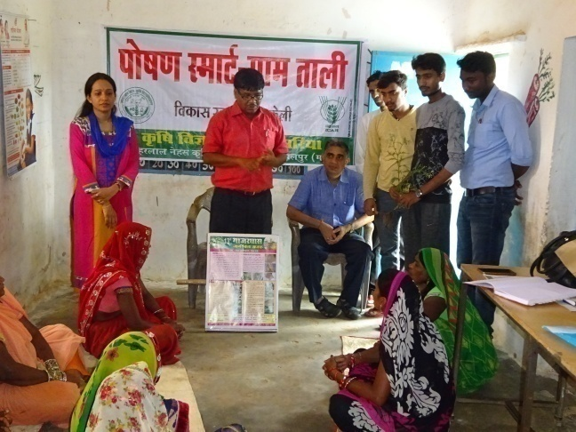 | 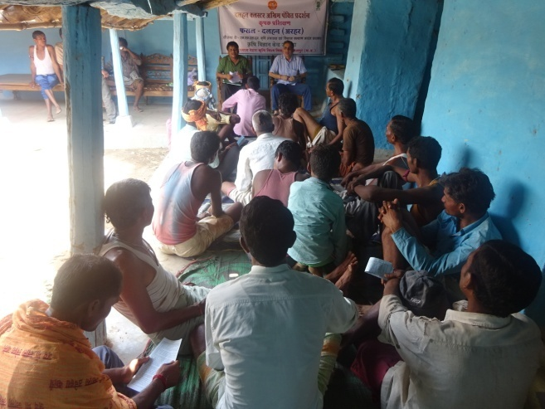 | 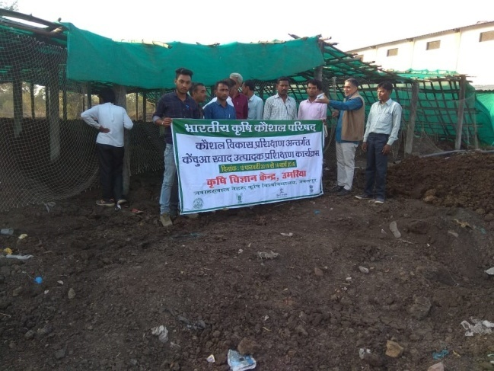
Training to farm women in NSV-Tali | Farmers training under NFSM at village Akmania | Skill development training on Vermi-compost producer
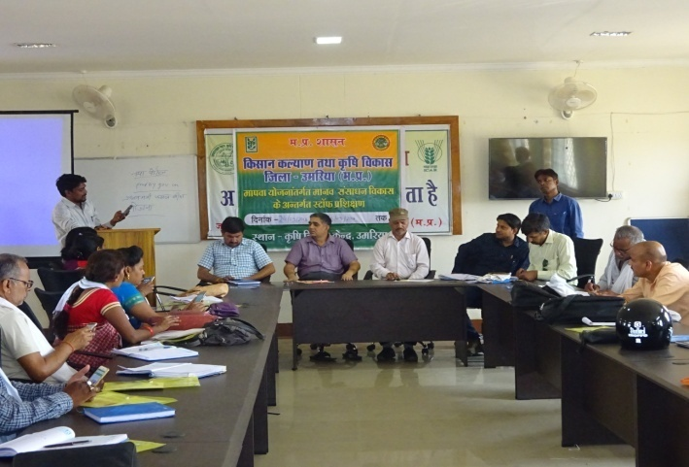 | 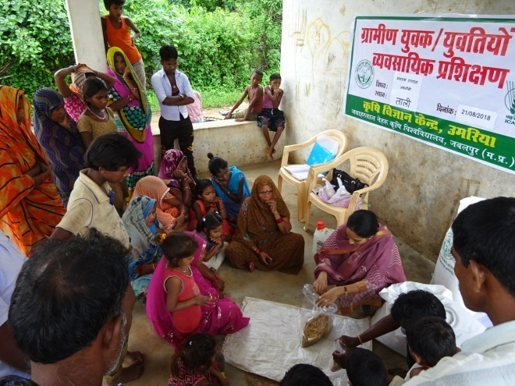 | 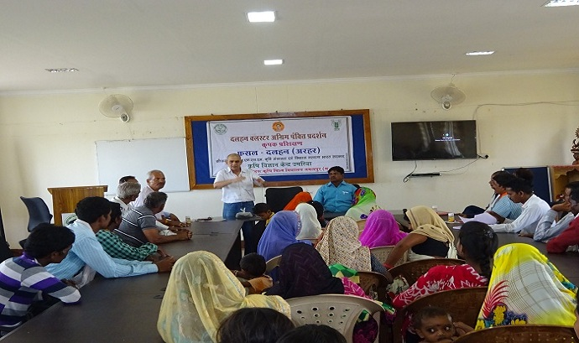
In-service training under MAPWA at KVK | RY Training on mushroom production at village Tali | Farmers training under NFSM (Pulse) at KVK
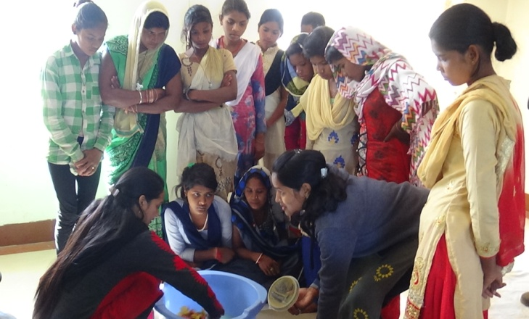 | 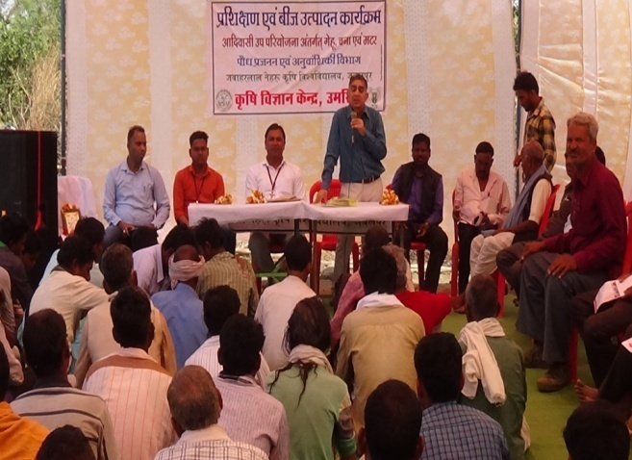 | 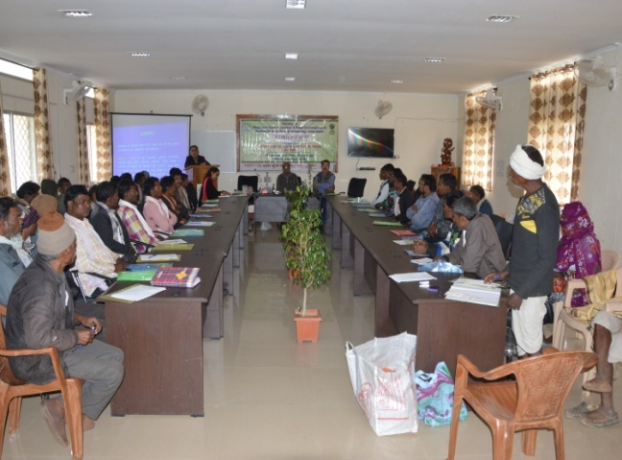
RY Training on Fruit and Vegetable Preservation | Sponsored training under TSP at village | Sponsored training on MAP at KVK

ON FARM TRIAL:
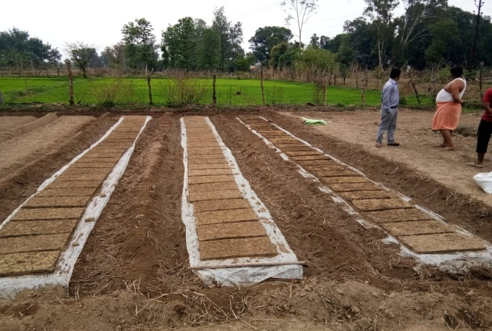 | 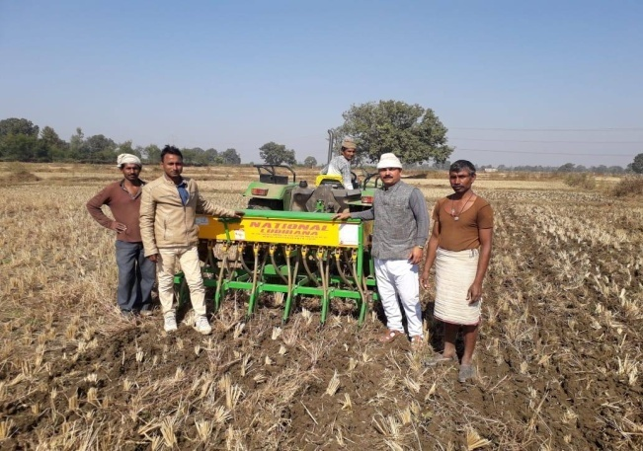 |  | 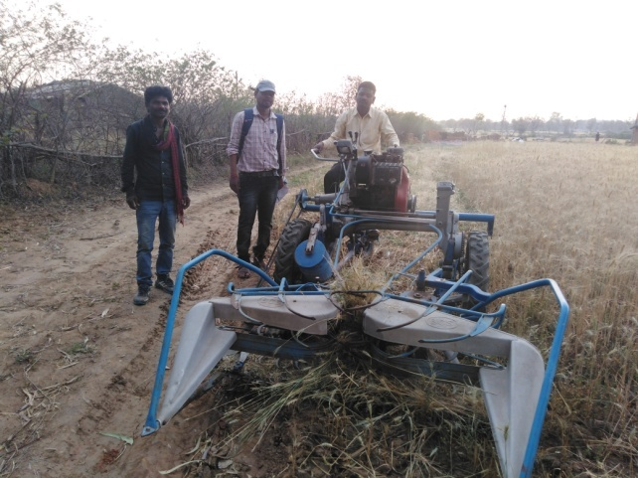
OFT- Nursery raising for Paddy transplanter | OFT- zero tillage with zero till drill |  | OFT- Reaper binder cutting wheat crop
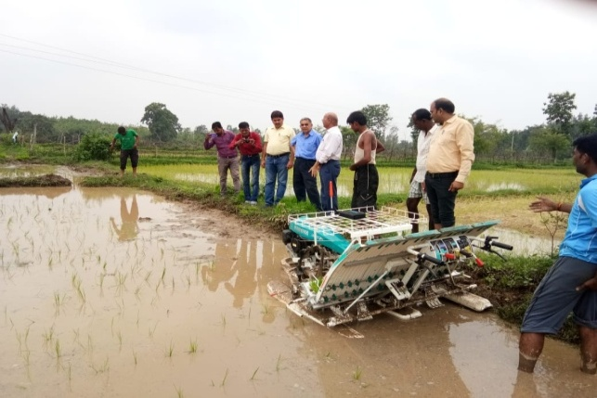 | 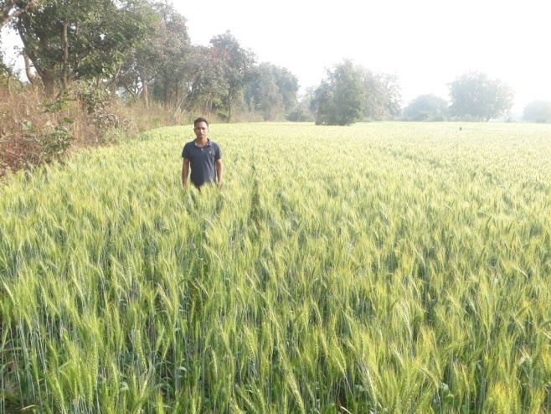 |  | 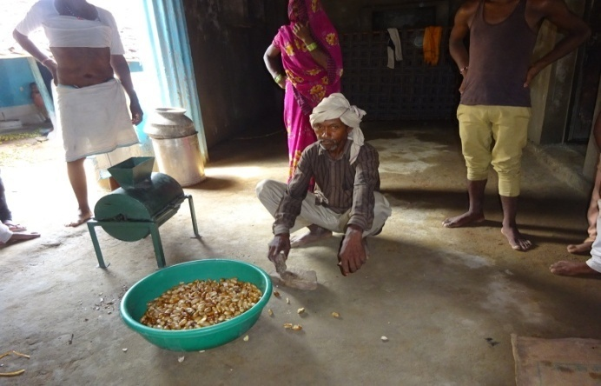
OFT- Paddy transplanting with Transplanter | OFT- Zero tillage with zero till drill |  | OFT- Mahua Decorticator
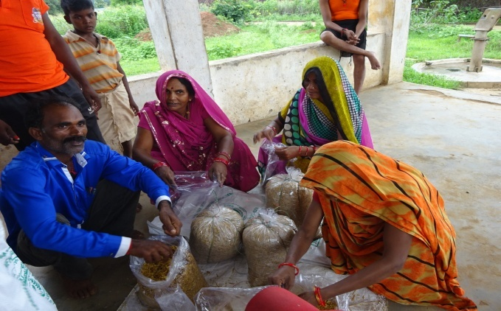 |  | 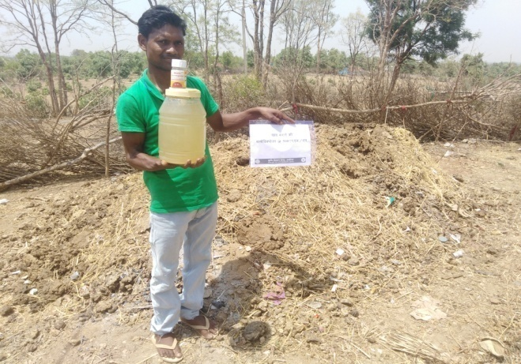 |  | 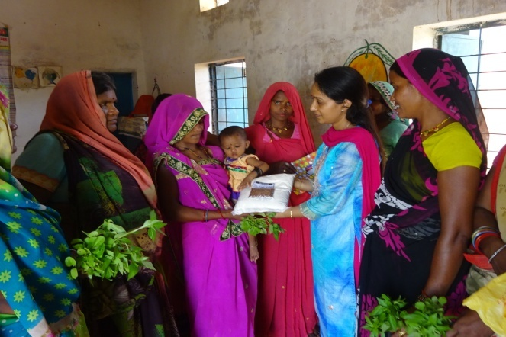
OFT- Mushroom production at NSV- Tali |  | OFT- Bio waste decomposer |  | OFT- Multi grain flour
FRONTLINE DEMONSTRATIONS:
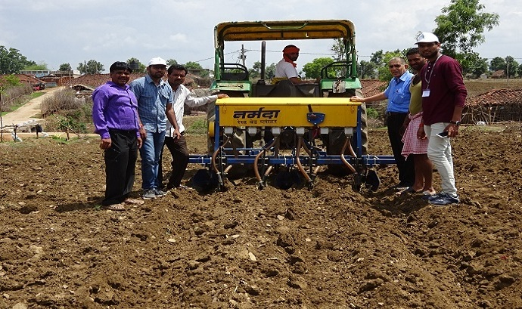 | 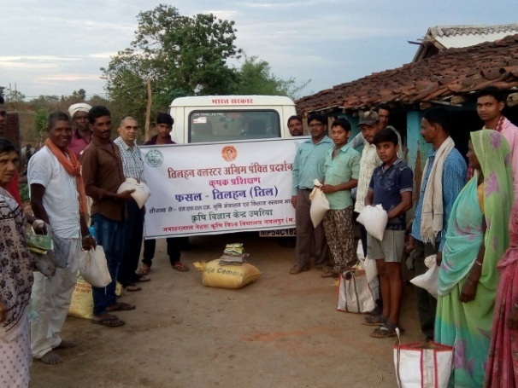 | 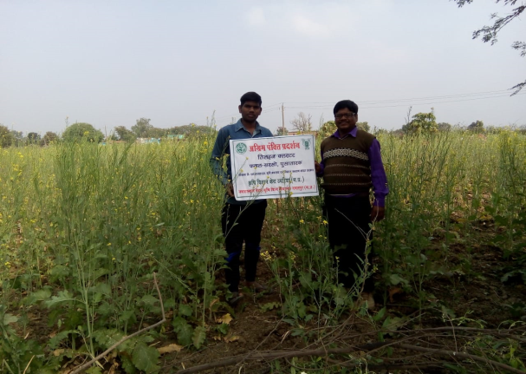
CFLD – Pigeon pea (Raised bed sowing) | CFLD- Sesame (Input distribution) | CFLD –Mustard (Pusa tarak)
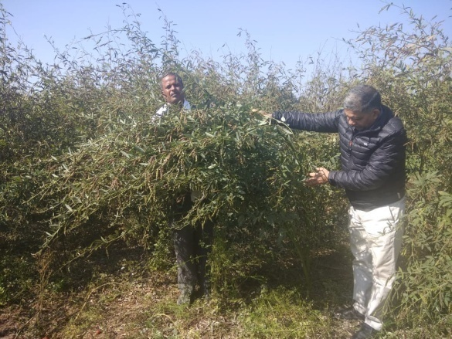 | 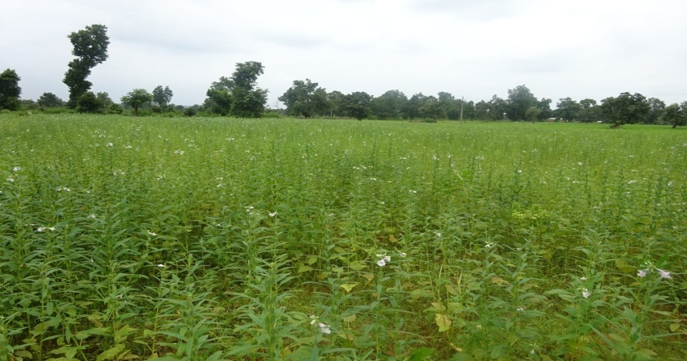 | 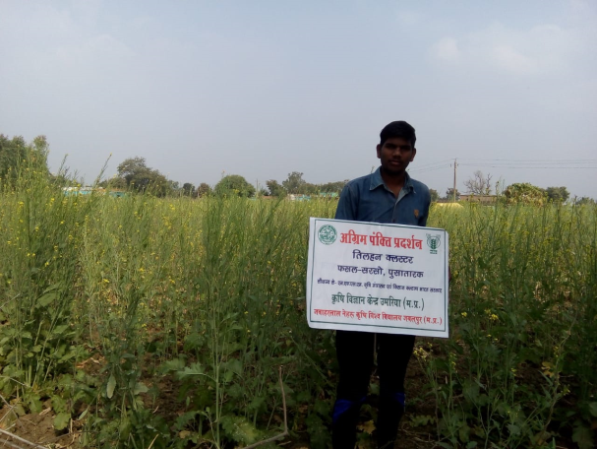
FLD on SPI in Pigeon pea | FLD – Sesame at farmers field | CFLD –Mustard (Pusa tarak)
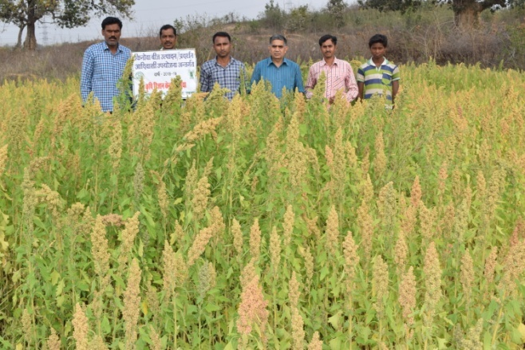 | 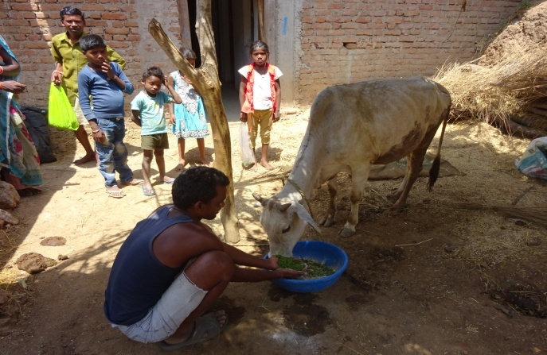 | 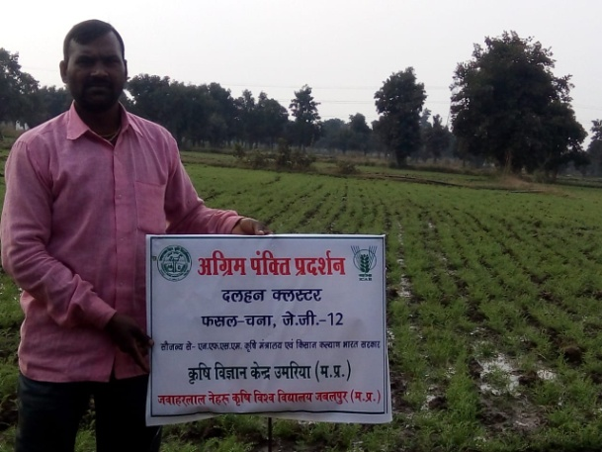
Demonstration on Quinoa under TSP | FLD-Azolla feeding to cow | FLD – Chick pea (JG-12)
EXTENSION ACTIVITIES:
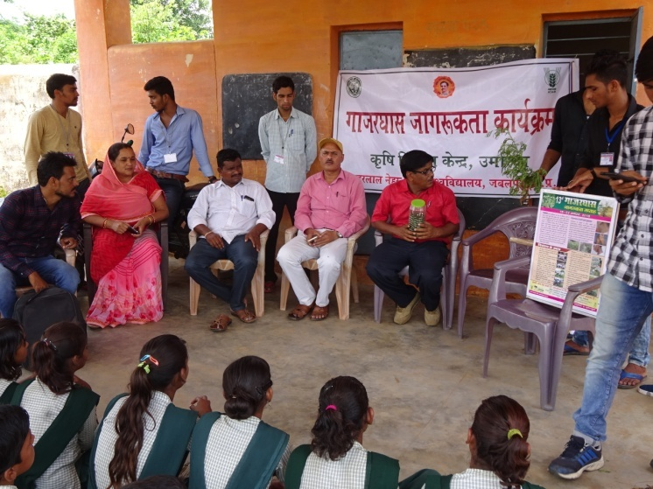 | 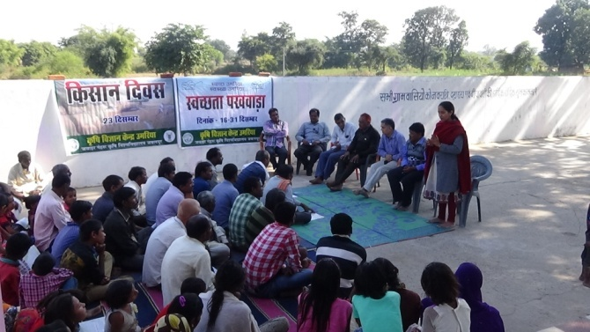 | 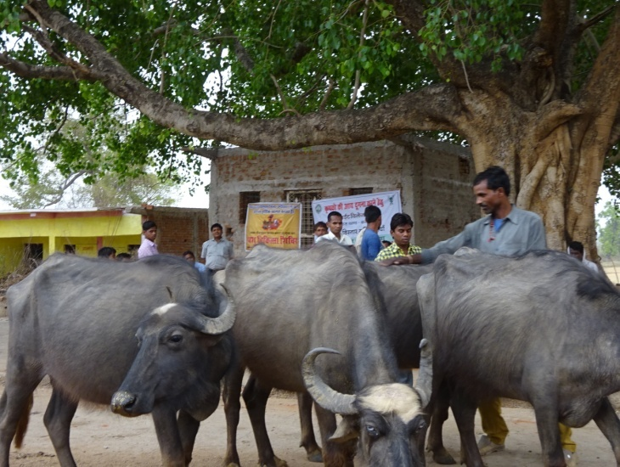
Parthenium awareness programme | Swacchata pakhwada and kisan diwas | Animal Health Camp at village Tali
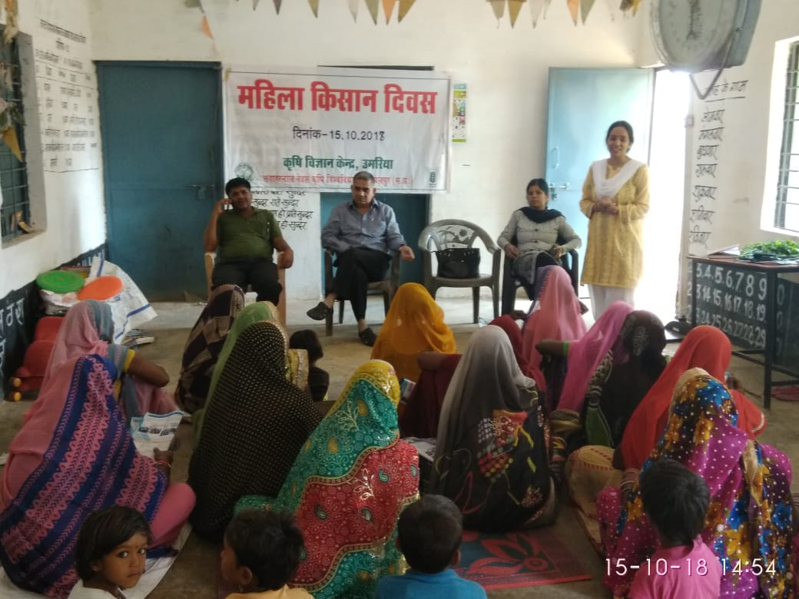 | 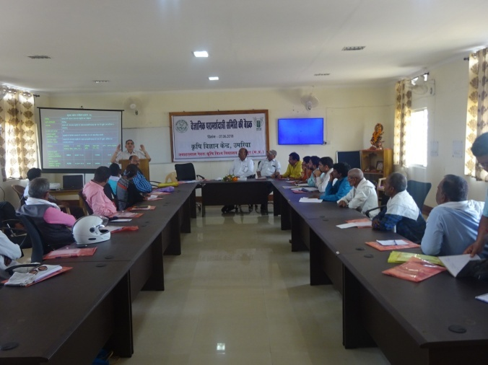 | 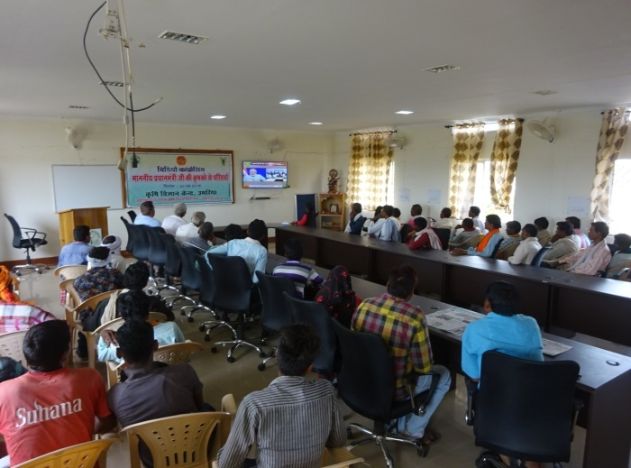
Mahila Kisan diwas celebration at village Kaccharwar | SAC meeting at KVK Umaria | PM live interaction with farmers (Webcasting)

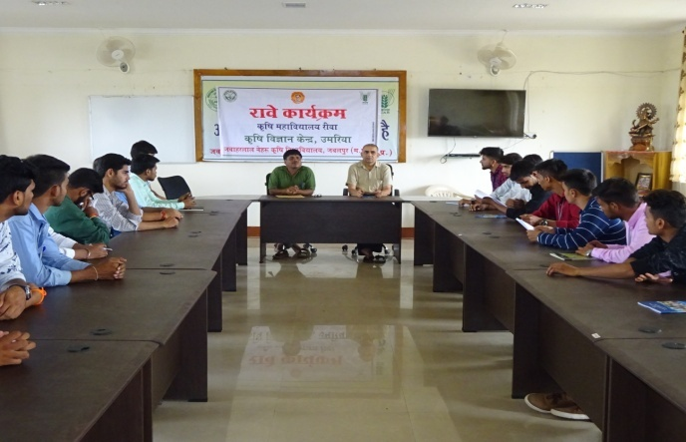 | 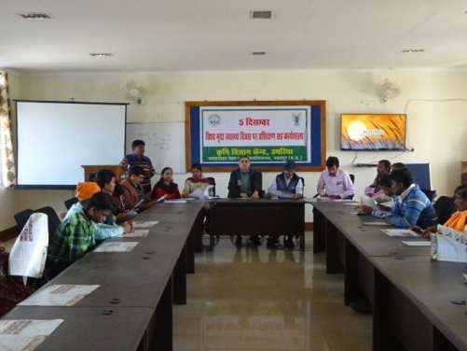 | 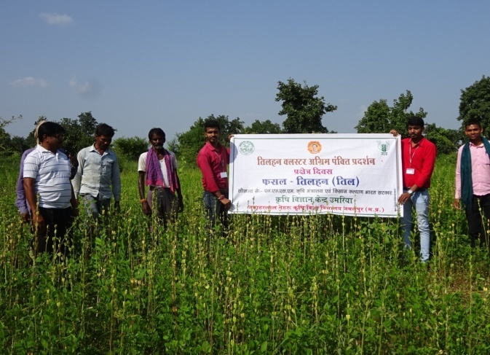
RAWE programme | Soil Health Day celebration at KVK | Field Day on Sesame Crop
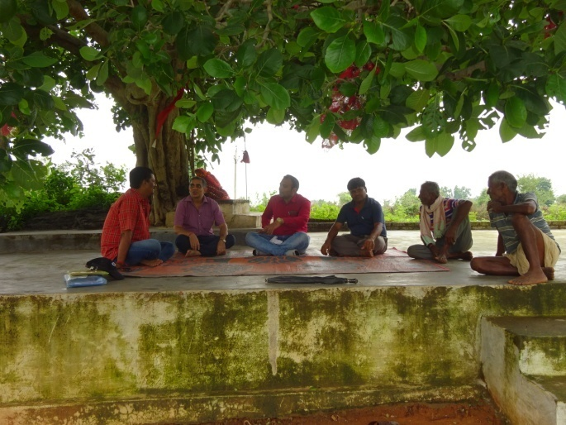 | 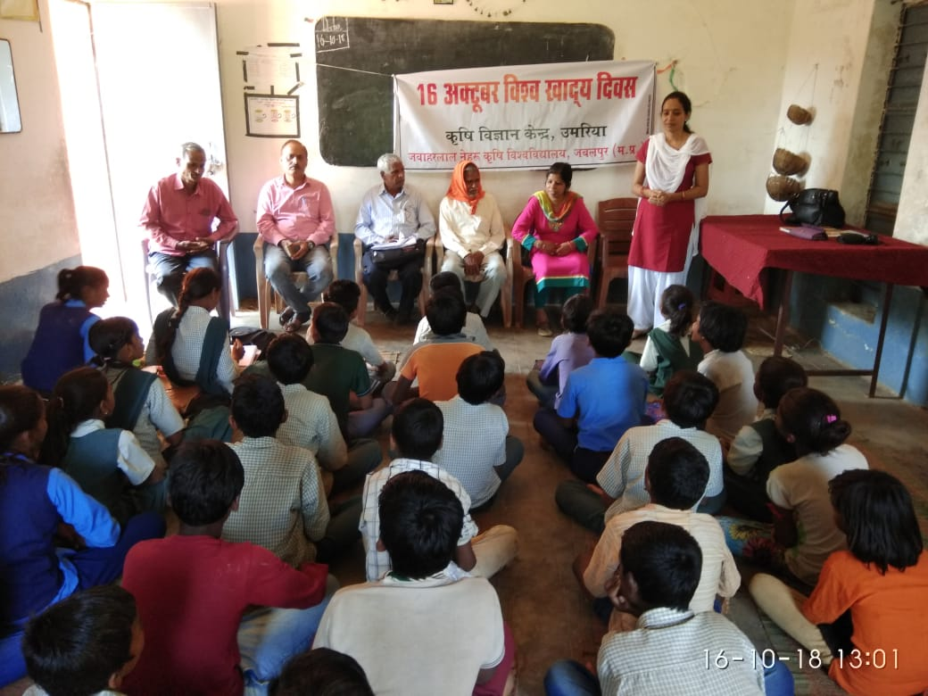 | 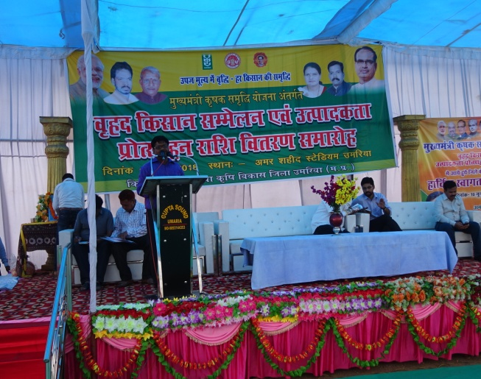
Farmers -Scientist interaction | World Food Day celebration at Village Ufri | Kisan Mela

FOOTFALL

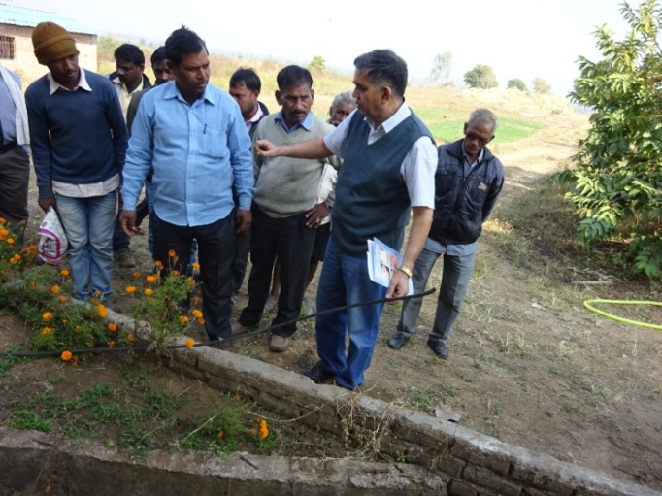 | 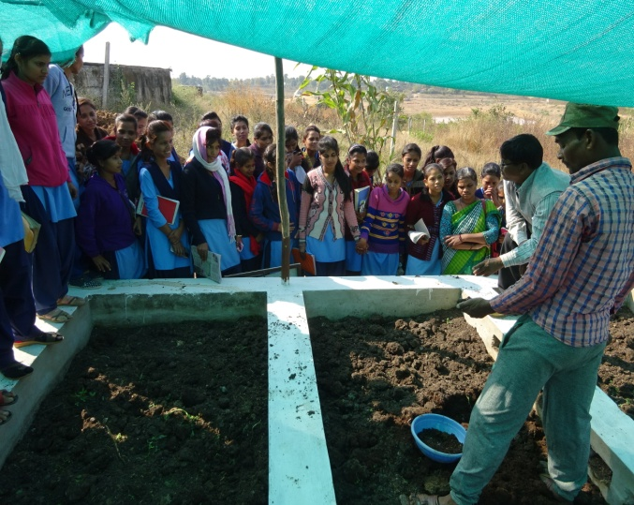
Footfall – sponsored from agricultural engineering department Umaria | Footfall – ITI student visit
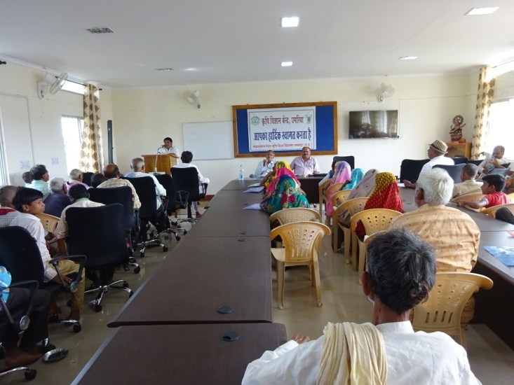 | 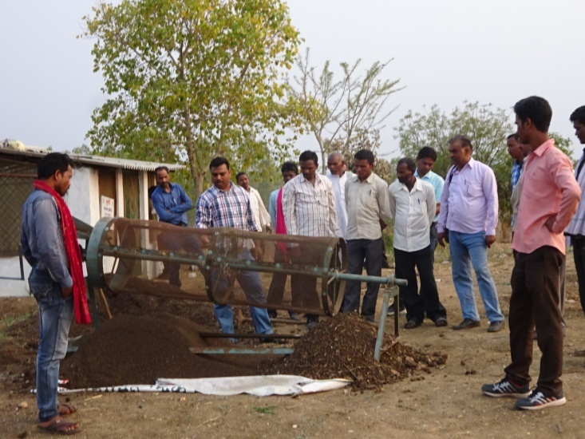
Footfall – ATMA Satna | Footfall – ATMA Anuppur

